Title | Head Coach | Assistant Coach
Name | Fruquwa Miller | Angelo Hillie
Email  cell | Fruquwa.Miller@yahoo.com  (248) 909-9364 | Ky.Butta1722@gmail.com  (313) 729-0167
Photo | 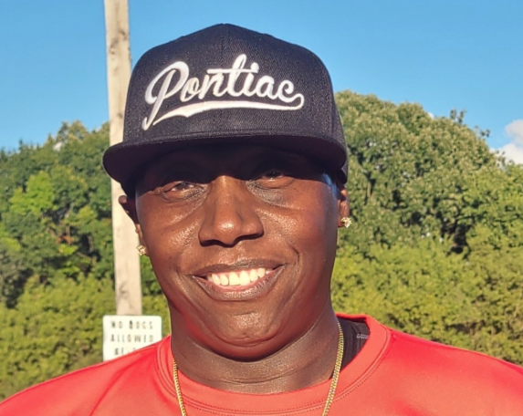 | 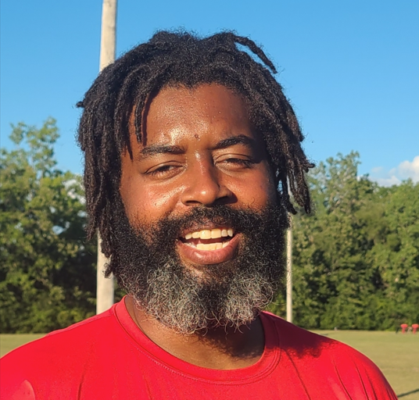

Jersey No | First Name | Last Name | Grade | Playing Age  (Before Sept 1st) | Photo
0 | Dedante | Hall Jr. | 8 | 13 | 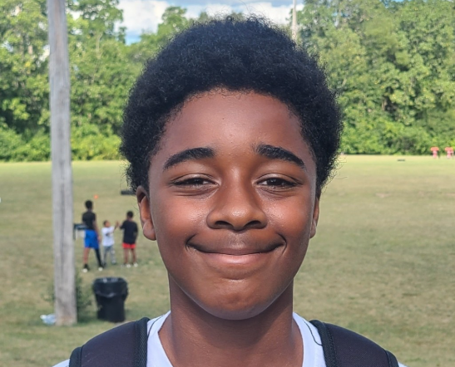
1 | Joel | Tirado | 8 | 14 | 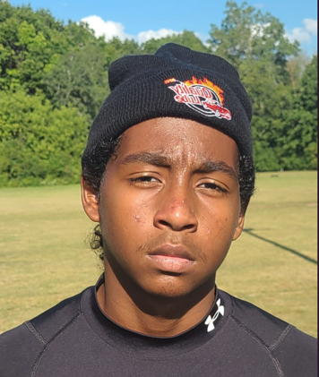
2 | Damon | Mallory | 8 | 12 | 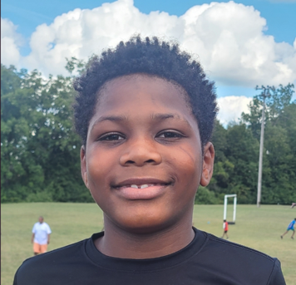
3 | Joshawn | Green | 8 | 11 | 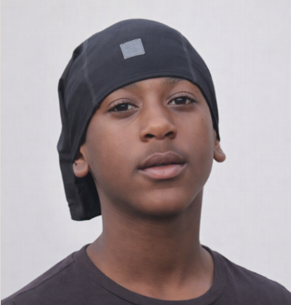
4 | Damani | Randolph | 7 | 13 | 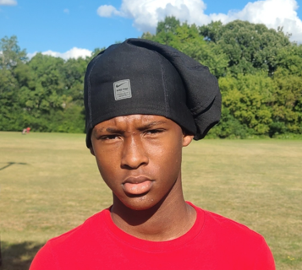
6 | Lavarie | Hamilton | 8 | 13 | 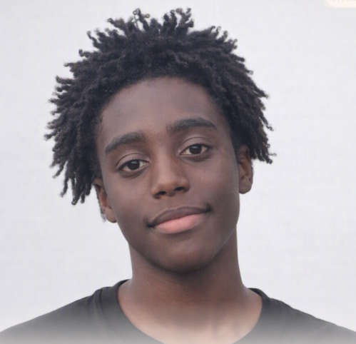
7 | Rodger | Stokes Jr. | 8 | 13 | 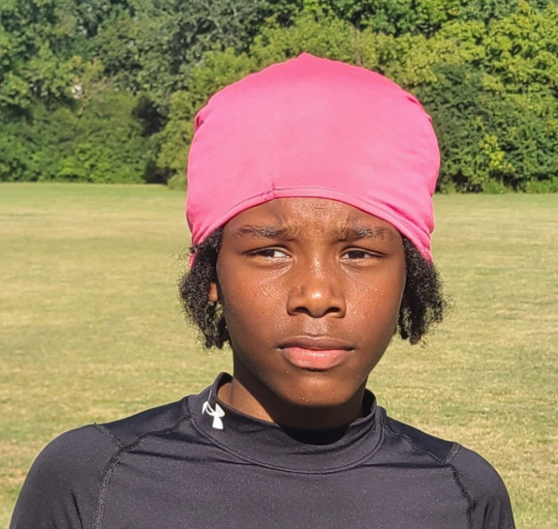
10 | Akari | Wooten | 8 | 13 | 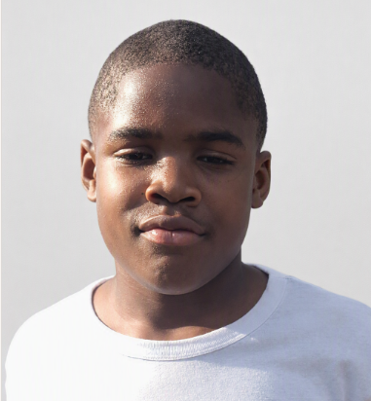
15 | Gunner | Cooper | 7 | 13 | 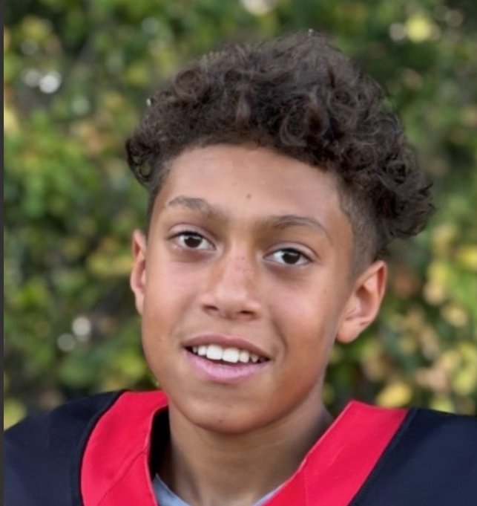
16 | Loyal | Smith | 6 | 11 | 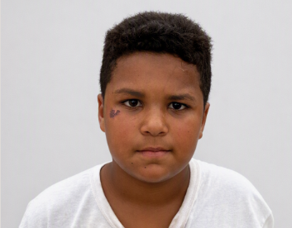
26 | Mason | Rush | 8 | 13 | 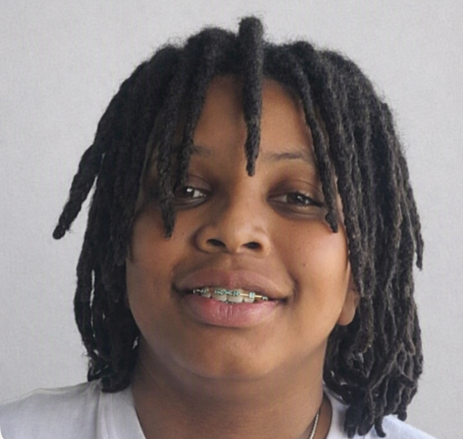
33 | Carter | Ware | 7 | 12 | 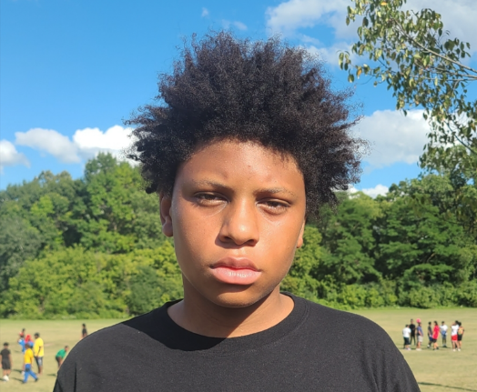
44 | Miguel | Nerio | 7 | 13 | 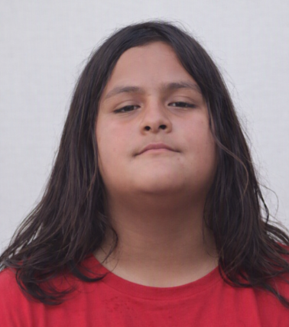
99 | Antowoine | Wooten | 8 | 13 | 