Organization: Rochester Raiders

Team: Varsity

Title | Head Coach | Unit Director | Ass’t Coach | Ass’t Coach
Name | David Markey | Chris Gould | Brett Burzynski | Brian Freels
Email  Cell | dmarkey1017@gmail.com  2489310372 | chrisgould09@hotmail.com  8575443261 | Brett.burzynski@gmail.com  248-941-1455 | bfreels3@gmail.com  2488821023
Photo |  |  |  | 

Title | Ass’t Coach | Ass’t Coach | Ass’t Coach | Ass’t Coach
Name | Anthony Reeves | Nick Browe | Will Montgomery | Dennis Edwards
Email  Cell | antreeves1@gmail.com  2693520265 | nickbrowe@yahoo.com  248-494-0800 | wmontgomery@theorsusgroup.com  248-703-7209 | dedwards@detroitchassis.com  3136909620
Photo |  |  |  | 

Title | Ass’t Coach | Ass’t Coach | Ass’t Coach | Ass’t Coach
Name | Gary Grochowski
Email  Cell | gary.grochowski@gmail.com  248.981.6468
Photo | 

** Coaches not identified on this Roster with a photo and contact information are NOT permitted on the sidelines of any MYFCC game. Coaches are required to have a signed Code of Conduct form on file.

*** If a player’s information is not complete, the Player is not eligible to play in any MYFCC regular season or playoff game.

**** Jersey number MUST be in numerical order, lowest to highest.
Organization/ Team: R

Jersey No. | First Name | Last Name | Grade | Playing Age  (Age before Sept 1st) | Photo
0 | Charlie | Lamb | 8th | 13 | 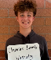
1 | Dominic | Edwards | 8th | 14 | 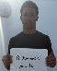
2 | Major | Kulis | 8th | 13 | 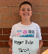
3 | Cole | Matuszak | 8th | 14 | 
4 | Drew | Newingham | 8th | 13 | 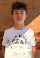S
6 | Isaac | Hoekstra | 8th | 13 | 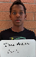
7 | Jacob | Geottes | 8th | 13 | 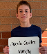
8 | Miles | Madigan | 8th | 13 | 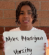
9 | Jake | Grochowski | 8th | 13 | 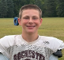
11 | Ethan | Markey | 8th | 13 | 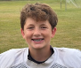
12 | Reeve | Montgomery | 8th | 13 | 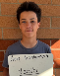
14 | Anthony | Ward | 8th | 13 | 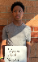
16 | Francis | Pompa | 8th | 13 | 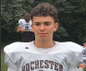
17 | Leonardo | Gogola | 8th | 13 | 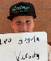
23 | Ben | Durda | 8th | 13 | 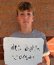
27 | Cooper | Erby | 8th | 13 | 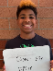
28 | Colin | McDougall | 7th | 13 | 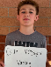
32 | Bennett | Sebastian | 8th | 14 | 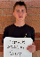
33 | Will | Burzynski | 8th | 13 | 
44 | Cole | Freels | 8th | 13 | 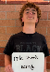
54 | Benjamin | Drankhan | 8th | 13 | 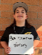
59 | Ryan | Gould | 7th | 13 | 
83 | Ben | Sun | 8th | 13 | 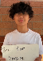
88 | Carlo | Bonetti | 8th | 13 | 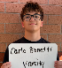
90 | Chace | Browe | 8th | 13 | 
95 | Mason | Reeves | 8th | 13 | 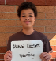
99 | Owen | Jacob | 8th | 13 | 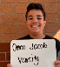

** Coaches not identified on this Roster with a photo and contact information are NOT permitted on the sidelines of any MYFCC game.

*** If a player’s information is not complete, the Player is not eligible to play in any MYFCC regular season or playoff game.

**** Jersey number MUST be in numerical order, lowest to highest.

