Organization: Warren Jets

Team: Junior Varisty

Title | Head Coach | Unit Director | Ass’t Coach | Ass’t Coach
Name | LaDayrl Winters | Adrianna Lee | William Bell | Antonie Ivy
Email  Cell | 248-979-4525 | 313-986-6790 | 313-320-6441 | 313-999-4224
Photo |  |  |  | 

Title | Ass’t Coach | Ass’t Coach | Ass’t Coach | Ass’t Coach
Name | Angelio Glass | Click or tap here to enter text. | Click or tap here to enter text. | Click or tap here to enter text.
Email  Cell | 248-470-3540 | Click or tap here to enter text. | Click or tap here to enter text. | Click or tap here to enter text.
Photo |  | Click or tap here to enter text. | Click or tap here to enter text. | Click or tap here to enter text.

Title | Ass’t Coach | Ass’t Coach | Ass’t Coach | Ass’t Coach
Name | Click or tap here to enter text. | Click or tap here to enter text. | Click or tap here to enter text. | Click or tap here to enter text.
Email  Cell | Click or tap here to enter text. | Click or tap here to enter text. | Click or tap here to enter text. | Click or tap here to enter text.
Photo | Click or tap here to enter text. | Click or tap here to enter text. | Click or tap here to enter text. | Click or tap here to enter text.

** Coaches not identified on this Roster with a photo and contact information are NOT permitted on the sidelines of any MYFCC game. Coaches are required to have a signed Code of Conduct form on file.

*** If a player’s information is not complete, the Player is not eligible to play in any MYFCC regular season or playoff game.

**** Jersey number MUST be in numerical order, lowest to highest.
Organization/ Team: Click or tap here to enter text.

Jersey No. | First Name | Last Name | Grade | Playing Age  (Age before Sept 1st) | Photo
0 | Deshawn | Glass | 6 | 11 | 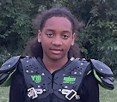
1 | D’Angelo | Green Jr | 7th | 12 | 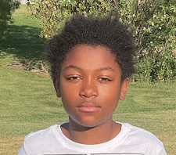
2 | Tristian | Winters | 6th | 11 | 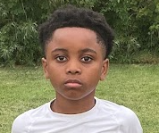
3 | Braylon | Seabrooks | 7th | 12 | 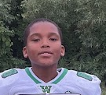
4 | Carter | Bell | 6th | 11 | 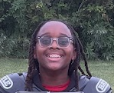
5 | Robert | Houston Jr | 7th | 12 | 
6 | Bryalon | Borden -Burton | 7 | 11 | 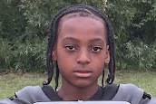
7 | Braxton | Ware | 6th | 11 | 
8 | Donald | White | 7th | 12 | 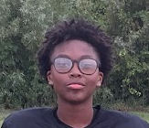
9 | Caleb | Chavez | 6th | 11 | 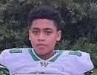
10 | Ra’von | Thomas | 6 | 11 | 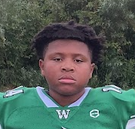
11 | Davion | Davis | 7 | 12 | 
12 | Kam’iron | Grandberry | 6 | 11 | 
13 | Emmet | Vaughn | 6 | 11 | 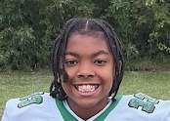
14 | Carson | Wright | 6 | 11 | 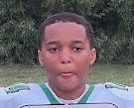
16 | Khari | Maze | 6th | 11 | 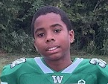
21 | Jordan | Hodges | 7th | 12 | 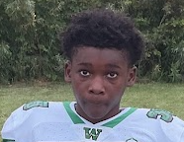
23 | Ayden | Johnson | 6th | 11 | 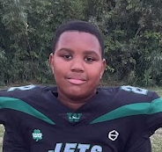
24 | Kaiden | Thomas | 7th | 12 | 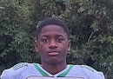
26 | Patrick | Sterling Jr | 6th | 11 | 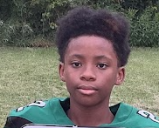
28 | Kaiden | Palmer | 7th | 12 | 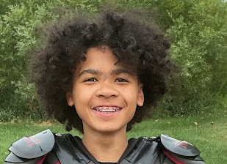
45 | Gabriel | Sakowski | 6th | 11 | 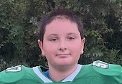
50 | Malachi | Lewis | 6th | 11 | 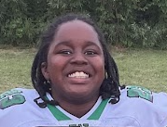
Click or tap here to enter text. | Click or tap here to enter text. | Click or tap here to enter text. | Click or tap here to enter text. | Click or tap here to enter text. | Click or tap here to enter text.
55 | Robert | Lee Jr | 6th | 11 | 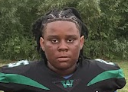
88 | Ian | Kwiathowshi | 6th | 11 | 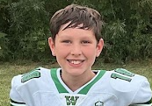
Click or tap here to enter text. | Click or tap here to enter text. | Click or tap here to enter text. | Click or tap here to enter text. | Click or tap here to enter text. | Click or tap here to enter text.
Click or tap here to enter text. | Click or tap here to enter text. | Click or tap here to enter text. | Click or tap here to enter text. | Click or tap here to enter text. | Click or tap here to enter text.
Click or tap here to enter text. | Click or tap here to enter text. | Click or tap here to enter text. | Click or tap here to enter text. | Click or tap here to enter text. | Click or tap here to enter text.
Click or tap here to enter text. | Click or tap here to enter text. | Click or tap here to enter text. | Click or tap here to enter text. | Click or tap here to enter text. | Click or tap here to enter text.
Click or tap here to enter text. | Click or tap here to enter text. | Click or tap here to enter text. | Click or tap here to enter text. | Click or tap here to enter text. | Click or tap here to enter text.
Click or tap here to enter text. | Click or tap here to enter text. | Click or tap here to enter text. | Click or tap here to enter text. | Click or tap here to enter text. | Click or tap here to enter text.
Click or tap here to enter text. | Click or tap here to enter text. | Click or tap here to enter text. | Click or tap here to enter text. | Click or tap here to enter text. | Click or tap here to enter text.
Click or tap here to enter text. | Click or tap here to enter text. | Click or tap here to enter text. | Click or tap here to enter text. | Click or tap here to enter text. | Click or tap here to enter text.
Click or tap here to enter text. | Click or tap here to enter text. | Click or tap here to enter text. | Click or tap here to enter text. | Click or tap here to enter text. | Click or tap here to enter text.
Click or tap here to enter text. | Click or tap here to enter text. | Click or tap here to enter text. | Click or tap here to enter text. | Click or tap here to enter text. | Click or tap here to enter text.
Click or tap here to enter text. | Click or tap here to enter text. | Click or tap here to enter text. | Click or tap here to enter text. | Click or tap here to enter text. | Click or tap here to enter text.
Click or tap here to enter text. | Click or tap here to enter text. | Click or tap here to enter text. | Click or tap here to enter text. | Click or tap here to enter text. | Click or tap here to enter text.
Click or tap here to enter text. | Click or tap here to enter text. | Click or tap here to enter text. | Click or tap here to enter text. | Click or tap here to enter text. | Click or tap here to enter text.
Click or tap here to enter text. | Click or tap here to enter text. | Click or tap here to enter text. | Click or tap here to enter text. | Click or tap here to enter text. | Click or tap here to enter text.
Click or tap here to enter text. | Click or tap here to enter text. | Click or tap here to enter text. | Click or tap here to enter text. | Click or tap here to enter text. | Click or tap here to enter text.
Click or tap here to enter text. | Click or tap here to enter text. | Click or tap here to enter text. | Click or tap here to enter text. | Click or tap here to enter text. | Click or tap here to enter text.
Click or tap here to enter text. | Click or tap here to enter text. | Click or tap here to enter text. | Click or tap here to enter text. | Click or tap here to enter text. | Click or tap here to enter text.
Click or tap here to enter text. | Click or tap here to enter text. | Click or tap here to enter text. | Click or tap here to enter text. | Click or tap here to enter text. | Click or tap here to enter text.
Click or tap here to enter text. | Click or tap here to enter text. | Click or tap here to enter text. | Click or tap here to enter text. | Click or tap here to enter text. | Click or tap here to enter text.
Click or tap here to enter text. | Click or tap here to enter text. | Click or tap here to enter text. | Click or tap here to enter text. | Click or tap here to enter text. | Click or tap here to enter text.
Click or tap here to enter text. | Click or tap here to enter text. | Click or tap here to enter text. | Click or tap here to enter text. | Click or tap here to enter text. | Click or tap here to enter text.

** Coaches not identified on this Roster with a photo and contact information are NOT permitted on the sidelines of any MYFCC game.

*** If a player’s information is not complete, the Player is not eligible to play in any MYFCC regular season or playoff game.

**** Jersey number MUST be in numerical order, lowest to highest.

