Organization: Orchard Lake Cardinals

Team: Varsity

Title | Head Coach | Unit Director | Ass’t Coach | Ass’t Coach
Name | KEYVON BARBEE | RYAN DERSHAM | DEQUANDRE CALDWELL | DARNELL HERRING
Email  Cell | 248-875-4065 | 248-672-3270 | 248-818-5593 | 248-949-8269
Photo |  | 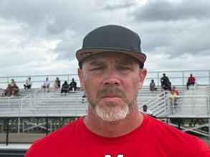 |  | 

Title | Ass’t Coach | Ass’t Coach | Ass’t Coach | Ass’t Coach
Name | MATTHEW RUPPERT | JUVONE STOVALL | AUSTIN WOOD | Click or tap here to enter text.
Email  Cell | 248-534-3779 | 248-636-3434 | 248-425-4491 | Click or tap here to enter text.
Photo |  |  |  | Click or tap here to enter text.

Title | Ass’t Coach | Ass’t Coach | Ass’t Coach | Ass’t Coach
Name | Click or tap here to enter text. | Click or tap here to enter text. | Click or tap here to enter text. | Click or tap here to enter text.
Email  Cell | Click or tap here to enter text. | Click or tap here to enter text. | Click or tap here to enter text. | Click or tap here to enter text.
Photo | Click or tap here to enter text. | Click or tap here to enter text. | Click or tap here to enter text. | Click or tap here to enter text.

** Coaches not identified on this Roster with a photo and contact information are NOT permitted on the sidelines of any MYFCC game. Coaches are required to have a signed Code of Conduct form on file.

*** If a player’s information is not complete, the Player is not eligible to play in any MYFCC regular season or playoff game.

**** Jersey number MUST be in numerical order, lowest to highest.
Organization/ Team: Orchard Lake Cardinals-Varsity

Jersey No. | First Name | Last Name | Grade | Playing Age  (Age before Sept 1st) | Photo
0 | DYLLON | PARKER | 8 | 13 | 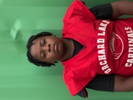
1 | SIR CORBAN | ANDERSON | 8 | 13 | 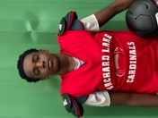
2 | DEJOHN | WRIGHT-LEAK | 8 | 13 | 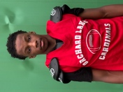
3 | LIAM | FRASER | 8 | 13 | 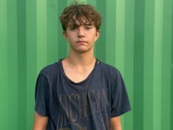
4 | JONNIE | STOVALL | 8 | 13 | 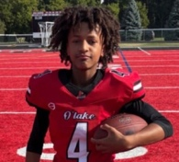
5 | ELIJAH | GONZALES | 8 | 13 | 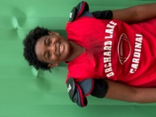
7 | VONZELL | LANG | 8 | 12 | 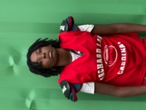
8 | DEAIRE | HERRING | 8 | 13 | 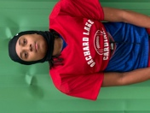
9 | NOAH | MOORE | 8 | 13 | 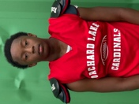
10 | BRENNAN | COYLE | 8 | 13 | 
11 | DEKOBEYON | WATKINS | 7 | 13 | 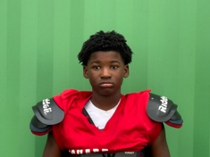
12 | BLAKE | DERSHAM | 8 | 13 | 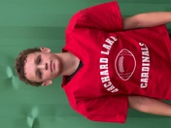
13 | JOAH | GREEN | 8 | 13 | 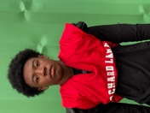
14 | DONTE | BEANE | 8 | 14 | 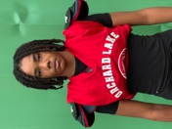
15 | JAEDON | ADAMS | 8 | 14 | 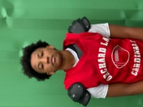
17 | SAVIOR | LOGAN | 8 | 14 | 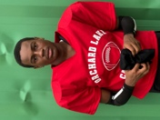
24 | RYLAN | MCKENNEY | 8 | 14 | 
28 | ANTHONY | SHELTON | 8 | 13 | 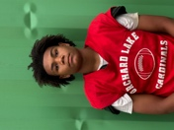
44 | ORYAN | GIBSON | 6 | 11 | 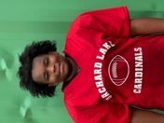
50 | JHACE | TURNER | 8 | 13 | 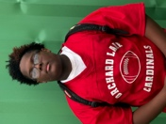
52 | BRYCE | JONES | 8 | 13 | 
54 | AUSTIN | PRICE | 8 | 13 | 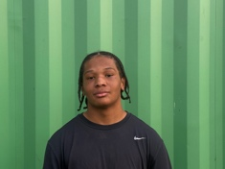
55 | DEQUANDRE | CALDWELL | 8 | 13 | 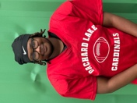
65 | EUGENE | PAYNE | 7 | 12 | 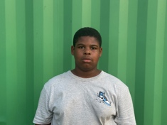
75 | MASON | WILLIAMS | 8 | 13 | 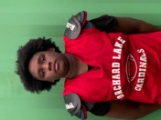
93 | ELIJAH | DOOLEY | 8 | 13 | 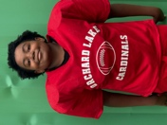
95 | LEVI | RUPPERT | 8 | 13 | 
99 | CAESAR | SHAW | 6 | 11 | 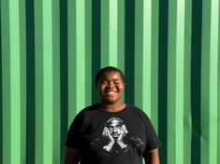
Click or tap here to enter text. | Click or tap here to enter text. | Click or tap here to enter text. | Click or tap here to enter text. | Click or tap here to enter text. | Click or tap here to enter text.
Click or tap here to enter text. | Click or tap here to enter text. | Click or tap here to enter text. | Click or tap here to enter text. | Click or tap here to enter text. | Click or tap here to enter text.
Click or tap here to enter text. | Click or tap here to enter text. | Click or tap here to enter text. | Click or tap here to enter text. | Click or tap here to enter text. | Click or tap here to enter text.
Click or tap here to enter text. | Click or tap here to enter text. | Click or tap here to enter text. | Click or tap here to enter text. | Click or tap here to enter text. | Click or tap here to enter text.
Click or tap here to enter text. | Click or tap here to enter text. | Click or tap here to enter text. | Click or tap here to enter text. | Click or tap here to enter text. | Click or tap here to enter text.
Click or tap here to enter text. | Click or tap here to enter text. | Click or tap here to enter text. | Click or tap here to enter text. | Click or tap here to enter text. | Click or tap here to enter text.
Click or tap here to enter text. | Click or tap here to enter text. | Click or tap here to enter text. | Click or tap here to enter text. | Click or tap here to enter text. | Click or tap here to enter text.
Click or tap here to enter text. | Click or tap here to enter text. | Click or tap here to enter text. | Click or tap here to enter text. | Click or tap here to enter text. | Click or tap here to enter text.
Click or tap here to enter text. | Click or tap here to enter text. | Click or tap here to enter text. | Click or tap here to enter text. | Click or tap here to enter text. | Click or tap here to enter text.
Click or tap here to enter text. | Click or tap here to enter text. | Click or tap here to enter text. | Click or tap here to enter text. | Click or tap here to enter text. | Click or tap here to enter text.
Click or tap here to enter text. | Click or tap here to enter text. | Click or tap here to enter text. | Click or tap here to enter text. | Click or tap here to enter text. | Click or tap here to enter text.
Click or tap here to enter text. | Click or tap here to enter text. | Click or tap here to enter text. | Click or tap here to enter text. | Click or tap here to enter text. | Click or tap here to enter text.
Click or tap here to enter text. | Click or tap here to enter text. | Click or tap here to enter text. | Click or tap here to enter text. | Click or tap here to enter text. | Click or tap here to enter text.
Click or tap here to enter text. | Click or tap here to enter text. | Click or tap here to enter text. | Click or tap here to enter text. | Click or tap here to enter text. | Click or tap here to enter text.
Click or tap here to enter text. | Click or tap here to enter text. | Click or tap here to enter text. | Click or tap here to enter text. | Click or tap here to enter text. | Click or tap here to enter text.
Click or tap here to enter text. | Click or tap here to enter text. | Click or tap here to enter text. | Click or tap here to enter text. | Click or tap here to enter text. | Click or tap here to enter text.
Click or tap here to enter text. | Click or tap here to enter text. | Click or tap here to enter text. | Click or tap here to enter text. | Click or tap here to enter text. | Click or tap here to enter text.
Click or tap here to enter text. | Click or tap here to enter text. | Click or tap here to enter text. | Click or tap here to enter text. | Click or tap here to enter text. | Click or tap here to enter text.
Click or tap here to enter text. | Click or tap here to enter text. | Click or tap here to enter text. | Click or tap here to enter text. | Click or tap here to enter text. | Click or tap here to enter text.

** Coaches not identified on this Roster with a photo and contact information are NOT permitted on the sidelines of any MYFCC game.

*** If a player’s information is not complete, the Player is not eligible to play in any MYFCC regular season or playoff game.

**** Jersey number MUST be in numerical order, lowest to highest.

