Organization: Orchard Lake Cardinals

Team: Junior Freshman

Title | Head Coach | Unit Director | Ass’t Coach | Ass’t Coach
Name | TORRION HARDY | Click or tap here to enter text. | MALCOM CLARK | HENRY ELAM
Email  Cell | 989-890-2808 | Click or tap here to enter text. | 248-342-3460 | 248-895-7305
Photo | 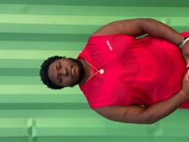 | Click or tap here to enter text. |  | 

Title | Ass’t Coach | Ass’t Coach | Ass’t Coach | Ass’t Coach
Name | DESMOND HERRING | RUSSELL GONZALES | Click or tap here to enter text. | Click or tap here to enter text.
Email  Cell | 586-883+0910 | 248-882-5567 | Click or tap here to enter text. | Click or tap here to enter text.
Photo |  |  | Click or tap here to enter text. | Click or tap here to enter text.

Title | Ass’t Coach | Ass’t Coach | Ass’t Coach | Ass’t Coach
Name | Click or tap here to enter text. | Click or tap here to enter text. | Click or tap here to enter text. | Click or tap here to enter text.
Email  Cell | Click or tap here to enter text. | Click or tap here to enter text. | Click or tap here to enter text. | Click or tap here to enter text.
Photo | Click or tap here to enter text. | Click or tap here to enter text. | Click or tap here to enter text. | Click or tap here to enter text.

** Coaches not identified on this Roster with a photo and contact information are NOT permitted on the sidelines of any MYFCC game. Coaches are required to have a signed Code of Conduct form on file.

*** If a player’s information is not complete, the Player is not eligible to play in any MYFCC regular season or playoff game.

**** Jersey number MUST be in numerical order, lowest to highest.
Organization/ Team: Orchard Lake Cardinals-Junior Freshman

Jersey No. | First Name | Last Name | Grade | Playing Age  (Age before Sept 1st) | Photo
0 | ISAIAH | WALKER | 1 | 6 | 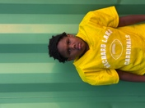
1 | LUCHIANO | BARKSDALE | 3 | 8 | 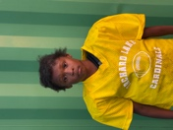
2 | CHASE | HERRING | 2 | 7 | 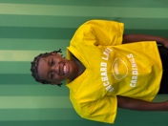
3 | KAIRO | ALLEN | 2 | 8 | 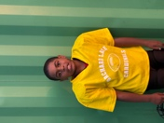
4 | GRAYSON | NORTH | 2 | 7 | 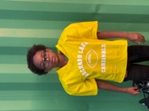
5 | JERZEY | BLACK | 1 | 6 | 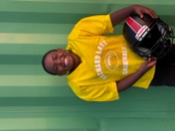
6 | KAI | BARNES | 1 | 6 | 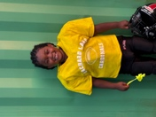
7 | DILLON | MOSS | 3 | 8 | 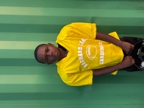
8 | ROBERT | CURRY JR | 1 | 6 | 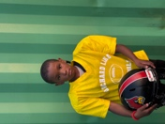
10 | BENTLEY | LITTLES | 3 | 8 | 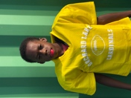
11 | DEMEIR | HERRING | 1 | 6 | 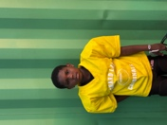
12 | JAHLIL “CRUZ” | VINING | 2 | 7 | 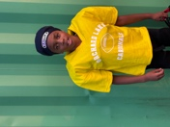
15 | KAIDEN | PRUITT | 1 | 6 | 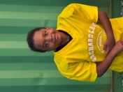
16 | DEJON | GORDON | 2 | 8 | 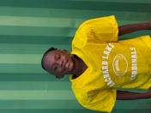
20 | JOSIAH | VINING | 3 | 8 | 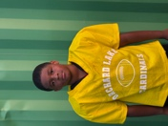
21 | AUSTIN | THREETS | 2 | 7 | 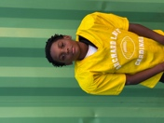
22 | GIANNI | LITTLES | 1 | 6 | 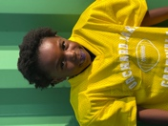
25 | CHASE | WINTERS | 3 | 8 | 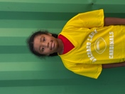
27 | ANDREW | SCANDRICK | 3 | 8 | 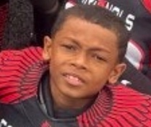
32 | DASH | REED | 2 | 7 | 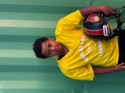
34 | WILLIAM | MCKENZIE-DAVIS | 3 | 8 | 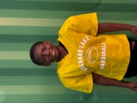
55 | BRANDON | PEOPLES JR | 3 | 8 | 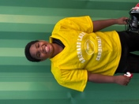
Click or tap here to enter text. | Click or tap here to enter text. | Click or tap here to enter text. | Click or tap here to enter text. | Click or tap here to enter text. | Click or tap here to enter text.
Click or tap here to enter text. | Click or tap here to enter text. | Click or tap here to enter text. | Click or tap here to enter text. | Click or tap here to enter text. | Click or tap here to enter text.
Click or tap here to enter text. | Click or tap here to enter text. | Click or tap here to enter text. | Click or tap here to enter text. | Click or tap here to enter text. | Click or tap here to enter text.
Click or tap here to enter text. | Click or tap here to enter text. | Click or tap here to enter text. | Click or tap here to enter text. | Click or tap here to enter text. | Click or tap here to enter text.
Click or tap here to enter text. | Click or tap here to enter text. | Click or tap here to enter text. | Click or tap here to enter text. | Click or tap here to enter text. | Click or tap here to enter text.
Click or tap here to enter text. | Click or tap here to enter text. | Click or tap here to enter text. | Click or tap here to enter text. | Click or tap here to enter text. | Click or tap here to enter text.
Click or tap here to enter text. | Click or tap here to enter text. | Click or tap here to enter text. | Click or tap here to enter text. | Click or tap here to enter text. | Click or tap here to enter text.
Click or tap here to enter text. | Click or tap here to enter text. | Click or tap here to enter text. | Click or tap here to enter text. | Click or tap here to enter text. | Click or tap here to enter text.
Click or tap here to enter text. | Click or tap here to enter text. | Click or tap here to enter text. | Click or tap here to enter text. | Click or tap here to enter text. | Click or tap here to enter text.
Click or tap here to enter text. | Click or tap here to enter text. | Click or tap here to enter text. | Click or tap here to enter text. | Click or tap here to enter text. | Click or tap here to enter text.
Click or tap here to enter text. | Click or tap here to enter text. | Click or tap here to enter text. | Click or tap here to enter text. | Click or tap here to enter text. | Click or tap here to enter text.
Click or tap here to enter text. | Click or tap here to enter text. | Click or tap here to enter text. | Click or tap here to enter text. | Click or tap here to enter text. | Click or tap here to enter text.
Click or tap here to enter text. | Click or tap here to enter text. | Click or tap here to enter text. | Click or tap here to enter text. | Click or tap here to enter text. | Click or tap here to enter text.
Click or tap here to enter text. | Click or tap here to enter text. | Click or tap here to enter text. | Click or tap here to enter text. | Click or tap here to enter text. | Click or tap here to enter text.
Click or tap here to enter text. | Click or tap here to enter text. | Click or tap here to enter text. | Click or tap here to enter text. | Click or tap here to enter text. | Click or tap here to enter text.
Click or tap here to enter text. | Click or tap here to enter text. | Click or tap here to enter text. | Click or tap here to enter text. | Click or tap here to enter text. | Click or tap here to enter text.
Click or tap here to enter text. | Click or tap here to enter text. | Click or tap here to enter text. | Click or tap here to enter text. | Click or tap here to enter text. | Click or tap here to enter text.
Click or tap here to enter text. | Click or tap here to enter text. | Click or tap here to enter text. | Click or tap here to enter text. | Click or tap here to enter text. | Click or tap here to enter text.
Click or tap here to enter text. | Click or tap here to enter text. | Click or tap here to enter text. | Click or tap here to enter text. | Click or tap here to enter text. | Click or tap here to enter text.
Click or tap here to enter text. | Click or tap here to enter text. | Click or tap here to enter text. | Click or tap here to enter text. | Click or tap here to enter text. | Click or tap here to enter text.
Click or tap here to enter text. | Click or tap here to enter text. | Click or tap here to enter text. | Click or tap here to enter text. | Click or tap here to enter text. | Click or tap here to enter text.
Click or tap here to enter text. | Click or tap here to enter text. | Click or tap here to enter text. | Click or tap here to enter text. | Click or tap here to enter text. | Click or tap here to enter text.
Click or tap here to enter text. | Click or tap here to enter text. | Click or tap here to enter text. | Click or tap here to enter text. | Click or tap here to enter text. | Click or tap here to enter text.
Click or tap here to enter text. | Click or tap here to enter text. | Click or tap here to enter text. | Click or tap here to enter text. | Click or tap here to enter text. | Click or tap here to enter text.
Click or tap here to enter text. | Click or tap here to enter text. | Click or tap here to enter text. | Click or tap here to enter text. | Click or tap here to enter text. | Click or tap here to enter text.

** Coaches not identified on this Roster with a photo and contact information are NOT permitted on the sidelines of any MYFCC game.

*** If a player’s information is not complete, the Player is not eligible to play in any MYFCC regular season or playoff game.

**** Jersey number MUST be in numerical order, lowest to highest.

