Organization: PPYFC

Team: Junior Freshman

Title | Head Coach | Unit Director | Ass’t Coach | Ass’t Coach
Name | Kent Hall | Gerald Smith  Shontelle Shelton | Antoine Wooten | Click or tap here to enter text.
Email  Cell | hallkent91@yahoo.com (248) 896-4355 | glssmith68@yahoo.com  (248) 563-5039 | (248)892-0999 | Click or tap here to enter text.
Photo |  |  |  | Click or tap here to enter text.

Title | Ass’t Coach | Ass’t Coach | Ass’t Coach | Ass’t Coach
Name | Click or tap here to enter text. | Click or tap here to enter text. | Click or tap here to enter text. | Click or tap here to enter text.
Email  Cell | Click or tap here to enter text. | Click or tap here to enter text. | Click or tap here to enter text. | Click or tap here to enter text.
Photo | Click or tap here to enter text. | Click or tap here to enter text. | Click or tap here to enter text. | Click or tap here to enter text.

Title | Ass’t Coach | Ass’t Coach | Ass’t Coach | Ass’t Coach
Name | Click or tap here to enter text. | Click or tap here to enter text. | Click or tap here to enter text. | Click or tap here to enter text.
Email  Cell | Click or tap here to enter text. | Click or tap here to enter text. | Click or tap here to enter text. | Click or tap here to enter text.
Photo | Click or tap here to enter text. | Click or tap here to enter text. | Click or tap here to enter text. | Click or tap here to enter text.

** Coaches not identified on this Roster with a photo and contact information are NOT permitted on the sidelines of any MYFCC game. Coaches are required to have a signed Code of Conduct form on file.

*** If a player’s information is not complete, the Player is not eligible to play in any MYFCC regular season or playoff game.

**** Jersey number MUST be in numerical order, lowest to highest.
Organization/ Team: Click or tap here to enter text.

0 | Cameron | Samples | 2 | 7 | 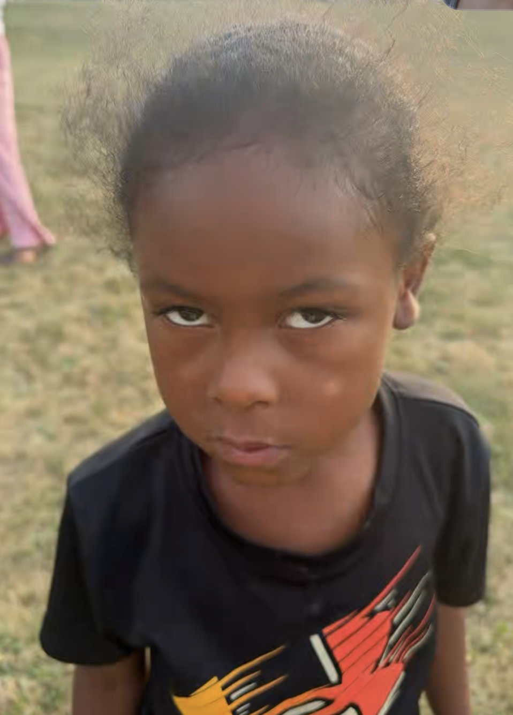
1 | Kelondre | Hill - Thomas | 3 | 8 | 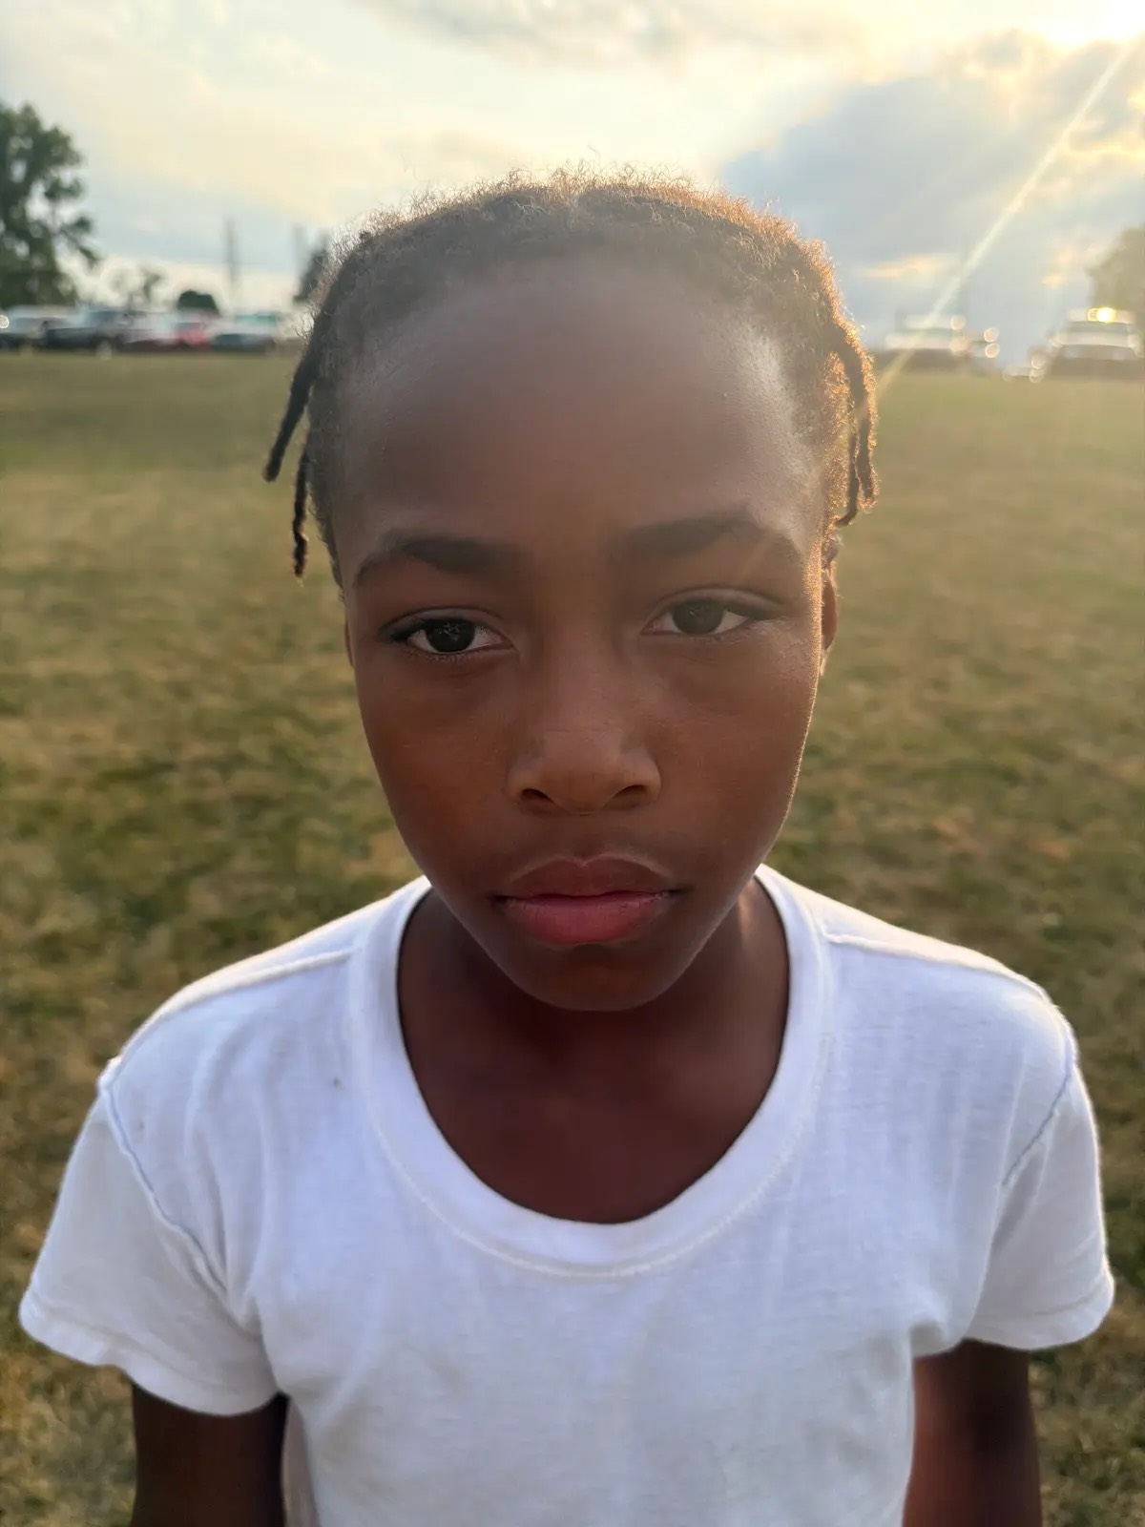
3 | Kamari | Hall | 1 | 6 | 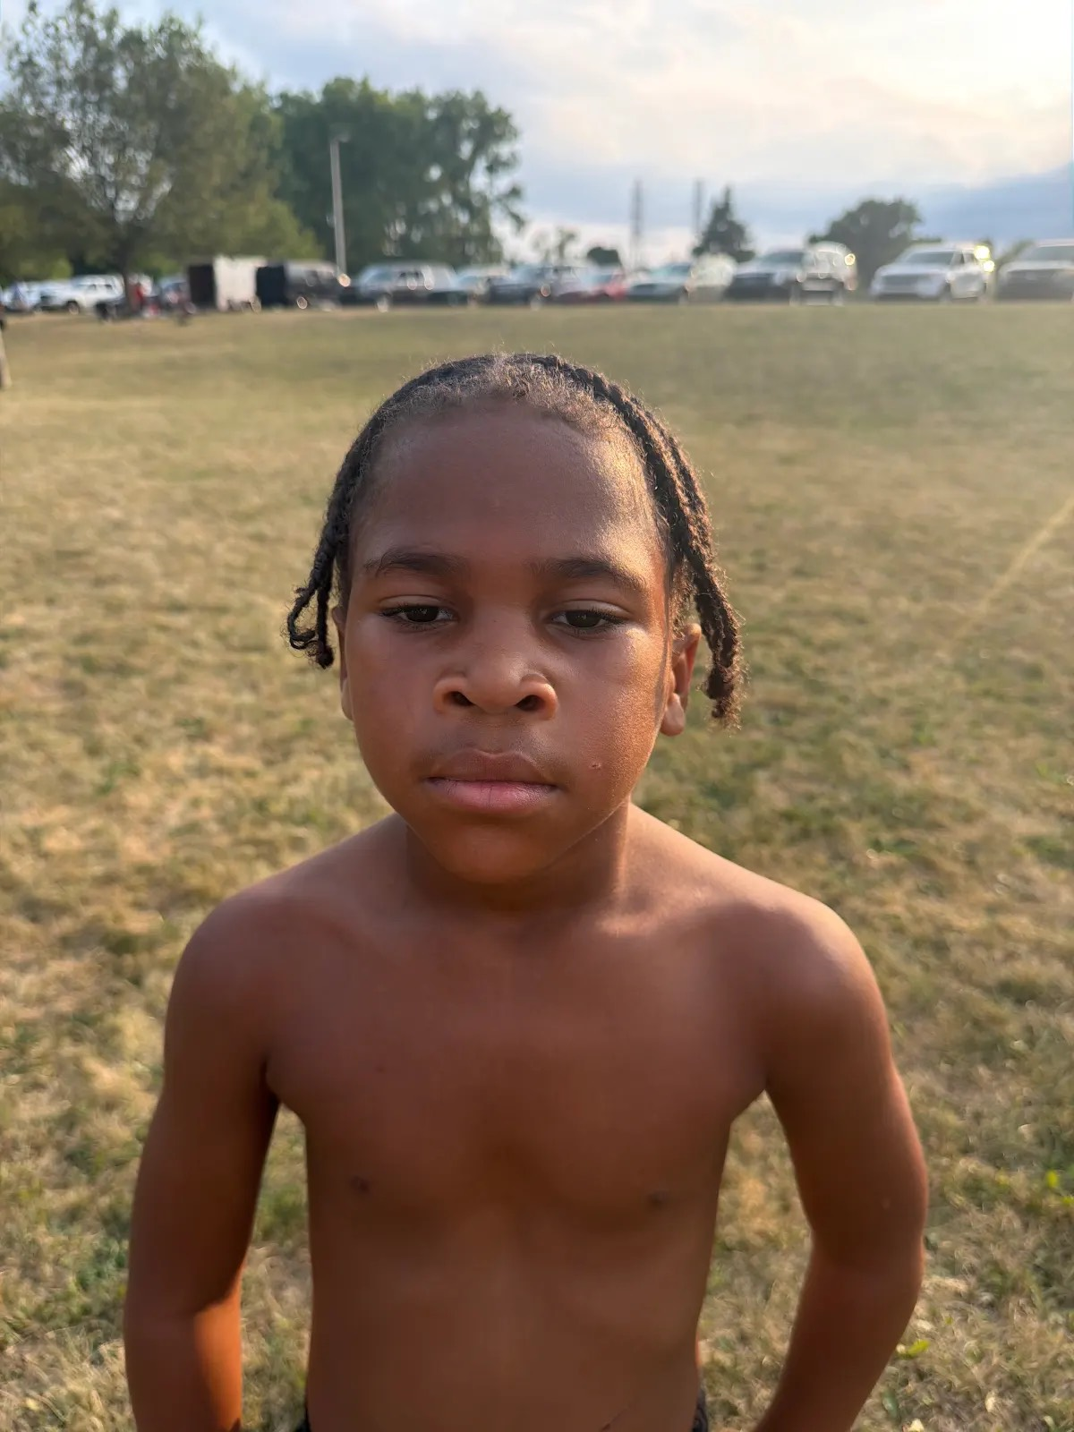
4 | Rayshawn | Osborne Jr | 1 | 6 | 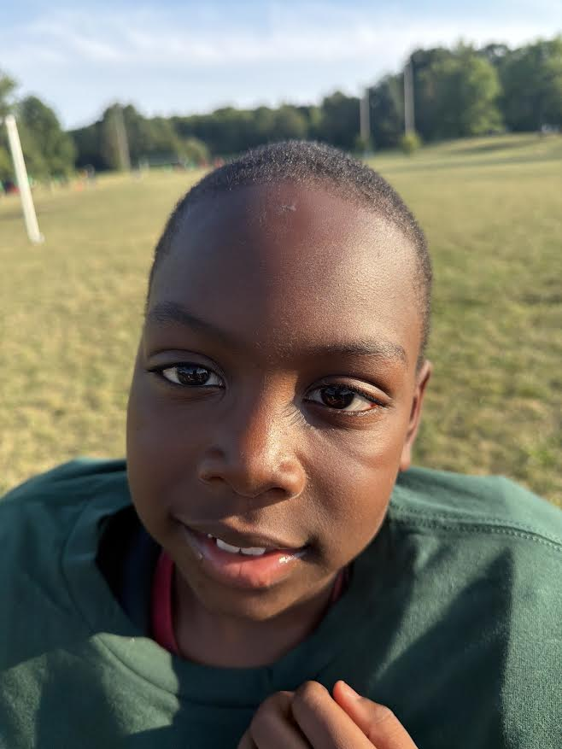
5 | Jermaine | McCray | 3 | 7 | 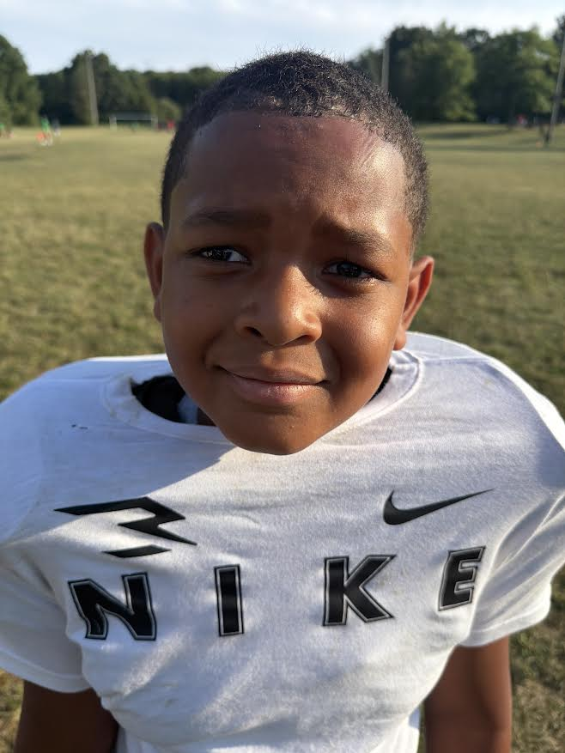
6 | LaVonte | Barnes | 3 | 8 | 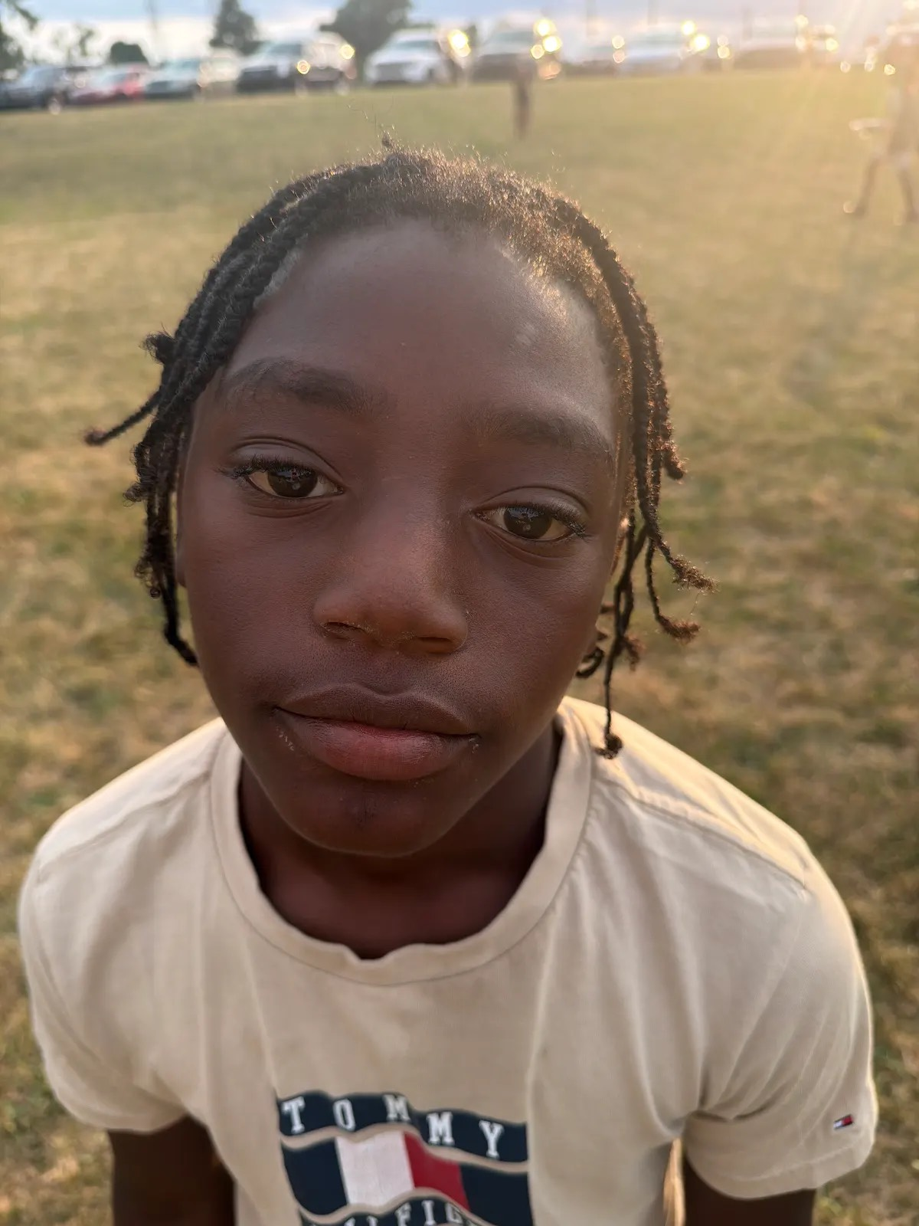
7 | Santana | Samples | 1 | 6 | 
8 | Kingston | Thomas | 2 | 7 | 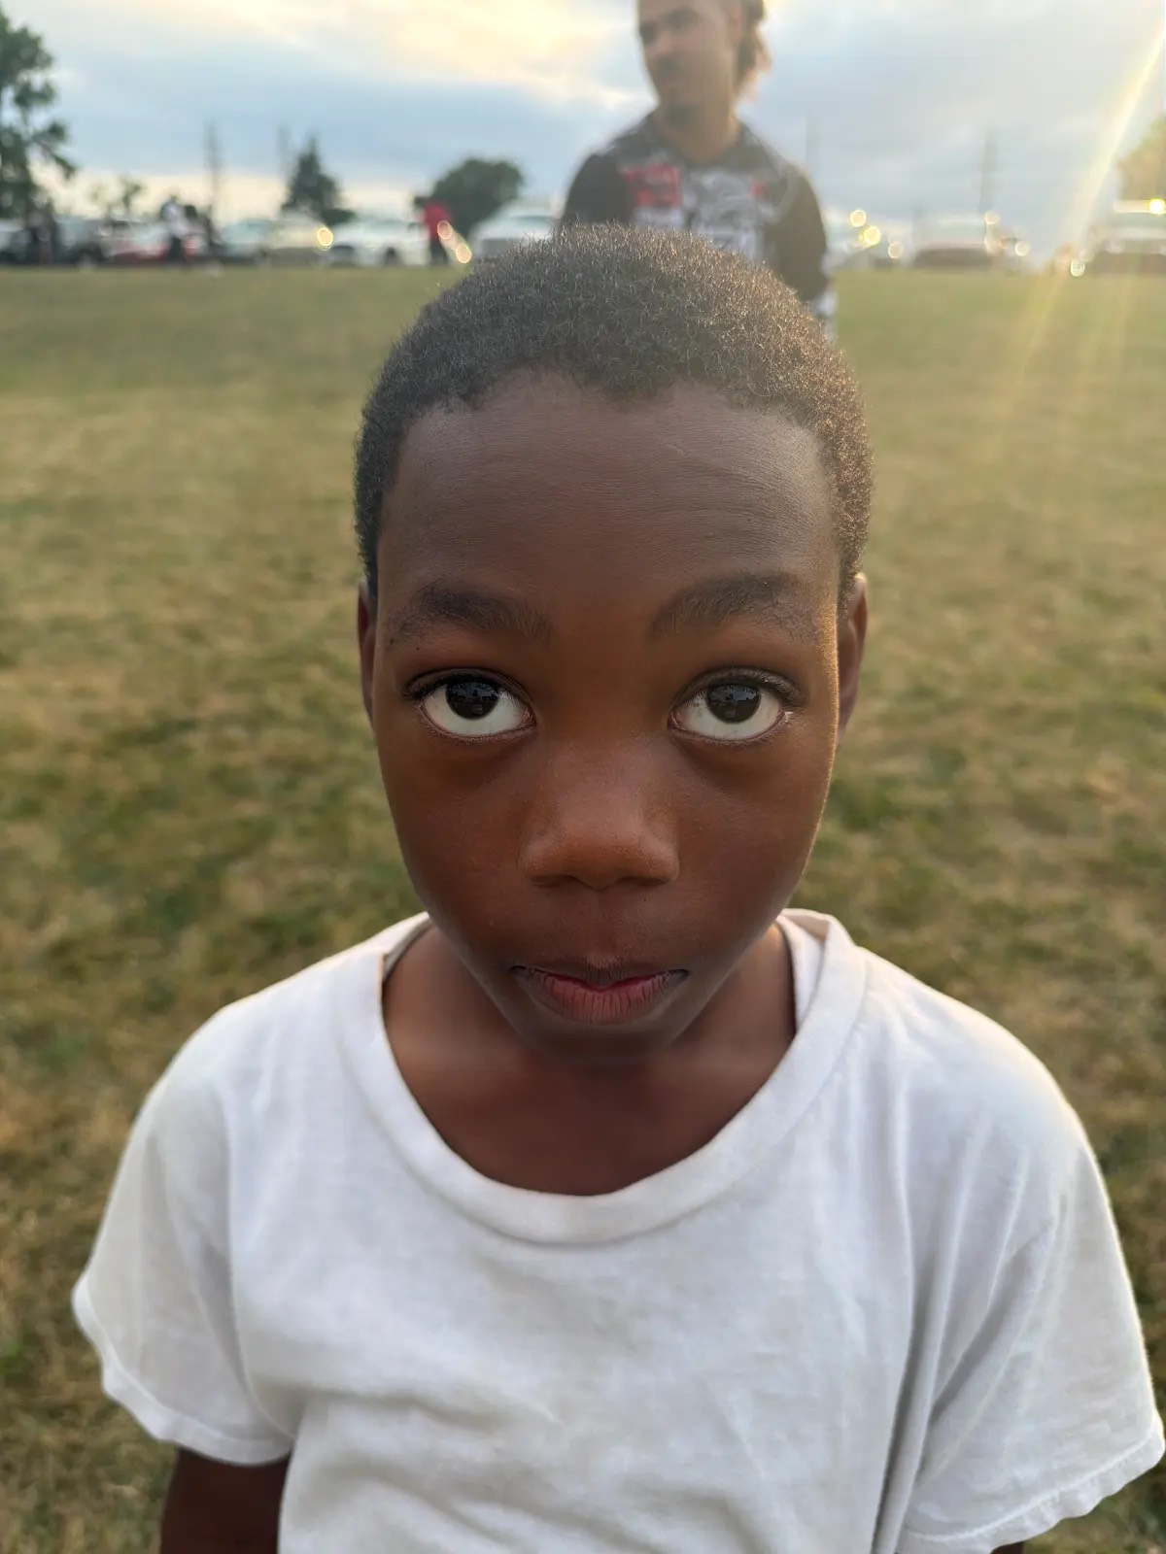
9 | Vince | Spann | 1 | 6 | 
10 | Gi’lanni | Lee | 3 | 7 | 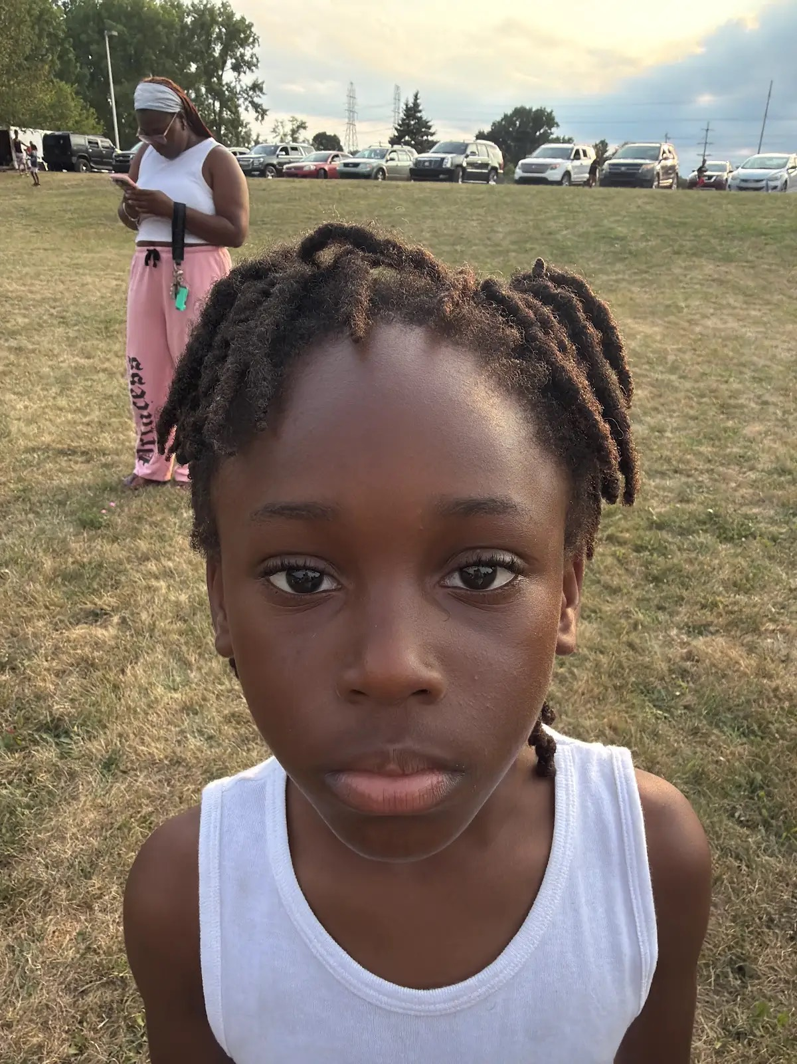
11 | Arthur | Allen | 2 | 7 | 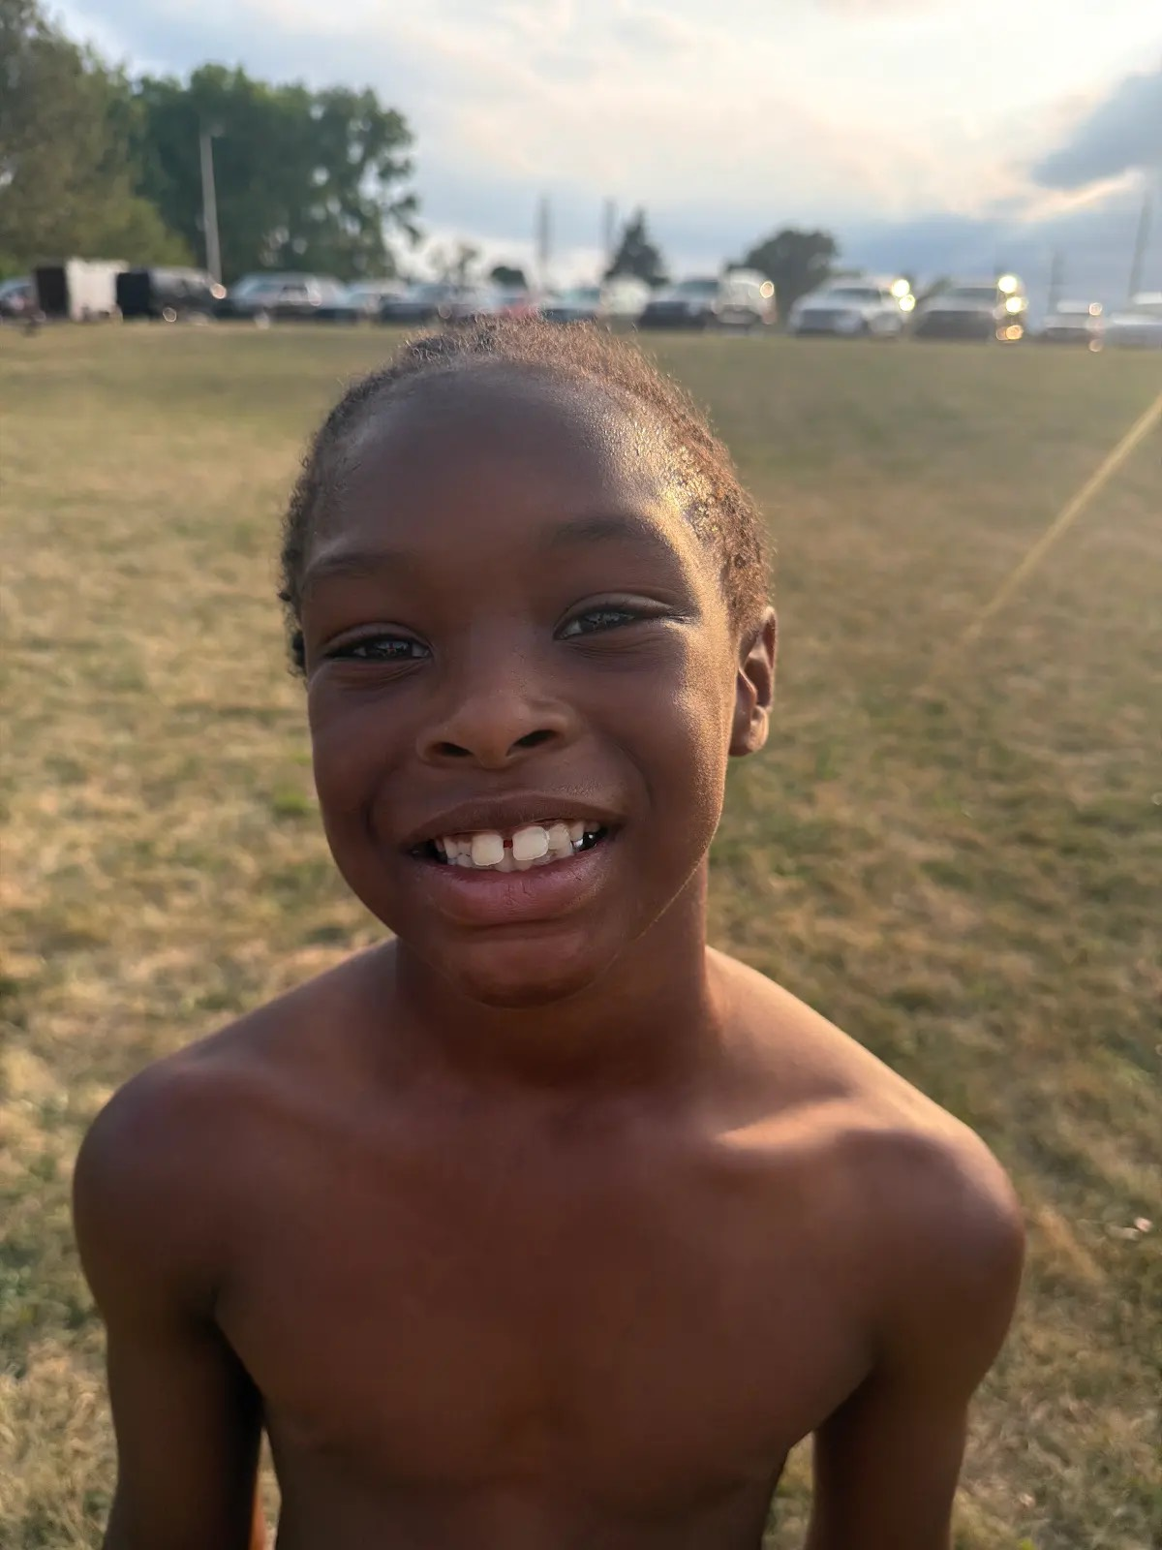
12 | Aiyana | Wright | 3 | 8 | 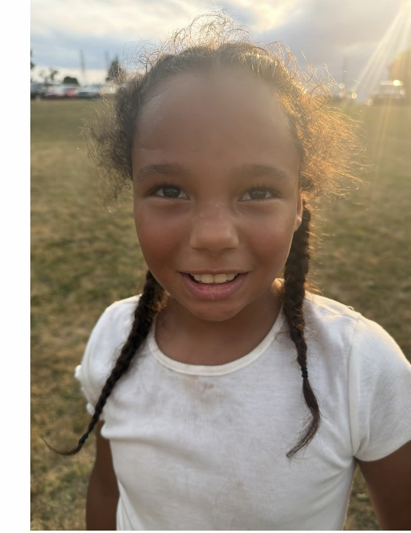
17 | E’Marj | Lance | 3 | 8 | 
24 | Zy’Aire | Howard | 2 | 7 | 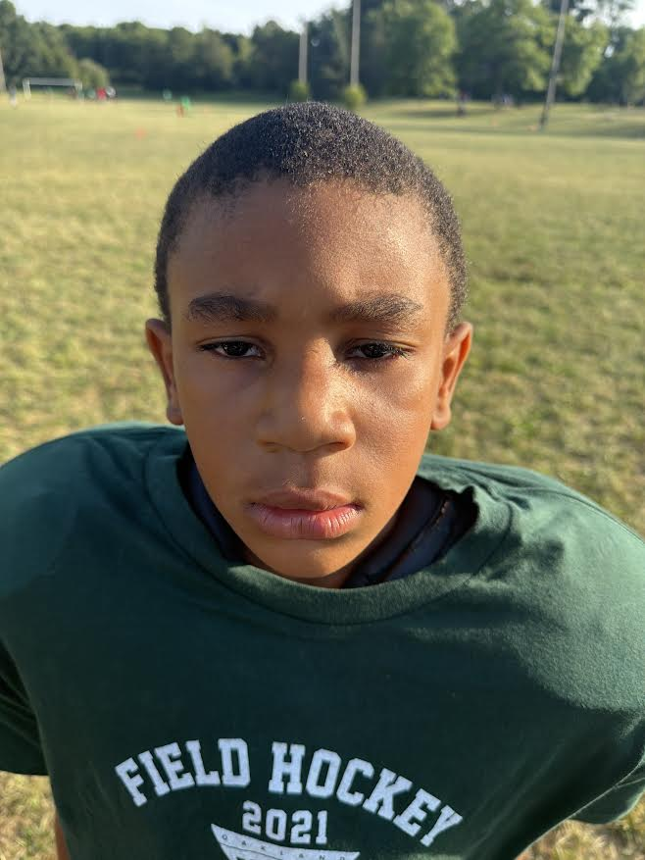
27 | Carson | McCallister | 2 | 7 | 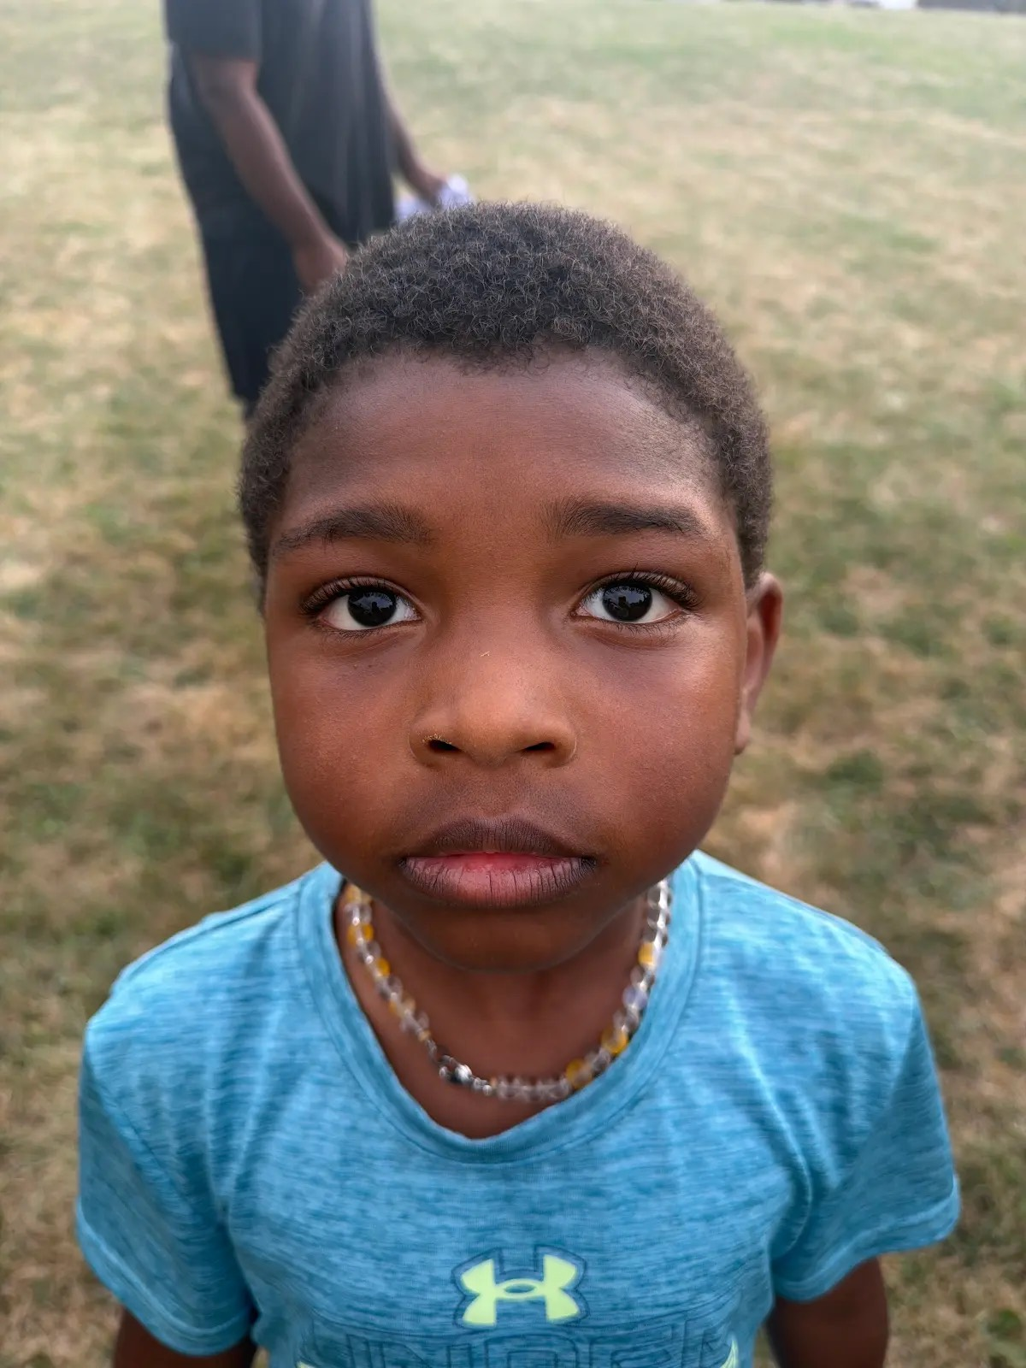
33 | Jemel | Oliver |  |  | 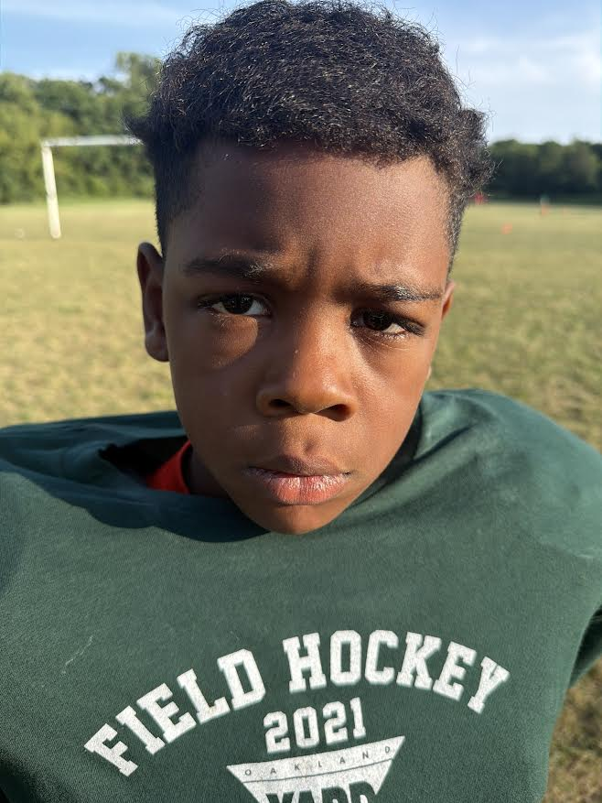
45 | Davion | Mays | 3 | 8 | 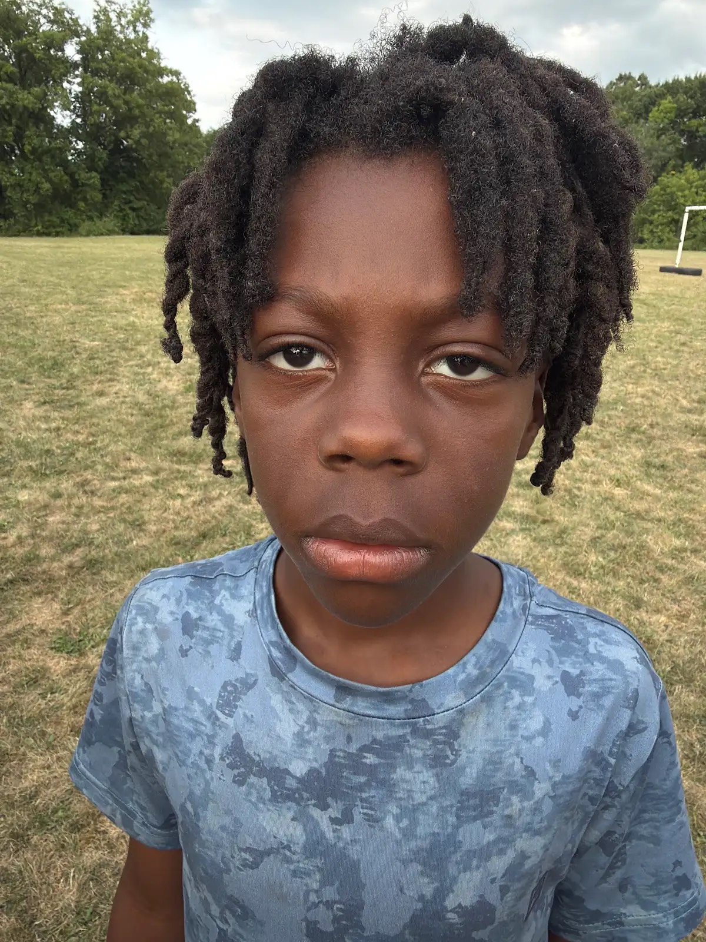
50 | Dash | Davis | 3 | 8 | 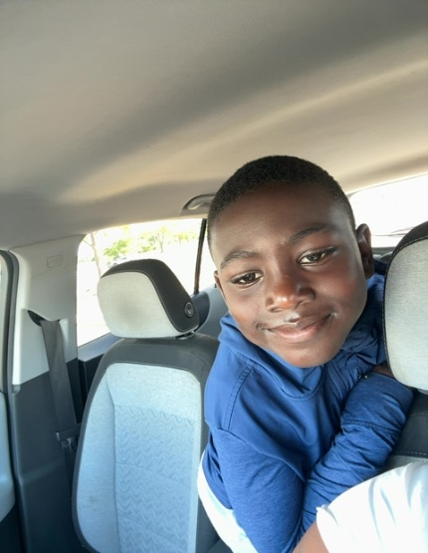
54 | Mykel | Shaw | 1 | 6 | 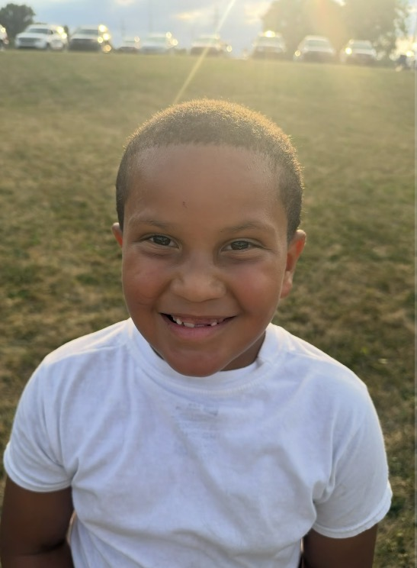
56 | Jakari | Green | 4 | 8 | 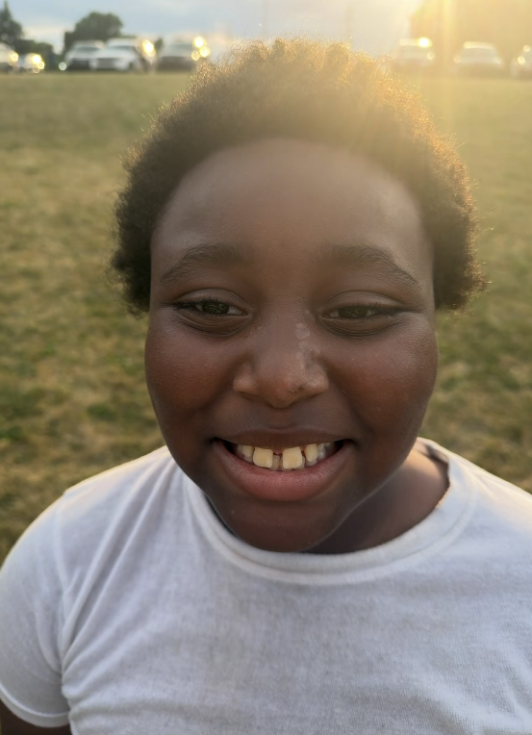
Click or tap here to enter text. | Click or tap here to enter text. | Click or tap here to enter text. | Click or tap here to enter text. | Click or tap here to enter text. | Click or tap here to enter text.
Click or tap here to enter text. | Click or tap here to enter text. | Click or tap here to enter text. | Click or tap here to enter text. | Click or tap here to enter text. | Click or tap here to enter text.
Click or tap here to enter text. | Click or tap here to enter text. | Click or tap here to enter text. | Click or tap here to enter text. | Click or tap here to enter text. | Click or tap here to enter text.
Click or tap here to enter text. | Click or tap here to enter text. | Click or tap here to enter text. | Click or tap here to enter text. | Click or tap here to enter text. | Click or tap here to enter text.
Click or tap here to enter text. | Click or tap here to enter text. | Click or tap here to enter text. | Click or tap here to enter text. | Click or tap here to enter text. | Click or tap here to enter text.
Click or tap here to enter text. | Click or tap here to enter text. | Click or tap here to enter text. | Click or tap here to enter text. | Click or tap here to enter text. | Click or tap here to enter text.
Click or tap here to enter text. | Click or tap here to enter text. | Click or tap here to enter text. | Click or tap here to enter text. | Click or tap here to enter text. | Click or tap here to enter text.
Click or tap here to enter text. | Click or tap here to enter text. | Click or tap here to enter text. | Click or tap here to enter text. | Click or tap here to enter text. | Click or tap here to enter text.
Click or tap here to enter text. | Click or tap here to enter text. | Click or tap here to enter text. | Click or tap here to enter text. | Click or tap here to enter text. | Click or tap here to enter text.
Click or tap here to enter text. | Click or tap here to enter text. | Click or tap here to enter text. | Click or tap here to enter text. | Click or tap here to enter text. | Click or tap here to enter text.
Click or tap here to enter text. | Click or tap here to enter text. | Click or tap here to enter text. | Click or tap here to enter text. | Click or tap here to enter text. | Click or tap here to enter text.
Click or tap here to enter text. | Click or tap here to enter text. | Click or tap here to enter text. | Click or tap here to enter text. | Click or tap here to enter text. | Click or tap here to enter text.
Click or tap here to enter text. | Click or tap here to enter text. | Click or tap here to enter text. | Click or tap here to enter text. | Click or tap here to enter text. | Click or tap here to enter text.
Click or tap here to enter text. | Click or tap here to enter text. | Click or tap here to enter text. | Click or tap here to enter text. | Click or tap here to enter text. | Click or tap here to enter text.
Click or tap here to enter text. | Click or tap here to enter text. | Click or tap here to enter text. | Click or tap here to enter text. | Click or tap here to enter text. | Click or tap here to enter text.
Click or tap here to enter text. | Click or tap here to enter text. | Click or tap here to enter text. | Click or tap here to enter text. | Click or tap here to enter text. | Click or tap here to enter text.
Click or tap here to enter text. | Click or tap here to enter text. | Click or tap here to enter text. | Click or tap here to enter text. | Click or tap here to enter text. | Click or tap here to enter text.
Click or tap here to enter text. | Click or tap here to enter text. | Click or tap here to enter text. | Click or tap here to enter text. | Click or tap here to enter text. | Click or tap here to enter text.
Click or tap here to enter text. | Click or tap here to enter text. | Click or tap here to enter text. | Click or tap here to enter text. | Click or tap here to enter text. | Click or tap here to enter text.
Click or tap here to enter text. | Click or tap here to enter text. | Click or tap here to enter text. | Click or tap here to enter text. | Click or tap here to enter text. | Click or tap here to enter text.
Click or tap here to enter text. | Click or tap here to enter text. | Click or tap here to enter text. | Click or tap here to enter text. | Click or tap here to enter text. | Click or tap here to enter text.
Click or tap here to enter text. | Click or tap here to enter text. | Click or tap here to enter text. | Click or tap here to enter text. | Click or tap here to enter text. | Click or tap here to enter text.
Click or tap here to enter text. | Click or tap here to enter text. | Click or tap here to enter text. | Click or tap here to enter text. | Click or tap here to enter text. | Click or tap here to enter text.
Click or tap here to enter text. | Click or tap here to enter text. | Click or tap here to enter text. | Click or tap here to enter text. | Click or tap here to enter text. | Click or tap here to enter text.
Click or tap here to enter text. | Click or tap here to enter text. | Click or tap here to enter text. | Click or tap here to enter text. | Click or tap here to enter text. | Click or tap here to enter text.
Click or tap here to enter text. | Click or tap here to enter text. | Click or tap here to enter text. | Click or tap here to enter text. | Click or tap here to enter text. | Click or tap here to enter text.

** Coaches not identified on this Roster with a photo and contact information are NOT permitted on the sidelines of any MYFCC game.

*** If a player’s information is not complete, the Player is not eligible to play in any MYFCC regular season or playoff game.

**** Jersey number MUST be in numerical order, lowest to highest.

