Title | Head Coach | Unit Director | Assistant Coach
Name | Lamar Allen | Gerald Smith | Kelondre Hill-Thomas  Freddie Gibson
Email  cell | (248) 954-5674 | glssmith68@gmail.com  (248) 563-5039
Photo | 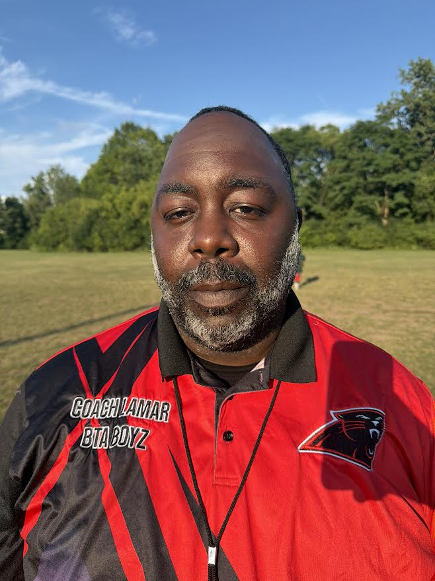 |  | 
 |  |  | 

Jersey No | First Name | Last Name | Grade | Playing Age  (Before Sept 1st) | Photo
1 | Anise | Lanehart | 4 | 10 | 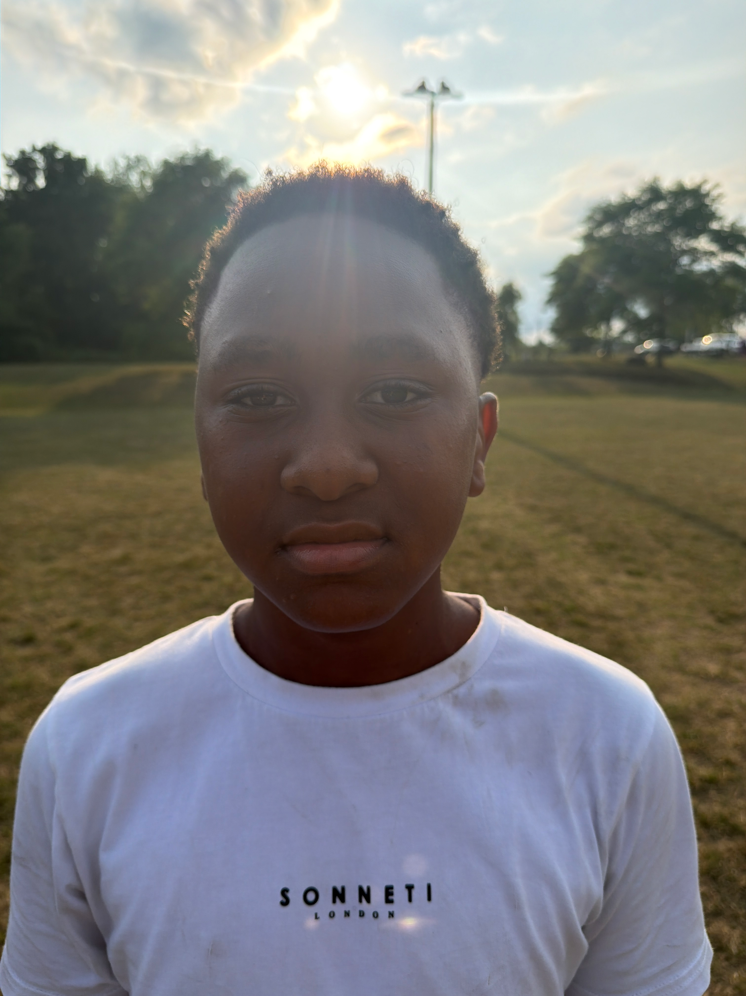
2 | Da’Mauri | Gibson | 5 | 10 | 
3 | Darrion | Huantez | 5 | 10 | 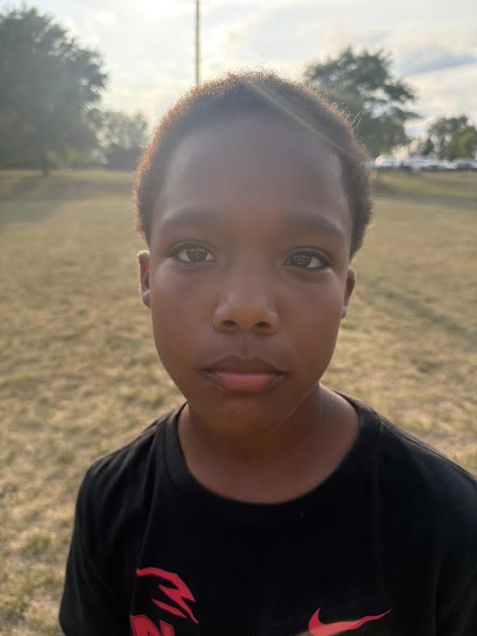
4 | Demond | Miller | 5 | 10 | 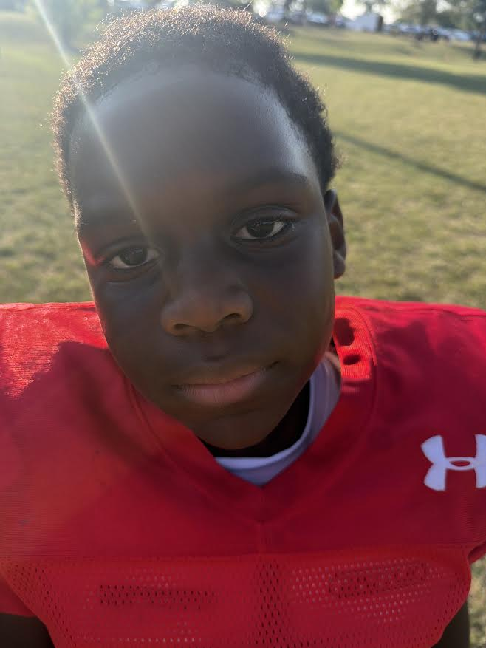
7 | Ronnie | Richardson |  | 10 | 
9 | Alexander | Parry | 4 | 9 | 
14 | Johnnie | Wilson | 5 | 10 | 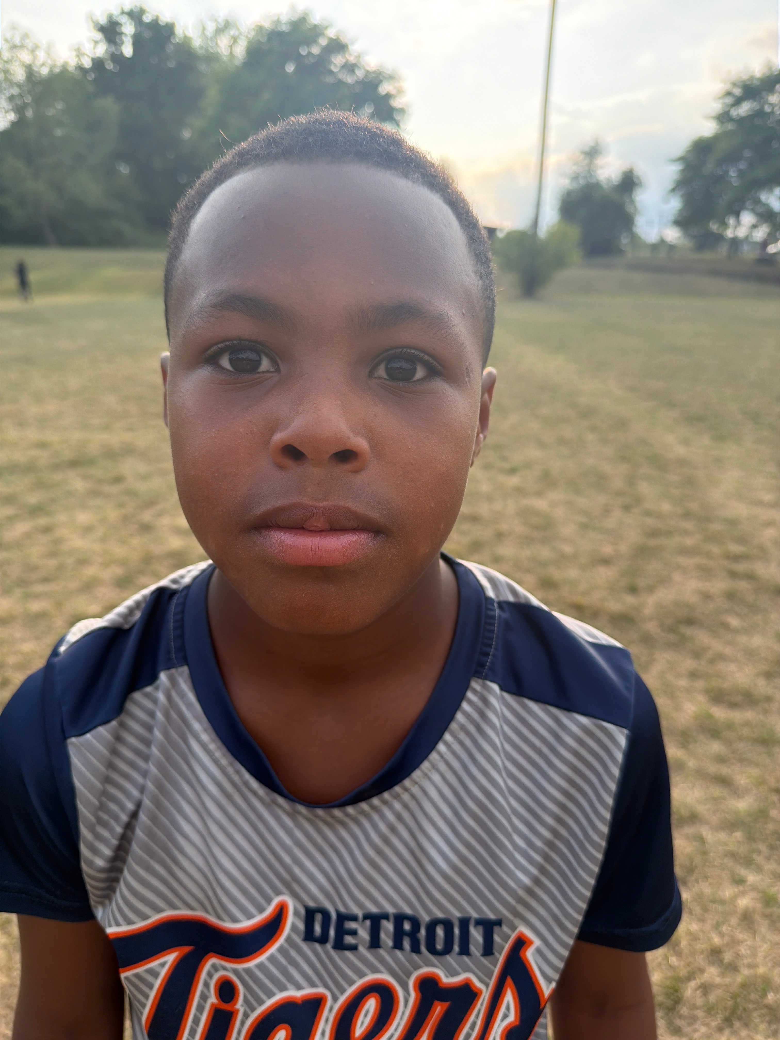
20 | Zanyla | Jackson | 5 | 10 | 
70 | A’shun | Wooten | 4 | 8 | 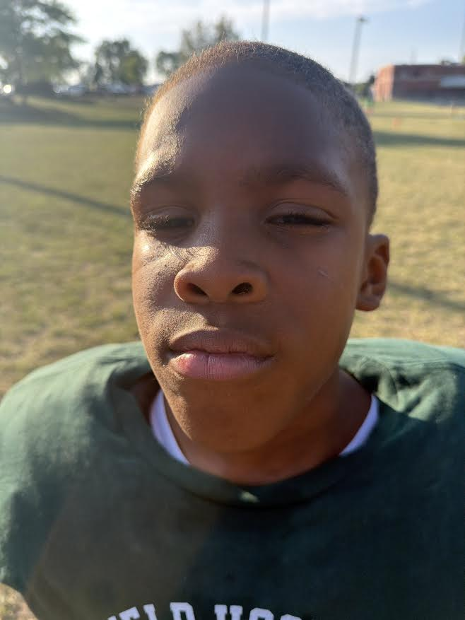
71 | Ah’maj | Wooten | 4 | 8 | 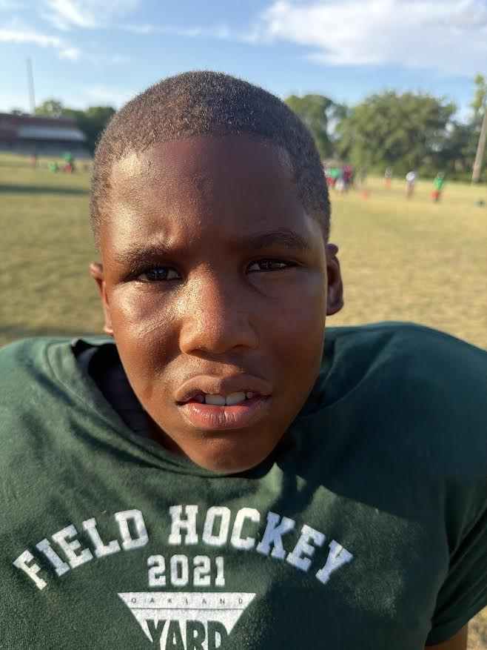
72 | Zayden | Williams | 4 | 10 | 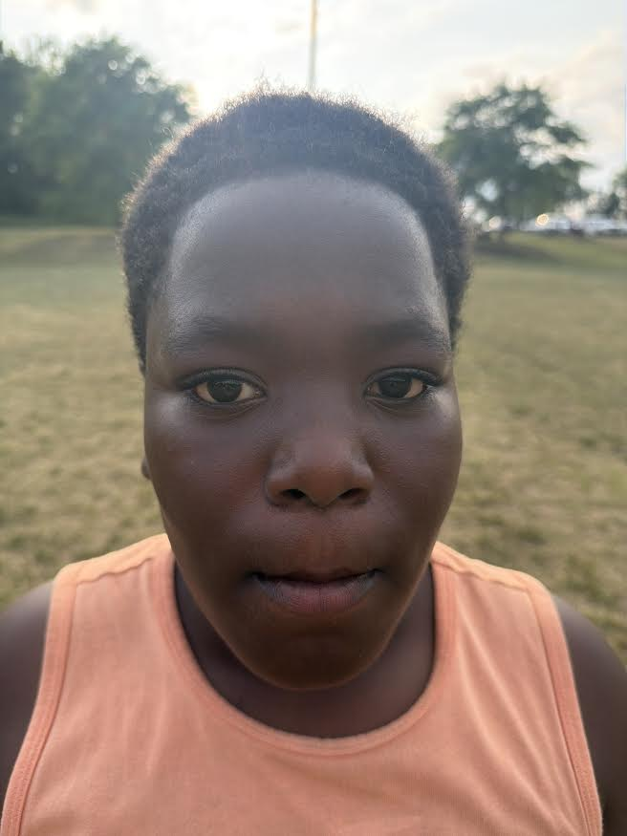
75 | Clifford | Abram | 2 | 8 | 
99 | Nehemiah | Wright | 4 | 9 | 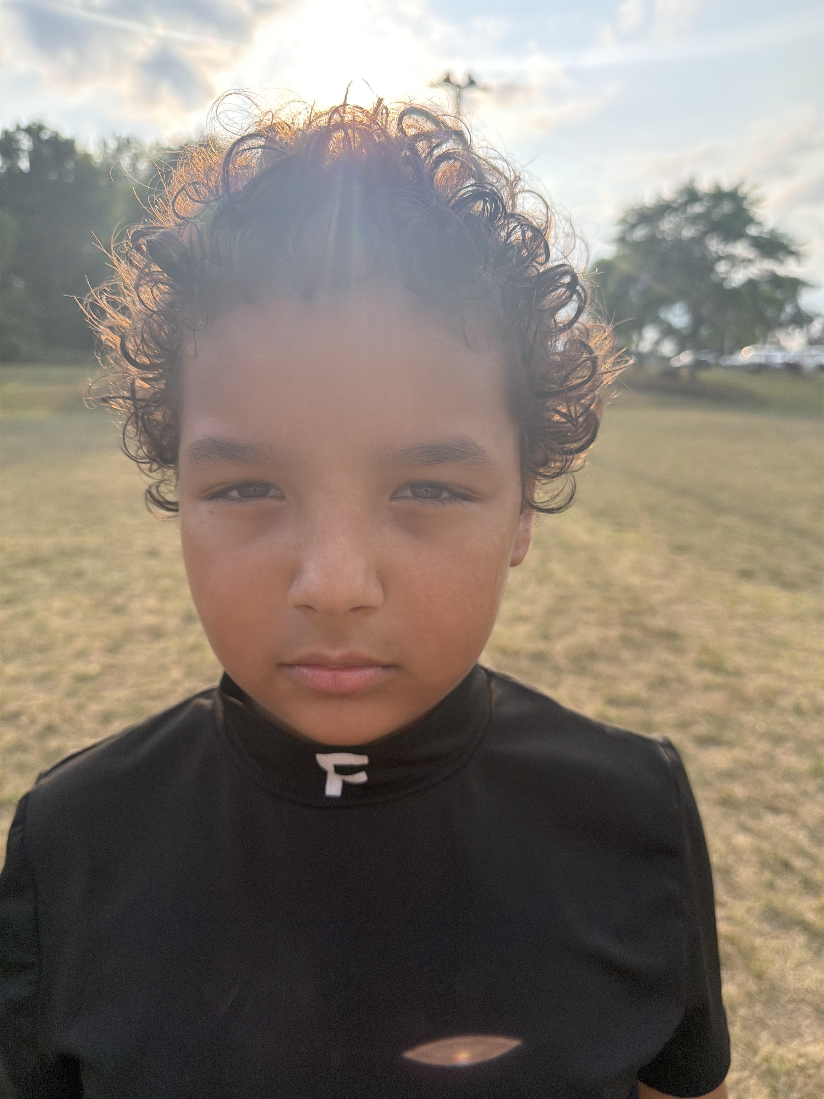
23 | Pharaoh | Robinson |  | 10 | 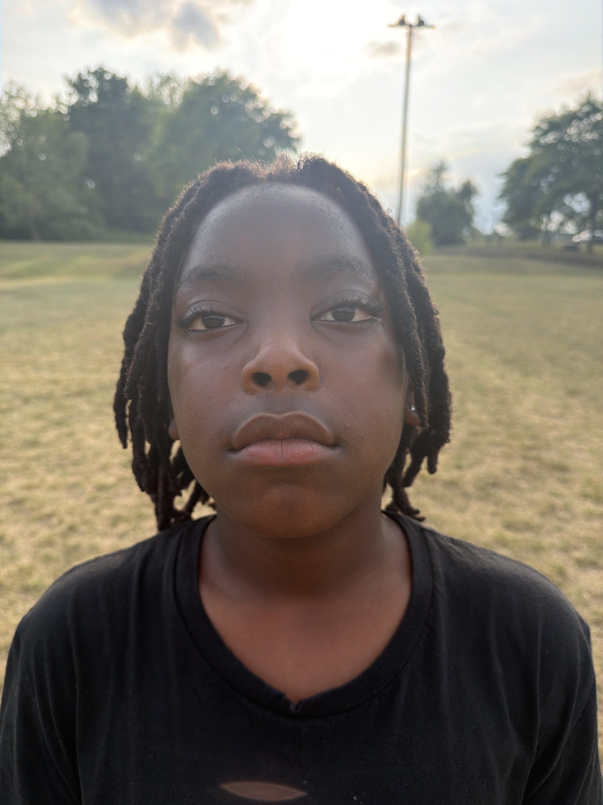
 | Terrell | Edwards | 4 | 9 | 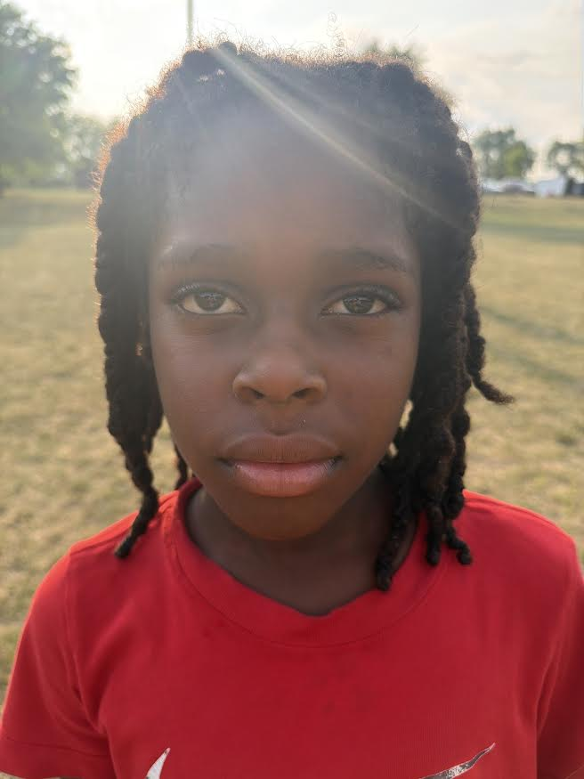
 | Justin | Jones | 4 | 9 | 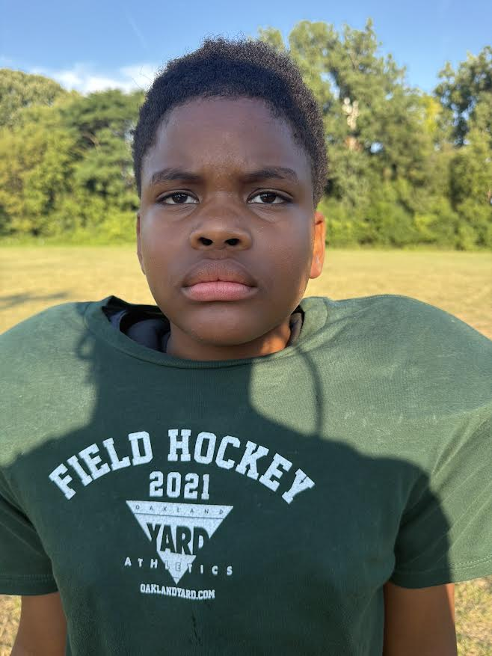
 | Jesus | Santos | 4 | 9 | 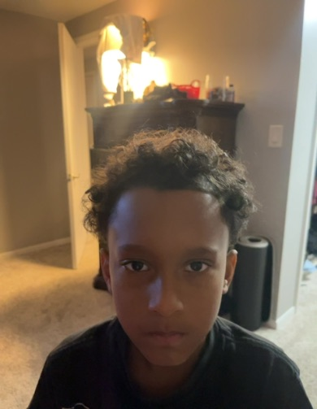
 | Dequan | Reed |  | 9

