Title | Head Coach | Unit Director | Ass’t Coach | Ass’t Coach
Name | Anthony Gage | Gerald Smith |  | Click or tap here to enter text.
Email  Cell | antgage1000@gmail.com  (248) 941-3673 | glssmith68@yahoo.com  (248) 563-5039 |  | Click or tap here to enter text.
Photo | 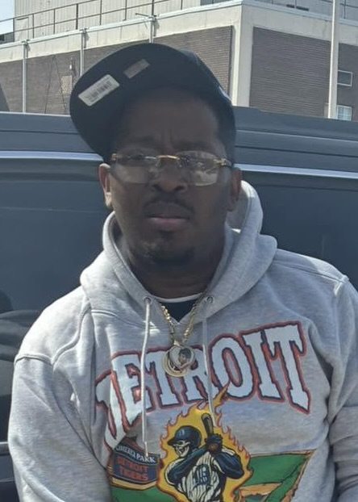 |  |  | Click or tap here to enter text.

Jersey No | First Name | Last Name | Grade | Playing Age  (Before Sept 1st) | Photo
1 | Carnell | Samples | 6 | 11 | 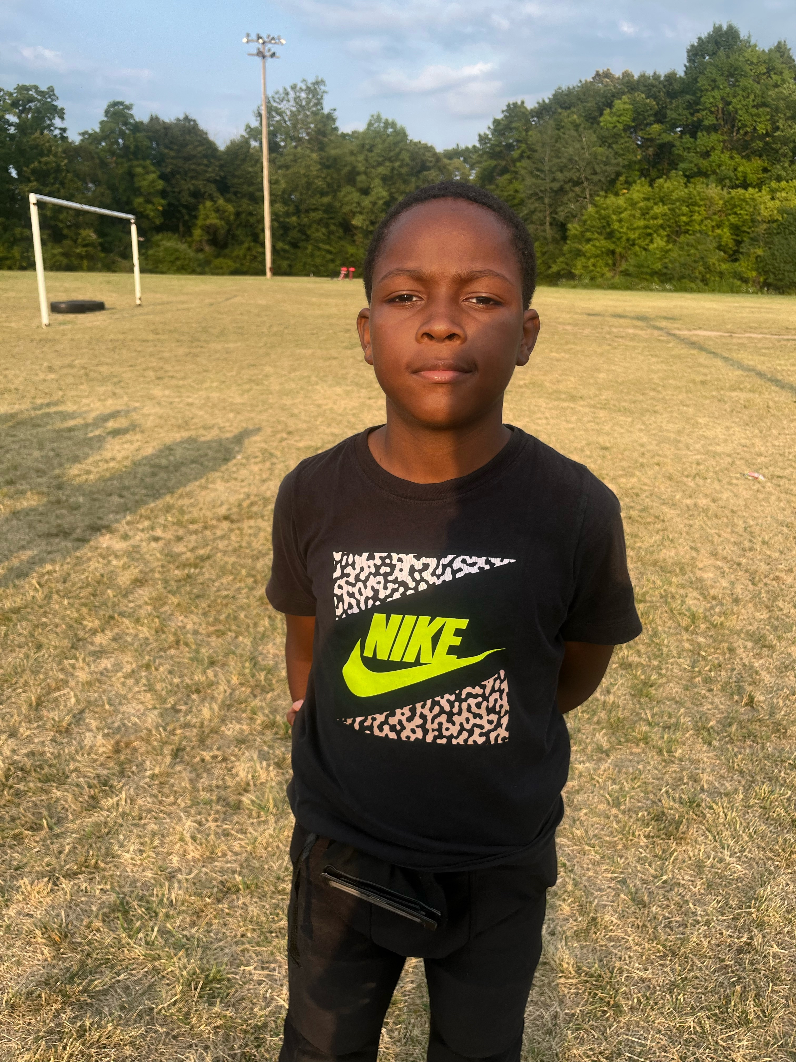
2 | Devascio | Jackson | 6 | 11 | 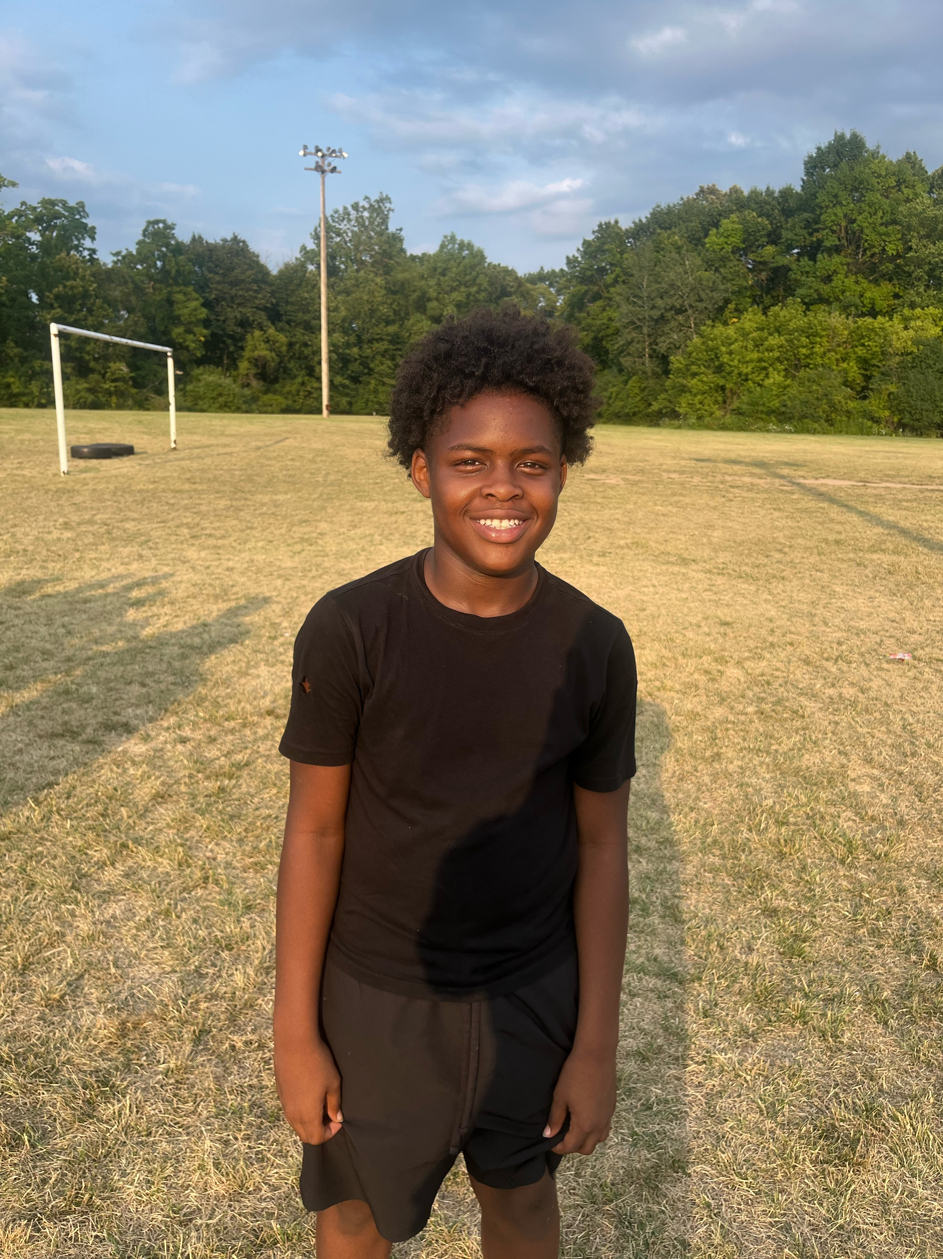
3 | Darwin | Huantez | 6 | 11 | 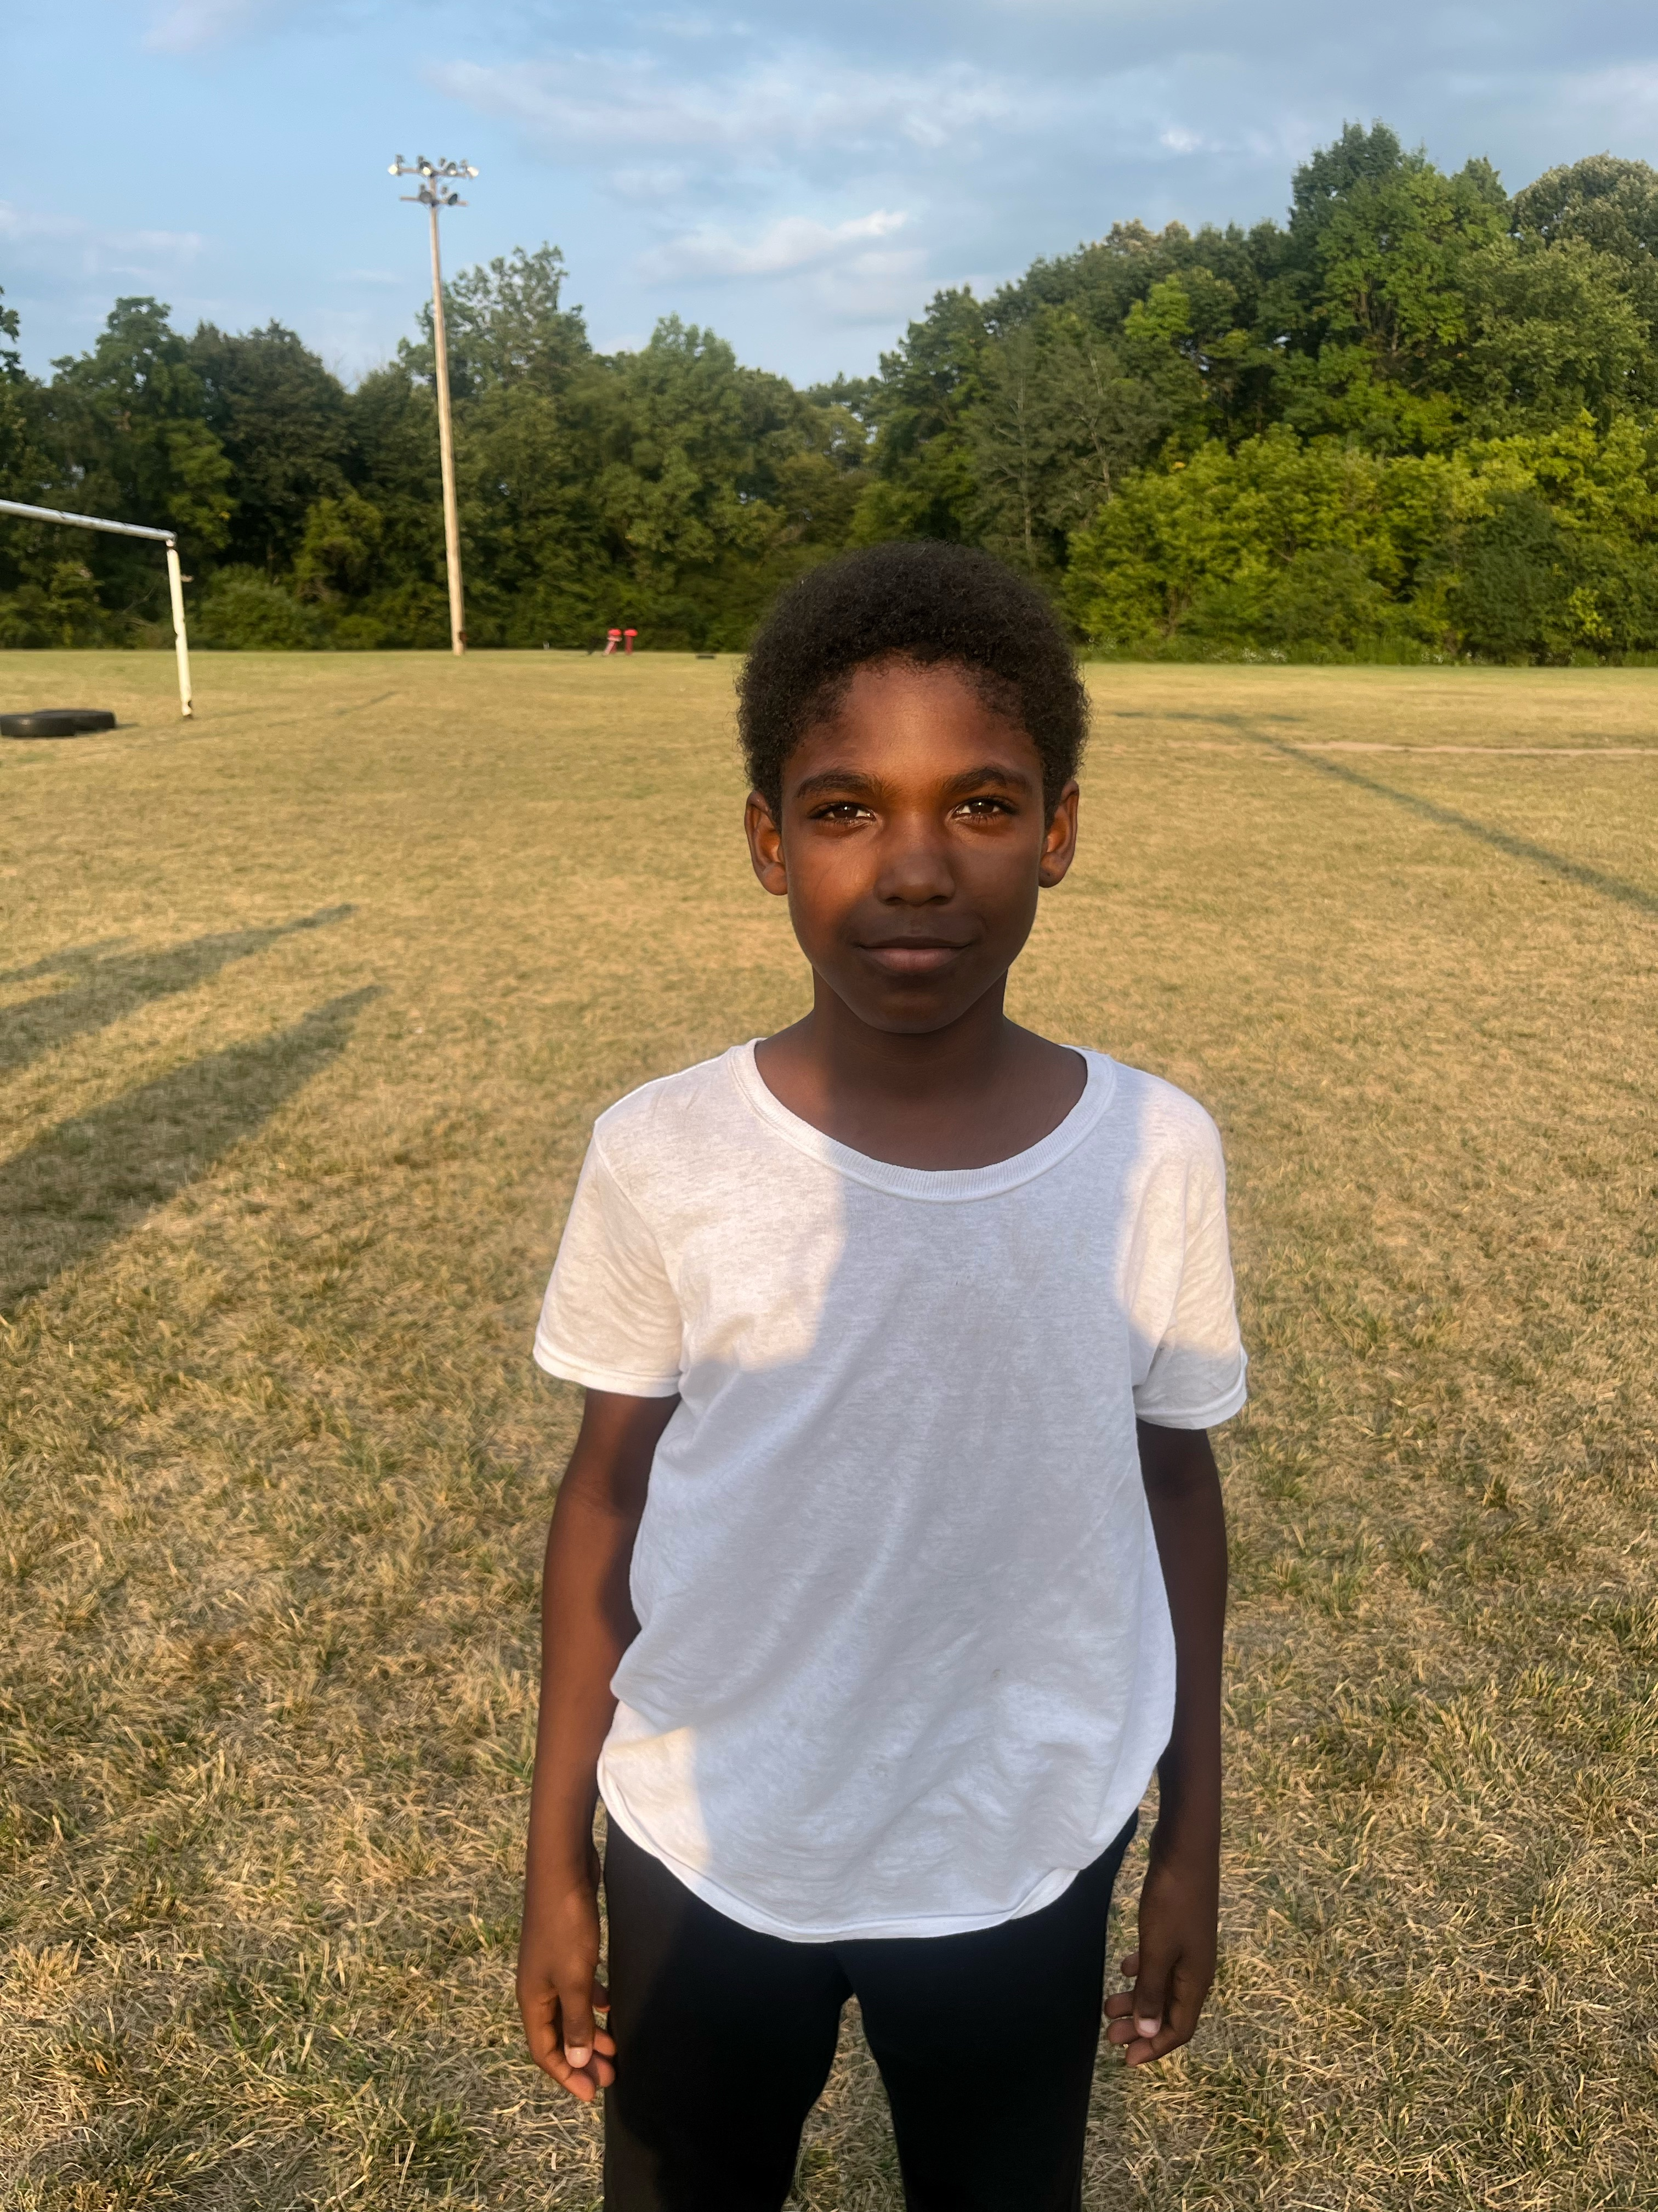
5 | Kaiden | McDonald | 6 | 11 | 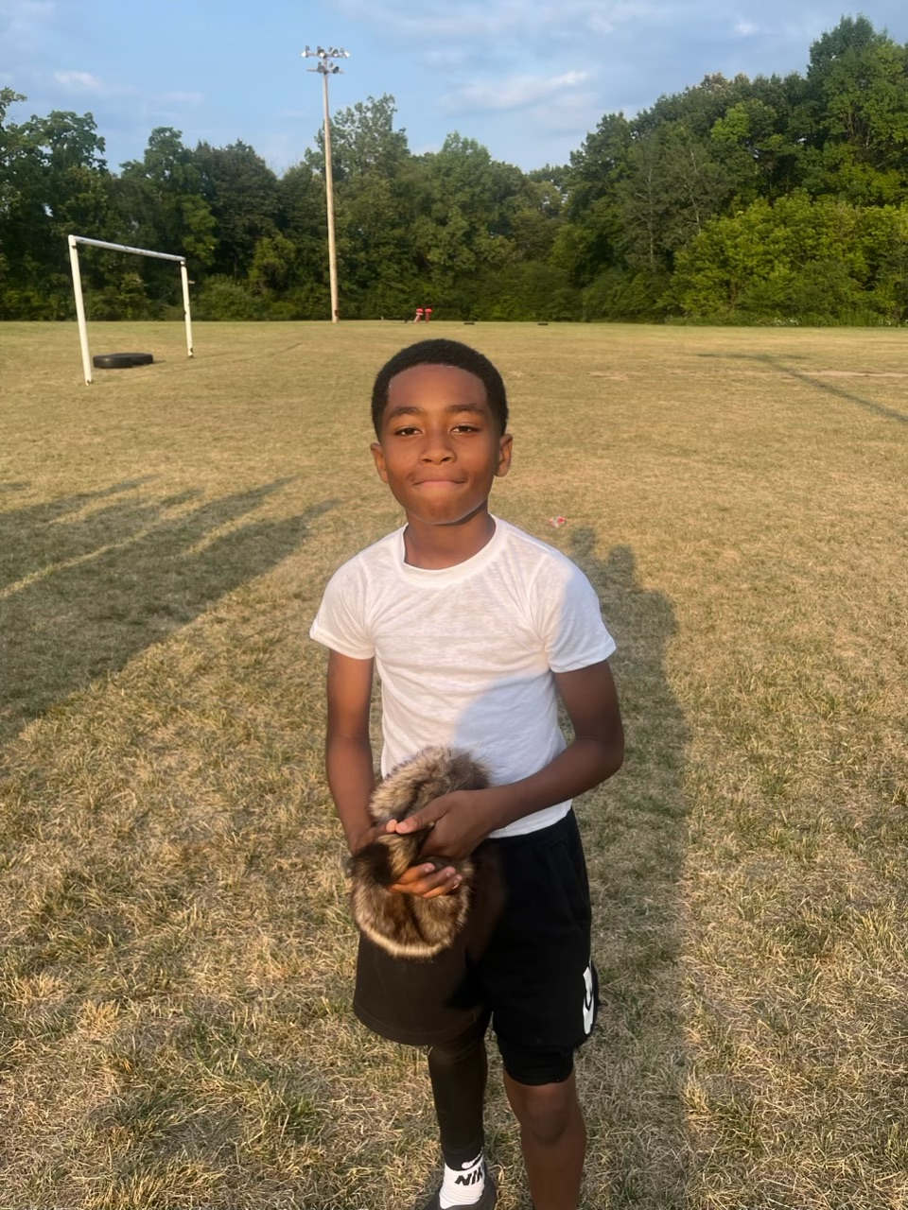
7 | Peyton | Hannah | 6 | 12 | 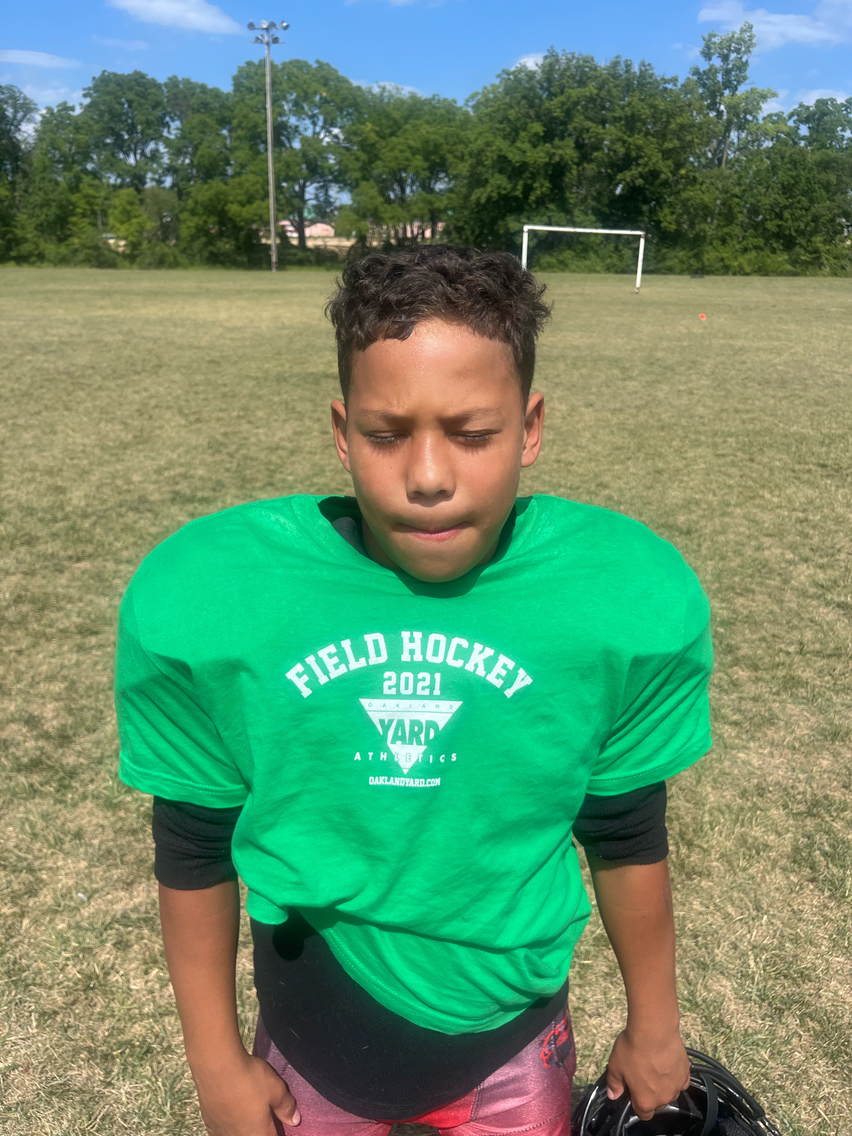
8 | Ayden | Elcan-Smith | 7 | 12 | 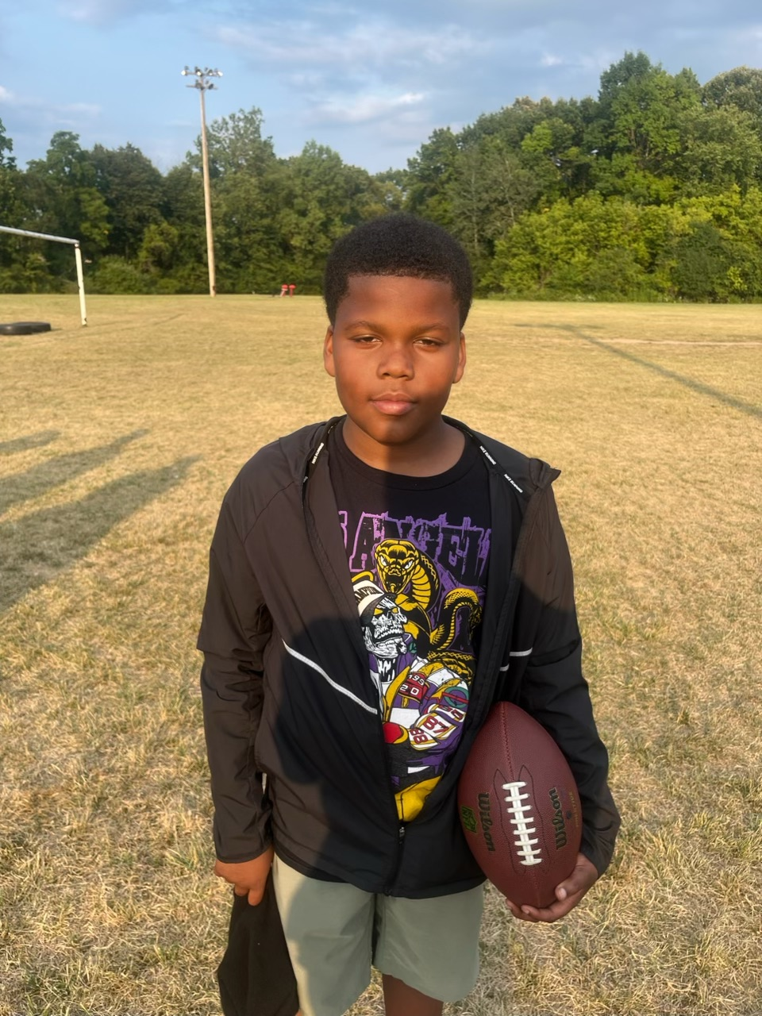
10 | Jayceon | Hathaway | 7 | 12 | 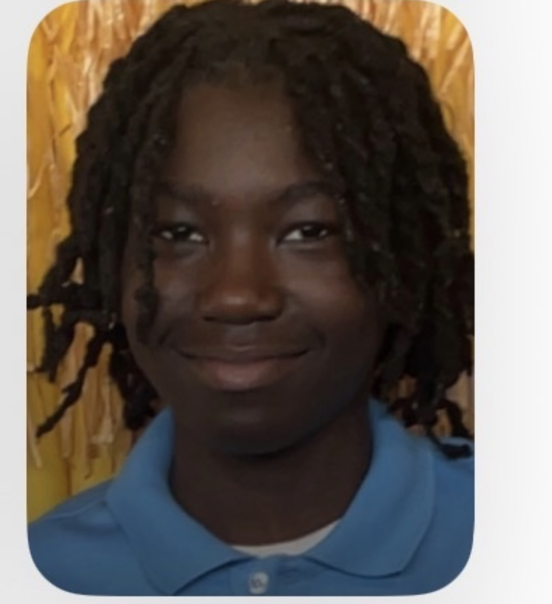
11 | Anthony | Gage | 6 | 11 | 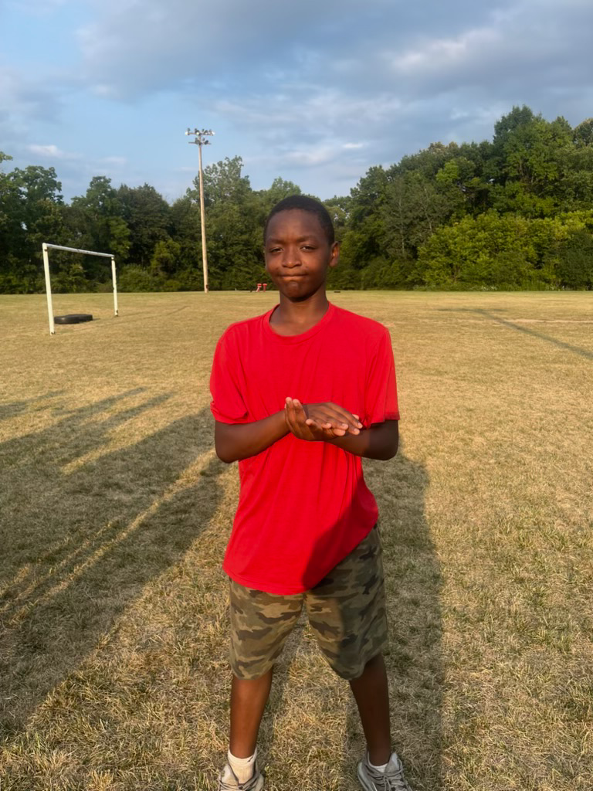
12 | Jamel | Hill | 8 | 12 | 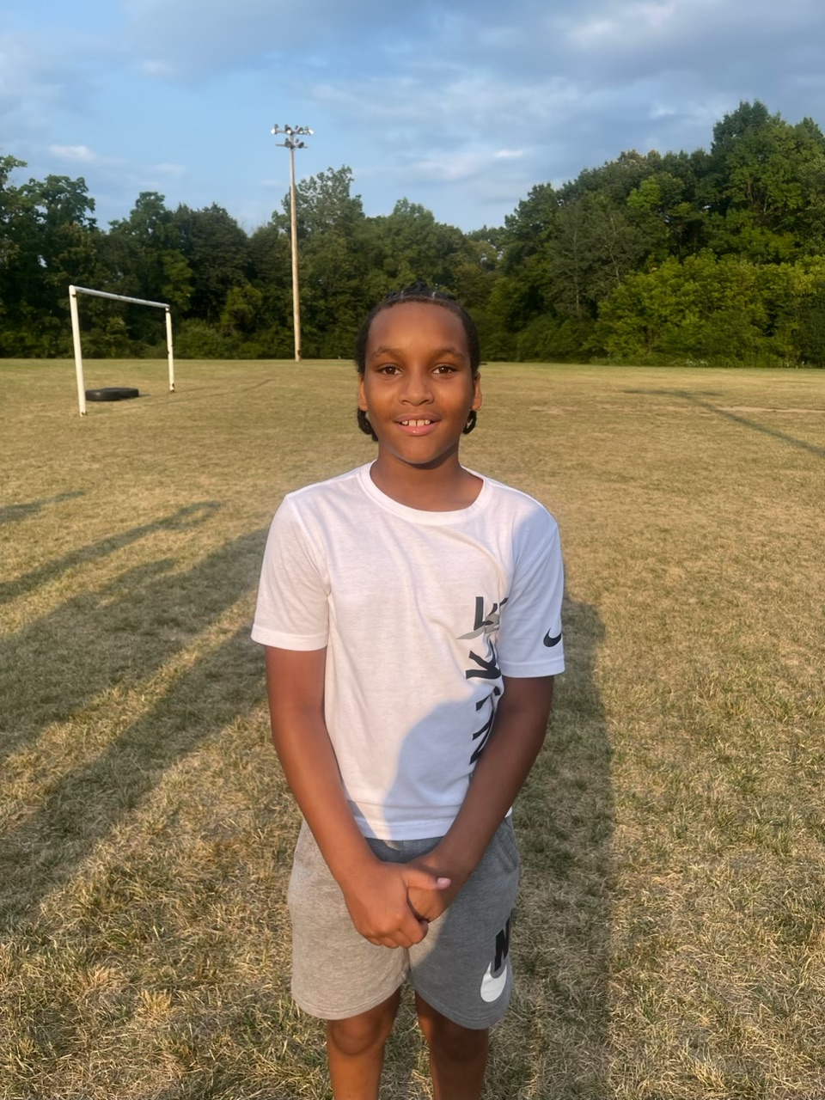
13 | Daquavion | Lawrence | 6 | 11 | 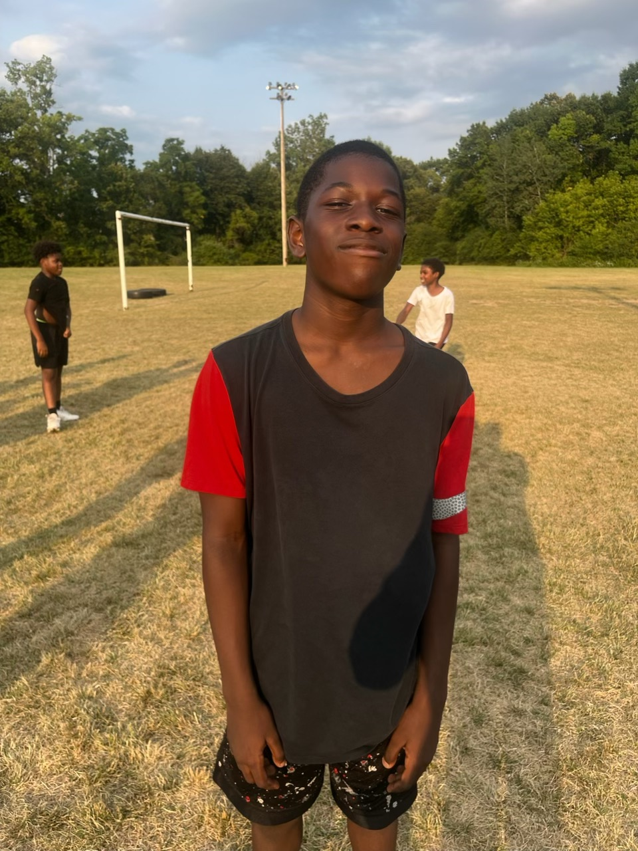
14 | Majeywan | Heady | 6 | 11 | 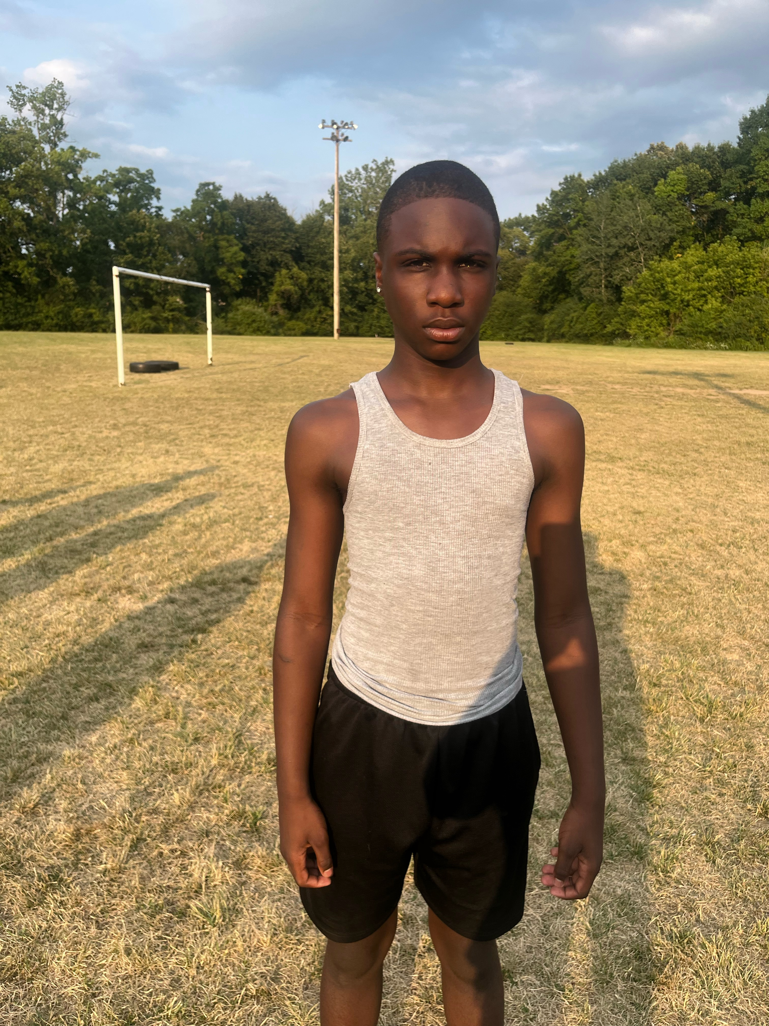
15 | Tayquan | Heady | 6 | 11 | 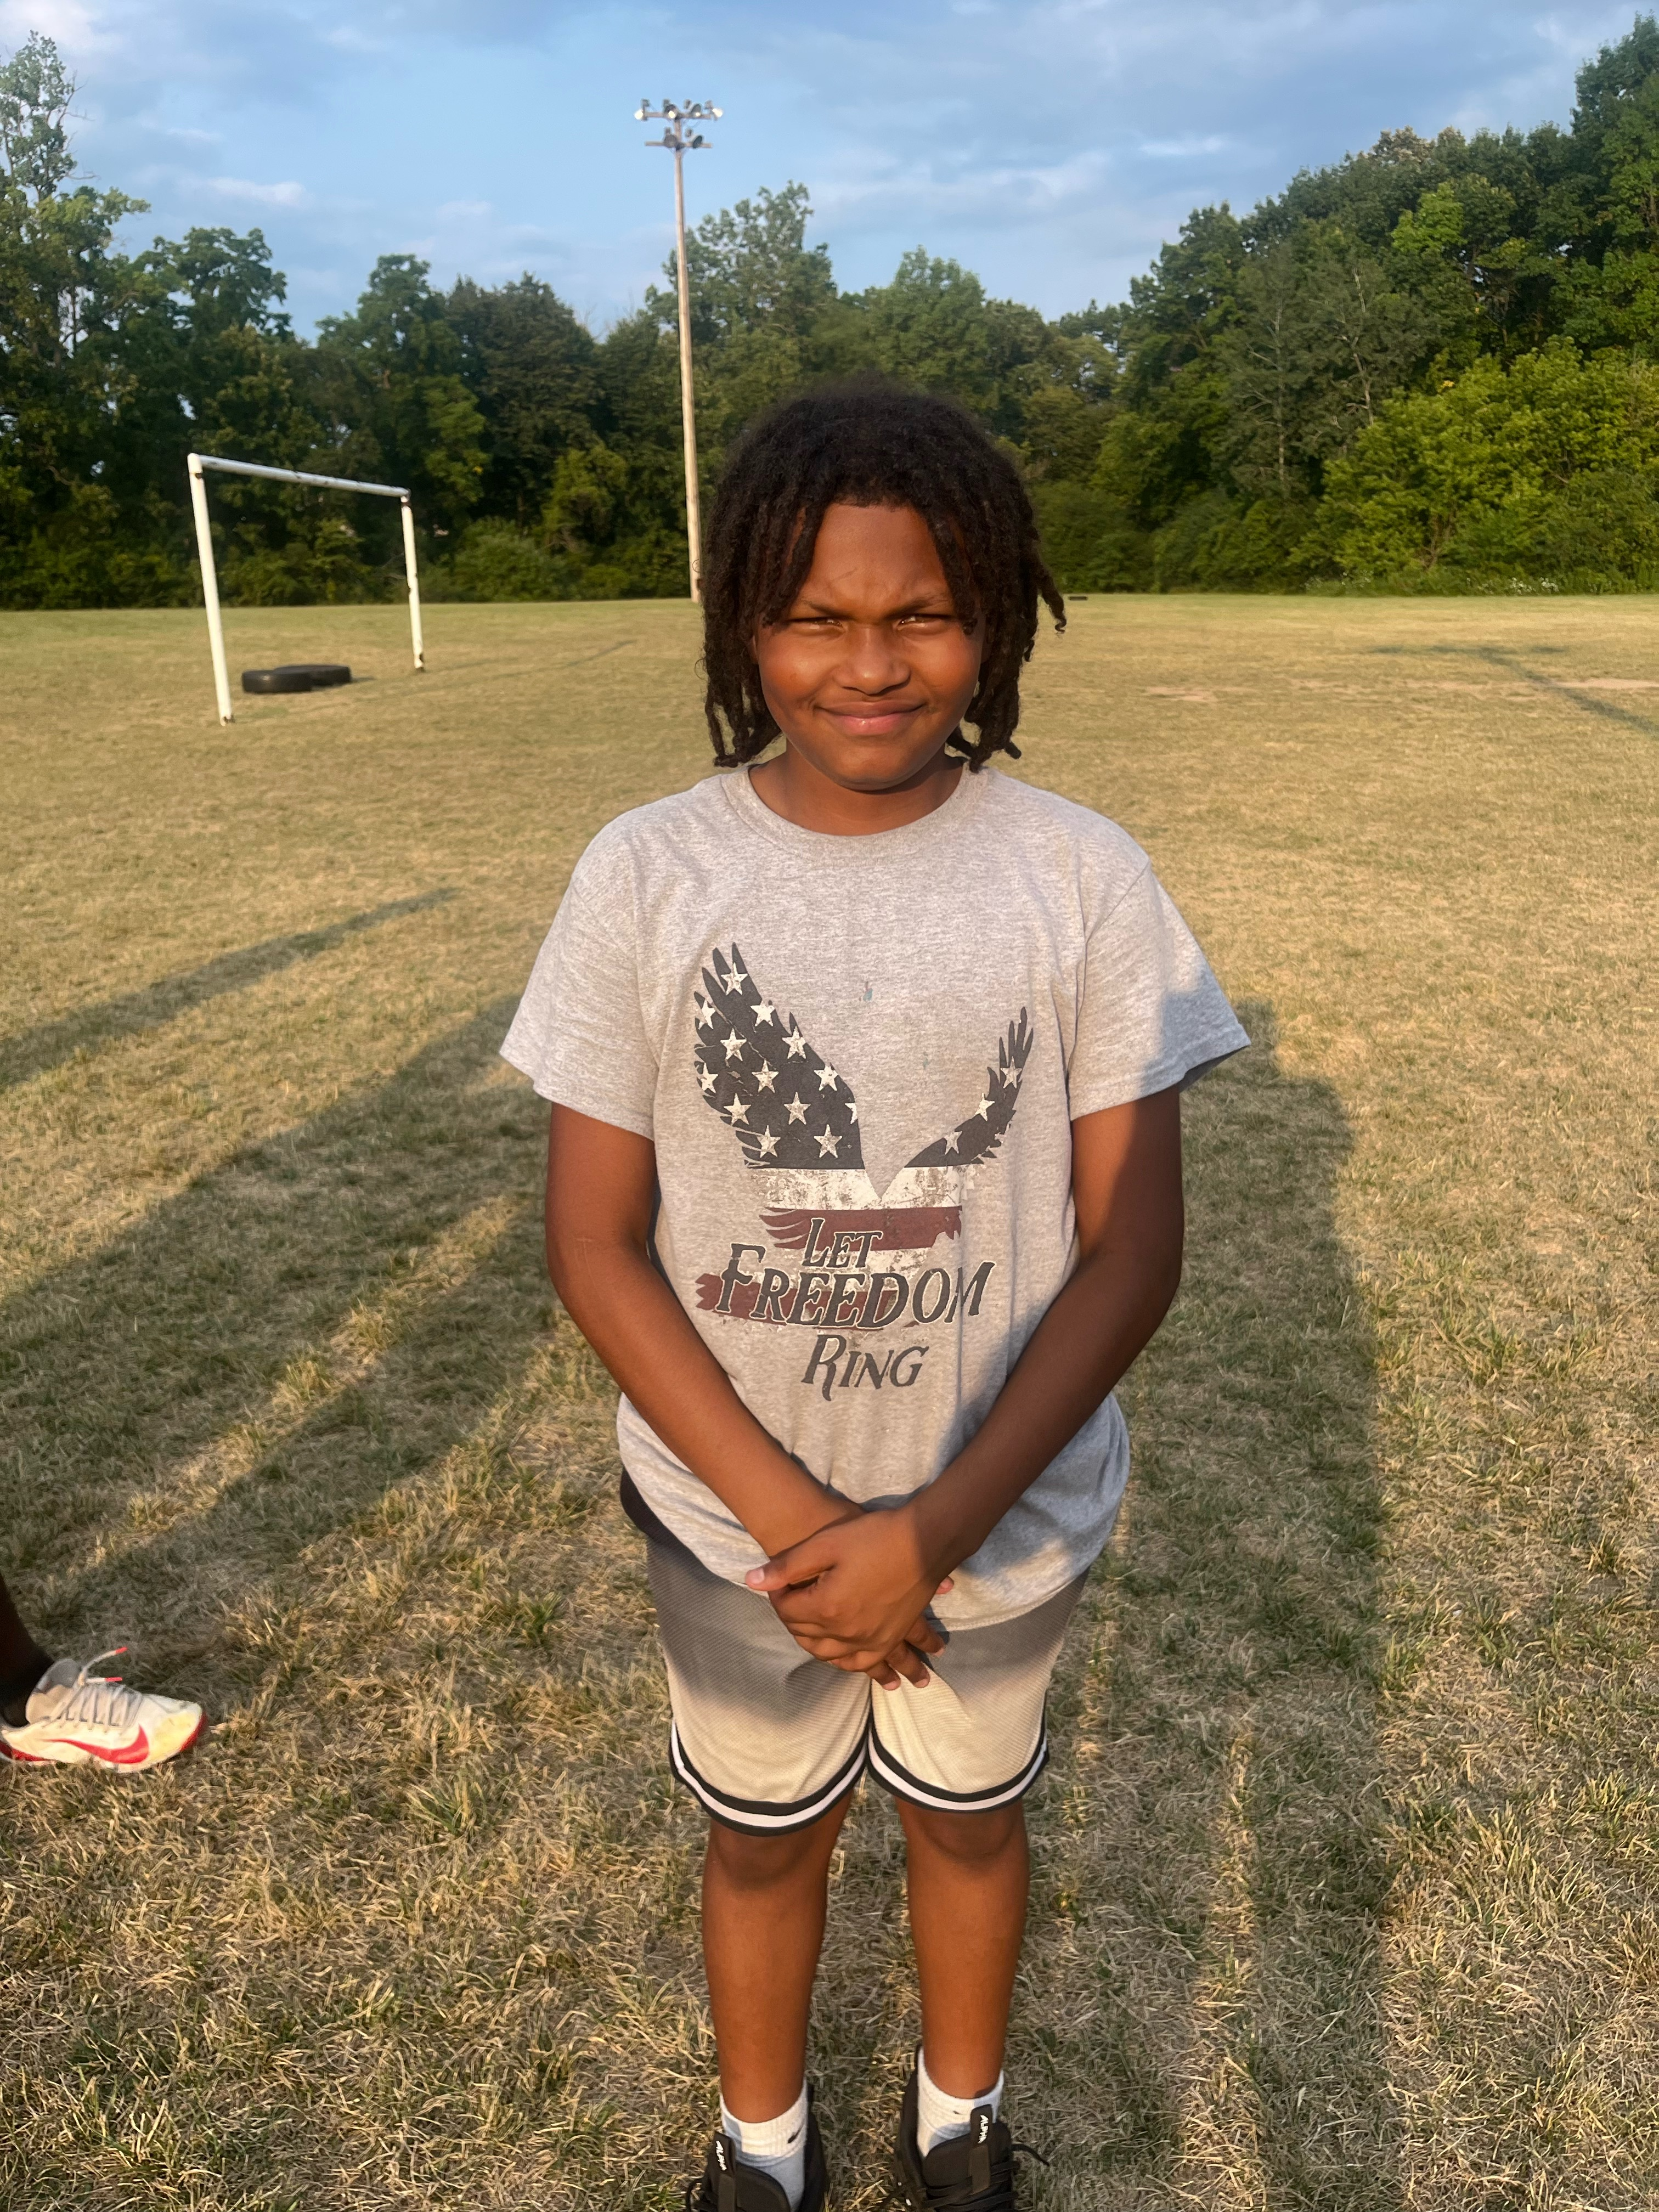
16 | Romello | Heady | 5 | 11 | 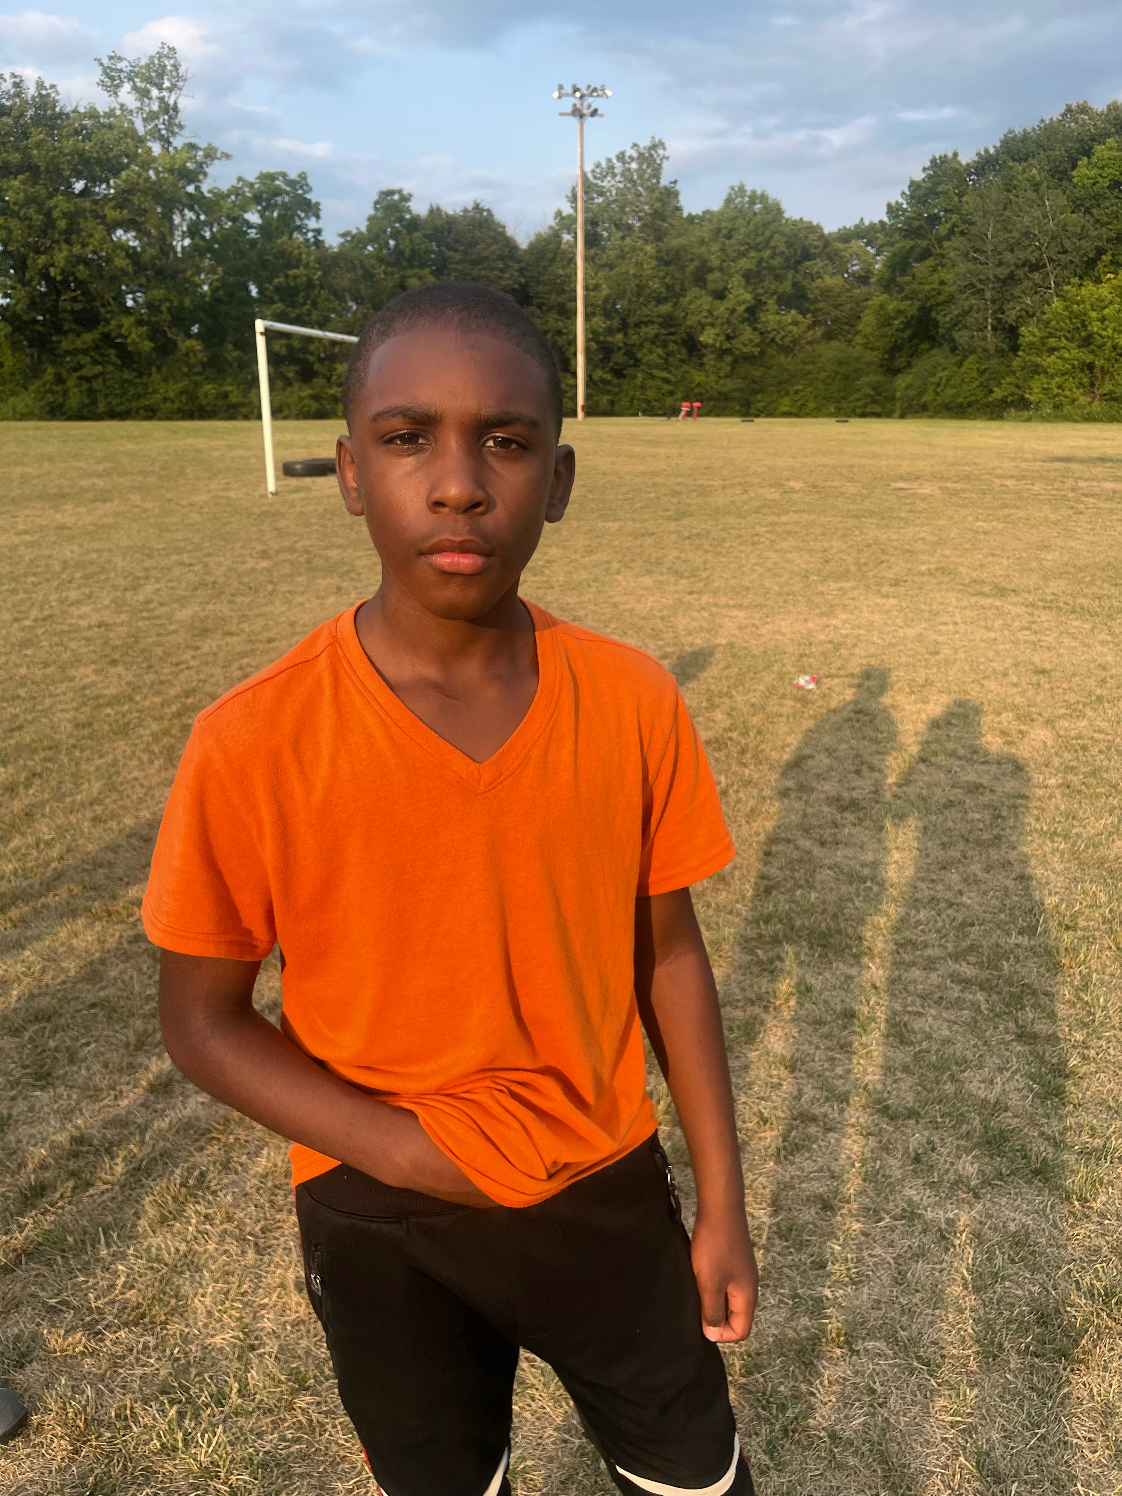
18 | Johnathan | Adams | 7 | 11 | 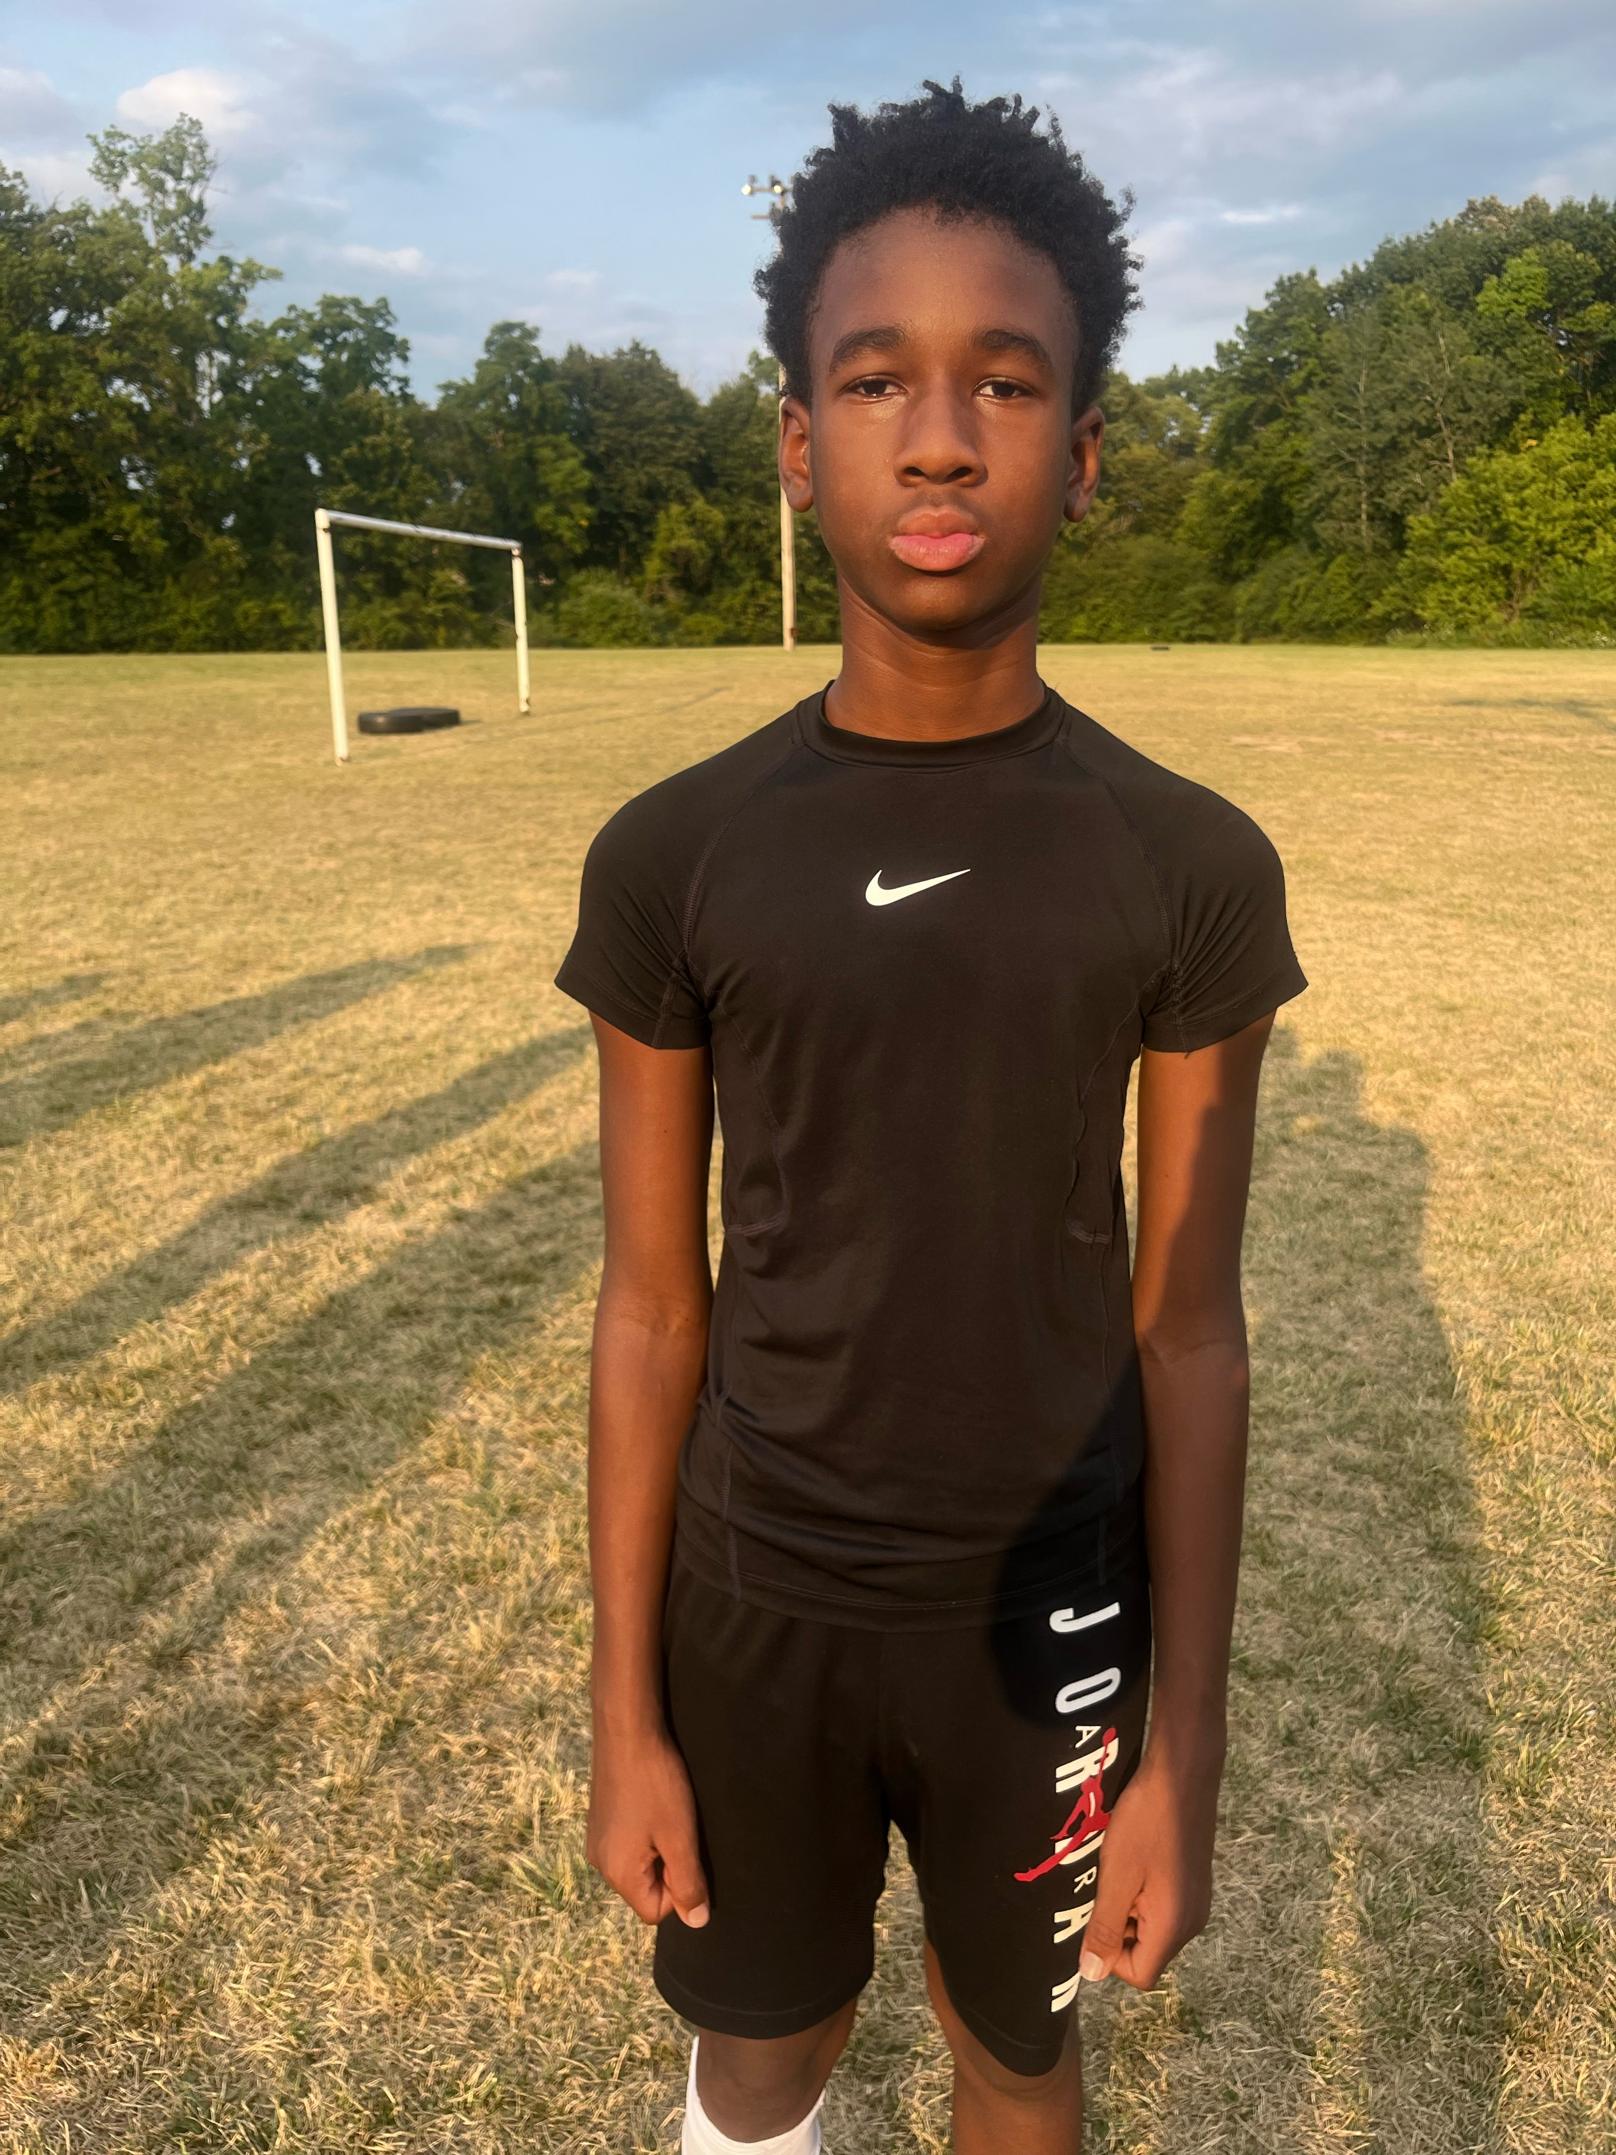
22 | Eugene | Wall | 7 | 12 | 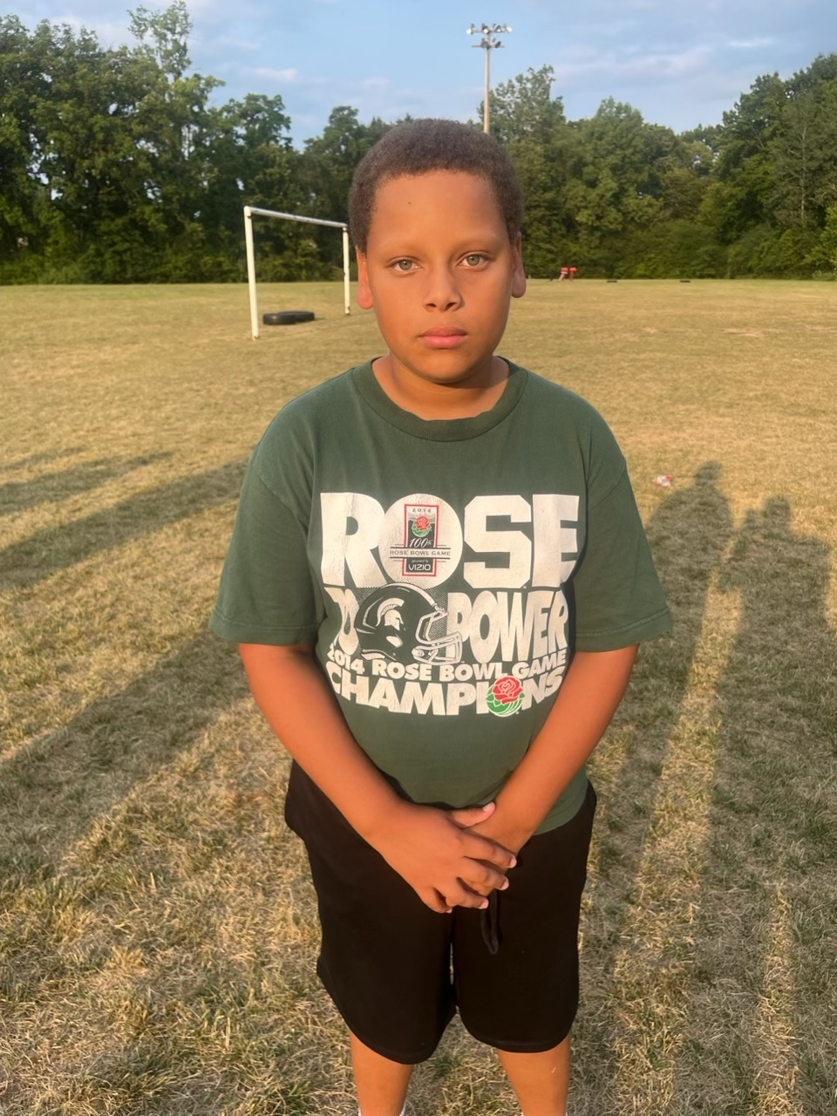
27 | Graisyn | Bercik | 5 | 10 | 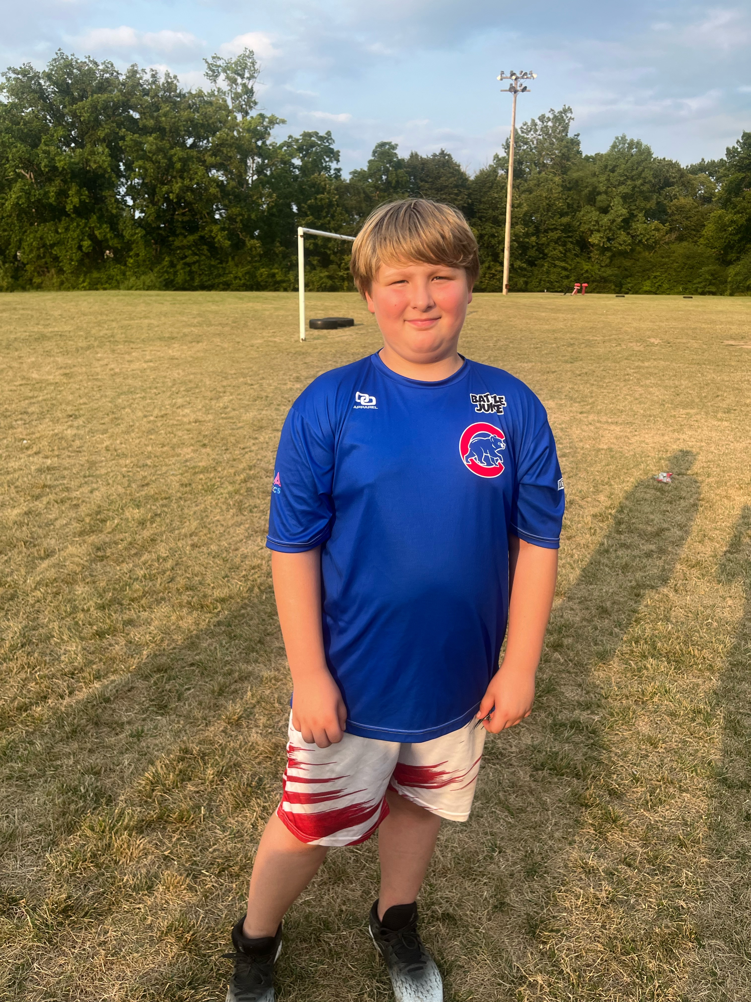
45 | Myles | Merriett | 5 | 10 | 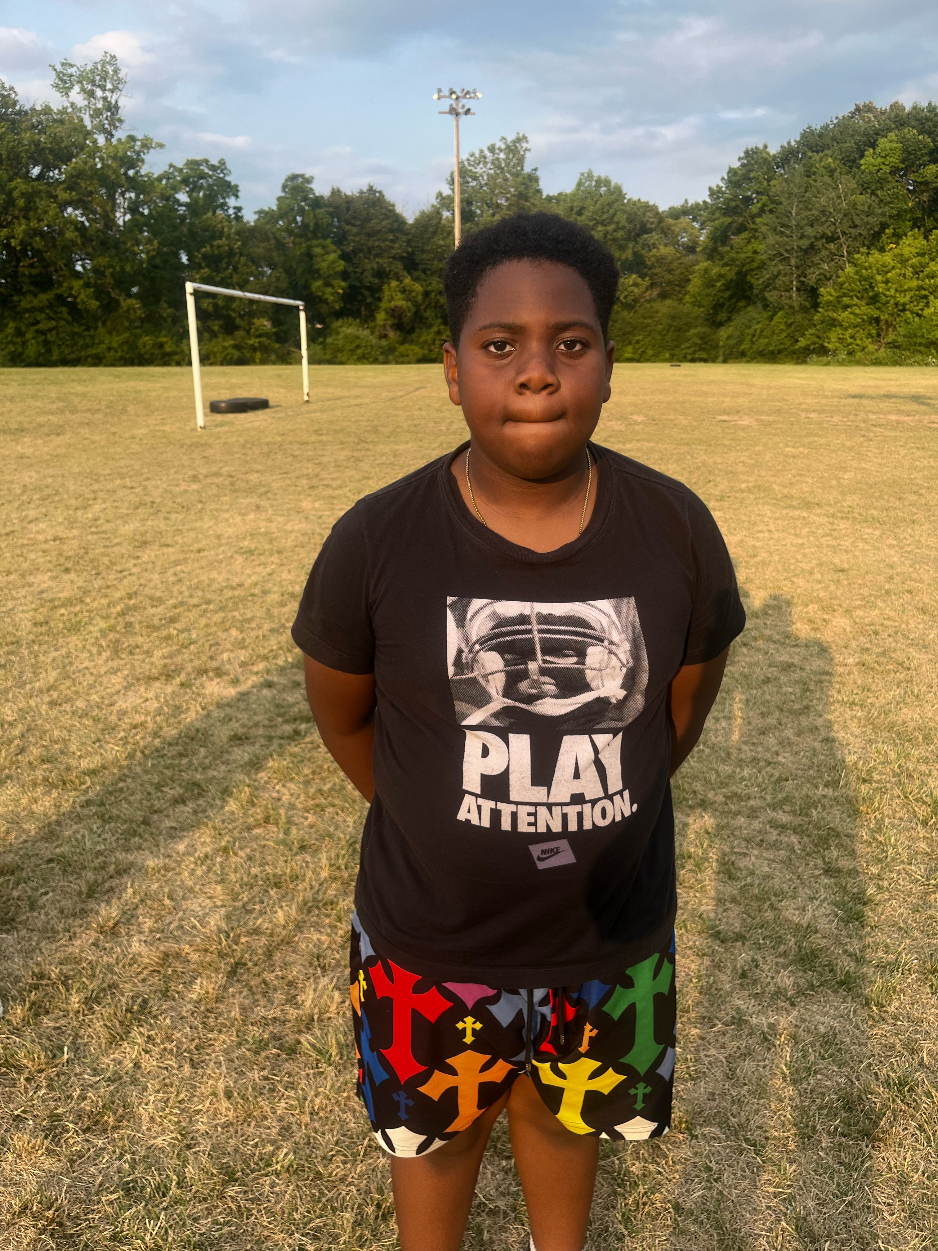
54 | Loyal | Smith | 6 | 11 | 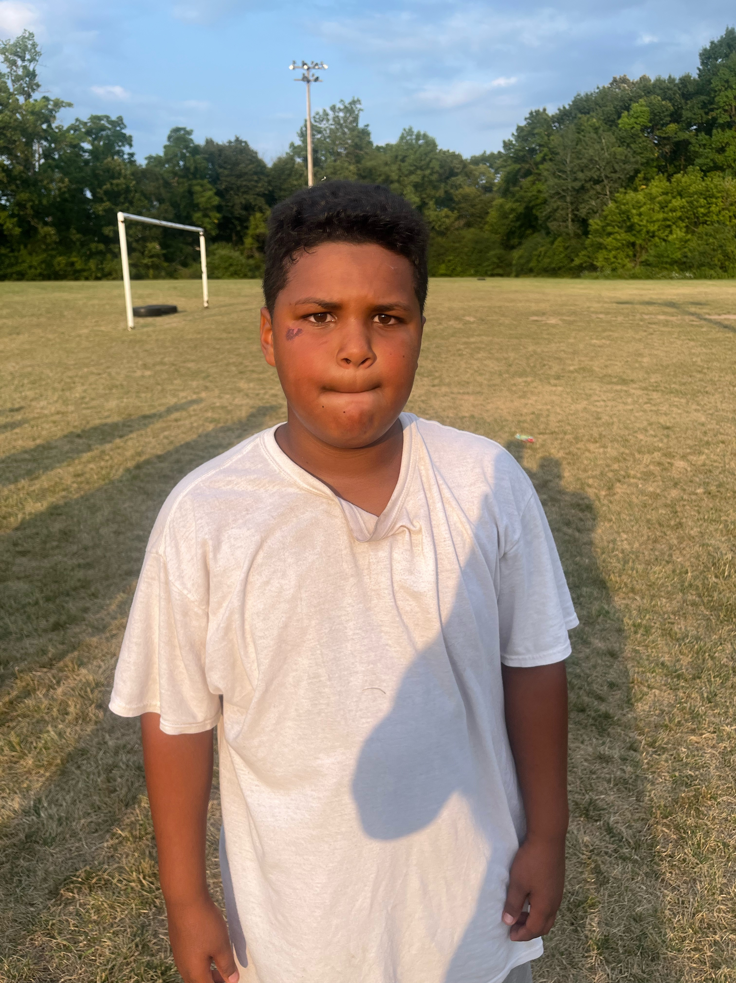
 | Ja’Leon | Lewis |  |  | 