Organization: Sterling Heights Kodiaks

Team: Varisty

Title | Head Coach | Unit Director | Ass’t Coach | Ass’t Coach
Name | Bill Tull | Bill Tull | Bashr Iwas | Brian Pike
Email  Cell | Click or tap here to enter text. | Click or tap here to enter text. | Click or tap here to enter text. | Click or tap here to enter text.
Photo |  |  |  | 

Title | Ass’t Coach | Ass’t Coach | Ass’t Coach | Ass’t Coach
Name | Ben Talan | Tyler Adair | Click or tap here to enter text. | Click or tap here to enter text.
Email  Cell | Click or tap here to enter text. | Click or tap here to enter text. | Click or tap here to enter text. | Click or tap here to enter text.
Photo |  |  | Click or tap here to enter text. | Click or tap here to enter text.

Title | Ass’t Coach | Ass’t Coach | Ass’t Coach | Ass’t Coach
Name | Click or tap here to enter text. | Click or tap here to enter text. | Click or tap here to enter text. | Click or tap here to enter text.
Email  Cell | Click or tap here to enter text. | Click or tap here to enter text. | Click or tap here to enter text. | Click or tap here to enter text.
Photo | Click or tap here to enter text. | Click or tap here to enter text. | Click or tap here to enter text. | Click or tap here to enter text.

** Coaches not identified on this Roster with a photo and contact information are NOT permitted on the sidelines of any MYFCC game. Coaches are required to have a signed Code of Conduct form on file.

*** If a player’s information is not complete, the Player is not eligible to play in any MYFCC regular season or playoff game.

**** Jersey number MUST be in numerical order, lowest to highest.
Organization/ Team: Varsity

Jersey No. | First Name | Last Name | Grade | Playing Age  (Age before Sept 1st) | Photo
0 | Dean | Delong | 7 | 13 | 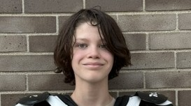
1 | Gary | Chestnutt | 8 | 14 | 
2 | Ivan | Reed III | 8 | 12 | 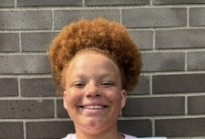
4 | Amari | Clark | 7 | 11 | 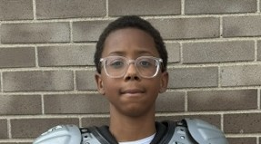
5 | Shane | North | 7 | 12 | 
10 | Christian | Adair | 8 | 12 | 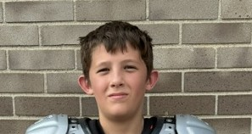
13 | Donovan | Dotson Jr | 8 | 13 | 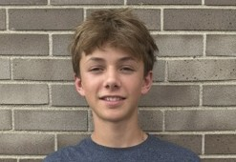
14 | Wyatt | Armstrong | 11 | 6 | 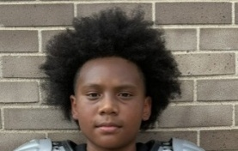
17 | Connor | Kelley | 8 | 14 | 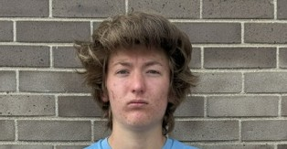
18 | Brayden | Tull | 8 | 13 | 
22 | Braxton | Tull | 6 | 11 | 
26 | Adrian | Sweet | 7 | 1242 | 
42 | Daniel | Harris | 8 | 13 | 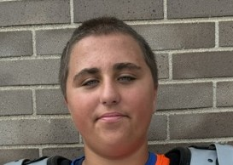
60 | Eric | Bydlos | 8 | 13 | 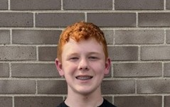
65 | Luca | Talan | 8 | 13 | 
71 | Howard | Griswold | 6 | 12 | 
78 | Jacob | Iwas | 7 | 13 | 
87 | William | Cole | 8 | 13 | 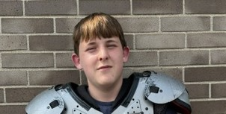
97 | Zachary | Burdette | 7 | 12 | 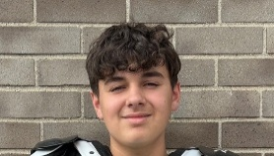
99 | Zander | Pike | 7 | 13 | 
11 | Jeremy | Edwards | 6 | 11 | Click or tap here to enter text.
 | Click or tap here to enter text. | Click or tap here to enter text. | Click or tap here to enter text. | Click or tap here to enter text. | Click or tap here to enter text.
Click or tap here to enter text. | Click or tap here to enter text. | Click or tap here to enter text. | Click or tap here to enter text. | Click or tap here to enter text. | Click or tap here to enter text.
Click or tap here to enter text. | Click or tap here to enter text. | Click or tap here to enter text. | Click or tap here to enter text. | Click or tap here to enter text. | Click or tap here to enter text.
Click or tap here to enter text. | Click or tap here to enter text. | Click or tap here to enter text. | Click or tap here to enter text. | Click or tap here to enter text. | Click or tap here to enter text.
Click or tap here to enter text. | Click or tap here to enter text. | Click or tap here to enter text. | Click or tap here to enter text. | Click or tap here to enter text. | Click or tap here to enter text.
Click or tap here to enter text. | Click or tap here to enter text. | Click or tap here to enter text. | Click or tap here to enter text. | Click or tap here to enter text. | Click or tap here to enter text.
Click or tap here to enter text. | Click or tap here to enter text. | Click or tap here to enter text. | Click or tap here to enter text. | Click or tap here to enter text. | Click or tap here to enter text.
Click or tap here to enter text. | Click or tap here to enter text. | Click or tap here to enter text. | Click or tap here to enter text. | Click or tap here to enter text. | Click or tap here to enter text.
Click or tap here to enter text. | Click or tap here to enter text. | Click or tap here to enter text. | Click or tap here to enter text. | Click or tap here to enter text. | Click or tap here to enter text.
Click or tap here to enter text. | Click or tap here to enter text. | Click or tap here to enter text. | Click or tap here to enter text. | Click or tap here to enter text. | Click or tap here to enter text.
Click or tap here to enter text. | Click or tap here to enter text. | Click or tap here to enter text. | Click or tap here to enter text. | Click or tap here to enter text. | Click or tap here to enter text.
Click or tap here to enter text. | Click or tap here to enter text. | Click or tap here to enter text. | Click or tap here to enter text. | Click or tap here to enter text. | Click or tap here to enter text.
Click or tap here to enter text. | Click or tap here to enter text. | Click or tap here to enter text. | Click or tap here to enter text. | Click or tap here to enter text. | Click or tap here to enter text.
Click or tap here to enter text. | Click or tap here to enter text. | Click or tap here to enter text. | Click or tap here to enter text. | Click or tap here to enter text. | Click or tap here to enter text.
Click or tap here to enter text. | Click or tap here to enter text. | Click or tap here to enter text. | Click or tap here to enter text. | Click or tap here to enter text. | Click or tap here to enter text.
Click or tap here to enter text. | Click or tap here to enter text. | Click or tap here to enter text. | Click or tap here to enter text. | Click or tap here to enter text. | Click or tap here to enter text.
Click or tap here to enter text. | Click or tap here to enter text. | Click or tap here to enter text. | Click or tap here to enter text. | Click or tap here to enter text. | Click or tap here to enter text.
Click or tap here to enter text. | Click or tap here to enter text. | Click or tap here to enter text. | Click or tap here to enter text. | Click or tap here to enter text. | Click or tap here to enter text.
Click or tap here to enter text. | Click or tap here to enter text. | Click or tap here to enter text. | Click or tap here to enter text. | Click or tap here to enter text. | Click or tap here to enter text.
Click or tap here to enter text. | Click or tap here to enter text. | Click or tap here to enter text. | Click or tap here to enter text. | Click or tap here to enter text. | Click or tap here to enter text.
Click or tap here to enter text. | Click or tap here to enter text. | Click or tap here to enter text. | Click or tap here to enter text. | Click or tap here to enter text. | Click or tap here to enter text.
Click or tap here to enter text. | Click or tap here to enter text. | Click or tap here to enter text. | Click or tap here to enter text. | Click or tap here to enter text. | Click or tap here to enter text.
Click or tap here to enter text. | Click or tap here to enter text. | Click or tap here to enter text. | Click or tap here to enter text. | Click or tap here to enter text. | Click or tap here to enter text.
Click or tap here to enter text. | Click or tap here to enter text. | Click or tap here to enter text. | Click or tap here to enter text. | Click or tap here to enter text. | Click or tap here to enter text.
Click or tap here to enter text. | Click or tap here to enter text. | Click or tap here to enter text. | Click or tap here to enter text. | Click or tap here to enter text. | Click or tap here to enter text.
Click or tap here to enter text. | Click or tap here to enter text. | Click or tap here to enter text. | Click or tap here to enter text. | Click or tap here to enter text. | Click or tap here to enter text.

** Coaches not identified on this Roster with a photo and contact information are NOT permitted on the sidelines of any MYFCC game.

*** If a player’s information is not complete, the Player is not eligible to play in any MYFCC regular season or playoff game.

**** Jersey number MUST be in numerical order, lowest to highest.

