Organization: Sterling Heights Kodiaks

Team: Freshman

Title | Head Coach | Unit Director | Ass’t Coach | Ass’t Coach
Name | Don Dotson | Bill Tull | George Kanonow | Rickey Marlow II
Email  Cell | Click or tap here to enter text. | 586 453 7276 | Click or tap here to enter text. | Click or tap here to enter text.
Photo | 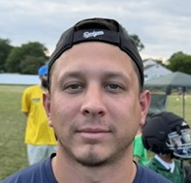 | Click or tap here to enter text. |  | 

Title | Ass’t Coach | Ass’t Coach | Ass’t Coach | Ass’t Coach
Name | Jeffrey Chamberlain | Edwin Griswold | Torey Bruce | Click or tap here to enter text.
Email  Cell | Click or tap here to enter text. | Click or tap here to enter text. | Click or tap here to enter text. | Click or tap here to enter text.
Photo |  | 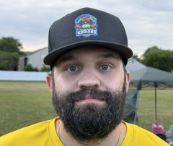 |  | Click or tap here to enter text.

Title | Ass’t Coach | Ass’t Coach | Ass’t Coach | Ass’t Coach
Name | Click or tap here to enter text. | Click or tap here to enter text. | Click or tap here to enter text. | Click or tap here to enter text.
Email  Cell | Click or tap here to enter text. | Click or tap here to enter text. | Click or tap here to enter text. | Click or tap here to enter text.
Photo | Click or tap here to enter text. | Click or tap here to enter text. | Click or tap here to enter text. | Click or tap here to enter text.

** Coaches not identified on this Roster with a photo and contact information are NOT permitted on the sidelines of any MYFCC game. Coaches are required to have a signed Code of Conduct form on file.

*** If a player’s information is not complete, the Player is not eligible to play in any MYFCC regular season or playoff game.

**** Jersey number MUST be in numerical order, lowest to highest.
Organization/ Team: Kodiaks Freshman

Jersey No. | First Name | Last Name | Grade | Playing Age  (Age before Sept 1st) | Photo
0 | Giovanni | Dotson | 3 | 8 | 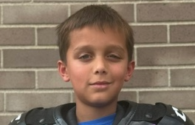
2 | Emery | Oliver | 3 | 8 | 
3 | Ricky | Marlow III | 4 | 9 | 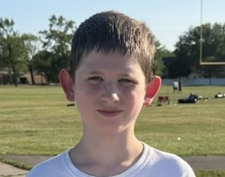
4 | Jaxon | Lambrix | 4 | 9 | 
6 | Abel | Thomason | 3 | 8 | 
9 | Benjamin | Chamberlain | 5 | 9 | 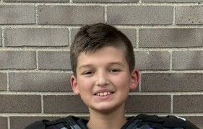
14 | Jack | Crabtree | 4 | 9 | 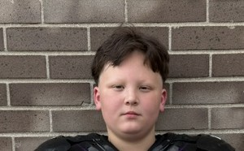
15 | Jayden | Dodge | 5 | 10 | 
16 | Kayden | Hummel | 4 | 9 | 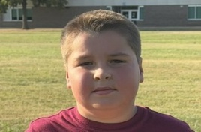
20 | Cecelia | Pesavento | 4 | 9 | 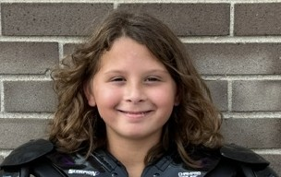
22 | Jaxon | Richardson | 6 | 10 | 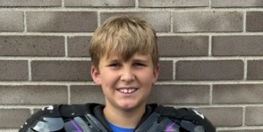
23 | Bennett | Martin | 4 | 9 | 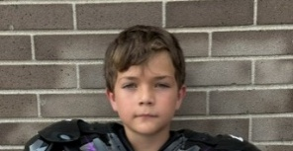
24 | Tyler | Bresnahan | 5 | 9 | 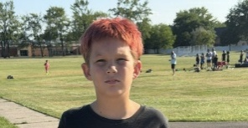
26 | Jet | Sweet | 2 | 7 | 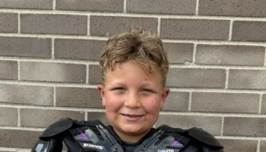
28 | Elijah | Addison | 2 | 7 | 
33 | Shon | Archer | 4 | 9 | 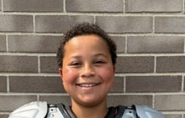
42 | Zachary | Richardson | 4 | 9 | 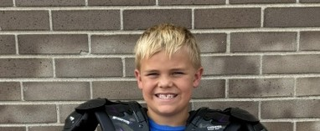
52 | Brenden | Bielski | 5 | 10 | 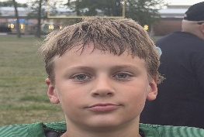
54 | Chance | Ashley | 2 | 7 | 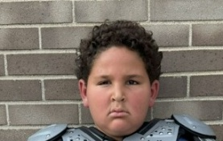
72 | Cashton | Rausch | 2 | 7 | 
78 | Easton | Albee | 5 | 10 | 
1 | Michael | Seals-Conley | 3 | 8 | 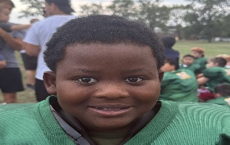
8 | Beckam | Sunisloe | 2 | 7 | 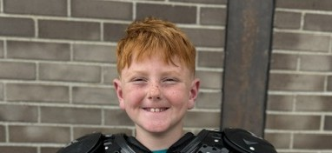
11 | Andrew | Keilman | 3 | 8 | 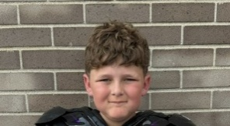
13 | Jayce | Lambert | 4 | 9 | 
17 | Hunter | Reese | 3 | 8 | 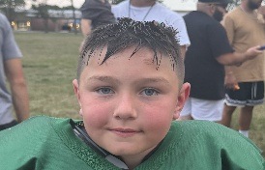
7 | Jax | Bruce | 2 | 7 | 
36 | Jakoby | Mauldin | Click or tap here to enter text. | Click or tap here to enter text. | Click or tap here to enter text.
Click or tap here to enter text. | Click or tap here to enter text. | Click or tap here to enter text. | Click or tap here to enter text. | Click or tap here to enter text. | Click or tap here to enter text.
Click or tap here to enter text. | Click or tap here to enter text. | Click or tap here to enter text. | Click or tap here to enter text. | Click or tap here to enter text. | Click or tap here to enter text.
Click or tap here to enter text. | Click or tap here to enter text. | Click or tap here to enter text. | Click or tap here to enter text. | Click or tap here to enter text. | Click or tap here to enter text.
Click or tap here to enter text. | Click or tap here to enter text. | Click or tap here to enter text. | Click or tap here to enter text. | Click or tap here to enter text. | Click or tap here to enter text.
Click or tap here to enter text. | Click or tap here to enter text. | Click or tap here to enter text. | Click or tap here to enter text. | Click or tap here to enter text. | Click or tap here to enter text.
Click or tap here to enter text. | Click or tap here to enter text. | Click or tap here to enter text. | Click or tap here to enter text. | Click or tap here to enter text. | Click or tap here to enter text.
Click or tap here to enter text. | Click or tap here to enter text. | Click or tap here to enter text. | Click or tap here to enter text. | Click or tap here to enter text. | Click or tap here to enter text.
Click or tap here to enter text. | Click or tap here to enter text. | Click or tap here to enter text. | Click or tap here to enter text. | Click or tap here to enter text. | Click or tap here to enter text.
Click or tap here to enter text. | Click or tap here to enter text. | Click or tap here to enter text. | Click or tap here to enter text. | Click or tap here to enter text. | Click or tap here to enter text.
Click or tap here to enter text. | Click or tap here to enter text. | Click or tap here to enter text. | Click or tap here to enter text. | Click or tap here to enter text. | Click or tap here to enter text.
Click or tap here to enter text. | Click or tap here to enter text. | Click or tap here to enter text. | Click or tap here to enter text. | Click or tap here to enter text. | Click or tap here to enter text.
Click or tap here to enter text. | Click or tap here to enter text. | Click or tap here to enter text. | Click or tap here to enter text. | Click or tap here to enter text. | Click or tap here to enter text.
Click or tap here to enter text. | Click or tap here to enter text. | Click or tap here to enter text. | Click or tap here to enter text. | Click or tap here to enter text. | Click or tap here to enter text.
Click or tap here to enter text. | Click or tap here to enter text. | Click or tap here to enter text. | Click or tap here to enter text. | Click or tap here to enter text. | Click or tap here to enter text.
Click or tap here to enter text. | Click or tap here to enter text. | Click or tap here to enter text. | Click or tap here to enter text. | Click or tap here to enter text. | Click or tap here to enter text.
Click or tap here to enter text. | Click or tap here to enter text. | Click or tap here to enter text. | Click or tap here to enter text. | Click or tap here to enter text. | Click or tap here to enter text.
Click or tap here to enter text. | Click or tap here to enter text. | Click or tap here to enter text. | Click or tap here to enter text. | Click or tap here to enter text. | Click or tap here to enter text.
Click or tap here to enter text. | Click or tap here to enter text. | Click or tap here to enter text. | Click or tap here to enter text. | Click or tap here to enter text. | Click or tap here to enter text.
Click or tap here to enter text. | Click or tap here to enter text. | Click or tap here to enter text. | Click or tap here to enter text. | Click or tap here to enter text. | Click or tap here to enter text.

** Coaches not identified on this Roster with a photo and contact information are NOT permitted on the sidelines of any MYFCC game.

*** If a player’s information is not complete, the Player is not eligible to play in any MYFCC regular season or playoff game.

**** Jersey number MUST be in numerical order, lowest to highest.

