Organization: Rochester Raiders

Team: JV Maroon

Title | Head Coach | Unit Director | Ass’t Coach | Ass’t Coach
Name | Eric Smith | Arturo Zayas | Michael Korynski | Tim Mullen
Email  Cell | 2483189914  esmith8232@gmail.com | 2489613135  zayayin@gmail.com | 2483216996  Mike.korynski@gmail.com | 2488903104  delt2424@yahoo.com
Photo |  |  |  | 

Title | Ass’t Coach | Ass’t Coach | Ass’t Coach | Ass’t Coach
Name | Mike MacCallum | Larry Harrington | Brian Furmaniak | Click or tap here to enter text.
Email  Cell | 2484703182  michael.maccallum@gmail.com | 5176721448  lawh23@gmail.com | 2488909927  bfurmaniak@oaklandinsurance.com | Click or tap here to enter text.
Photo |  |  |  | Click or tap here to enter text.

Title | Ass’t Coach | Ass’t Coach | Ass’t Coach | Ass’t Coach
Name | Click or tap here to enter text. | Click or tap here to enter text. | Click or tap here to enter text. | Click or tap here to enter text.
Email  Cell | Click or tap here to enter text. | Click or tap here to enter text. | Click or tap here to enter text. | Click or tap here to enter text.
Photo | Click or tap here to enter text. | Click or tap here to enter text. | Click or tap here to enter text. | Click or tap here to enter text.

** Coaches not identified on this Roster with a photo and contact information are NOT permitted on the sidelines of any MYFCC game. Coaches are required to have a signed Code of Conduct form on file.

*** If a player’s information is not complete, the Player is not eligible to play in any MYFCC regular season or playoff game.

**** Jersey number MUST be in numerical order, lowest to highest.
Organization/ Team: Rochester JV Maroon

Jersey No. | First Name | Last Name | Grade | Playing Age  (Age before Sept 1st) | Photo
2 | Antwuan | Kyles Jr | 5th | 11 | 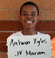
4 | Caleb | Steaban | 7th | 12 | 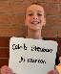
8 | Jack | Bierlein | 6th | 12 | 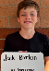
12 | Bennett | Tripoli | 7th | 12 | 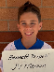
14 | Raymond | Weller | 5th | 11 | 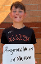
16 | Gavin | Koike | 7th | 12 | 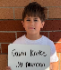
18 | Charlie | MacCallum | 6th | 12 | 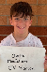
20 | Jackson | Ortiz | 6th | 12 | 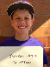
22 | Jacob | Roldan | 6th | 11 | 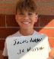
24 | Wesley | Beebe | 6th | 12 | 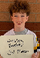
28 | Lucas | Korynski | 6th | 11 | 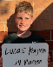
32 | Brendan | Mullen | 7th | 12 | 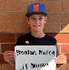
34 | Blake | Dillard | 6th | 11 | 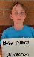
36 | Lucas | Chue | 6th | 11 | 
40 | Henry | Hathaway | 5th | 11 | 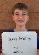
44 | Blake | Harrington | 5th | 11 | 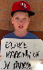
46 | Dante | Zayas | 7th | 12 | 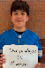
48 | Liam | Laporte | 6th | 12 | 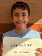
56 | Gavin | Fakult | 7th | 12 | 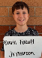
58 | Santiago | Berain | 7th | 12 | 
62 | Johnny | Opatik | 7th | 12 | 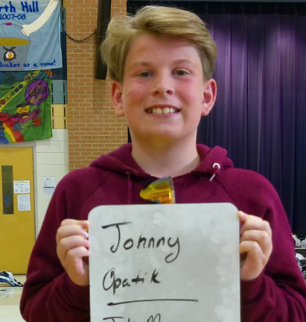
64 | Jackson | MacDonald | 7th | 12 | 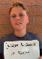
68 | Mateo | Hernandez | 6th | 11 | 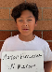
72 | Mason | Furmaniak | 6th | 11 | 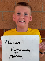
76 | Jackson | Paletta | 7th | 12 | 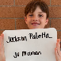
80 | Nolan | Dorsey | 7th | 12 | 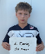
84 | Elliot | Smith | 7th | 12 | 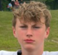
88 | Aidan | Martin | 6th | 11 | 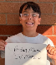
90 | Matthew | Choi | ? | 12 | 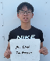
92 | Luke | Colucci | 7th | 12 | 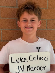
96 | Lukas | Delia | 7th | 12 | 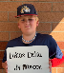

** Coaches not identified on this Roster with a photo and contact information are NOT permitted on the sidelines of any MYFCC game.

*** If a player’s information is not complete, the Player is not eligible to play in any MYFCC regular season or playoff game.

**** Jersey number MUST be in numerical order, lowest to highest.

