Organization: Warren Jets

Team: Varsity

Title | Head Coach | Unit Director | Ass’t Coach | Ass’t Coach
Name | Thomas Hervey | Kathy Caffee | James Terry | Demetrius Fitzgerald
Email  Cell | 313-265-5629 | 586-946-6252 | 810-956-0327 | 313-671-5118
Photo |  |  |  | 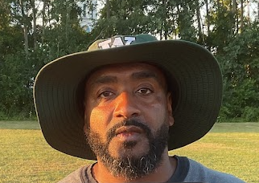

Title | Ass’t Coach | Ass’t Coach | Ass’t Coach | Ass’t Coach
Name | Clint Ware | Eric Parker | Rapphel Cooper | TEAM DAD – Craig Caffee
Email  Cell | 586-368-7166 | 313-498--5208 | 989-475-1833 | 586-216-1188
Photo |  |  |  | 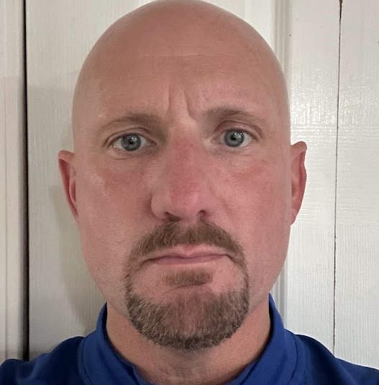

Title | Ass’t Coach | Ass’t Coach | Ass’t Coach | Ass’t Coach
Name | Click or tap here to enter text. | Click or tap here to enter text. | Click or tap here to enter text. | Click or tap here to enter text.
Email  Cell | Click or tap here to enter text. | Click or tap here to enter text. | Click or tap here to enter text. | Click or tap here to enter text.
Photo | Click or tap here to enter text. | Click or tap here to enter text. | Click or tap here to enter text. | Click or tap here to enter text.

** Coaches not identified on this Roster with a photo and contact information are NOT permitted on the sidelines of any MYFCC game. Coaches are required to have a signed Code of Conduct form on file.

*** If a player’s information is not complete, the Player is not eligible to play in any MYFCC regular season or playoff game.

**** Jersey number MUST be in numerical order, lowest to highest.
Organization/ Team: Click or tap here to enter text.

Jersey No. | First Name | Last Name | Grade | Playing Age  (Age before Sept 1st) | Photo
0 | Steven | Henderson Jr | 8th | 13 | 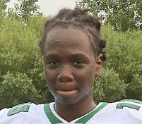
1 | DeMauri | Fitzgerald | 8th | 13 | 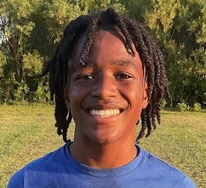
2 | Mohamed | Samb | 8th | 13 | 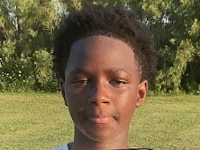
3 | Wesslon | Gray III | 8th | 14 | 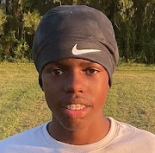
4 | Zahier | Taylor | 8th | 13 | 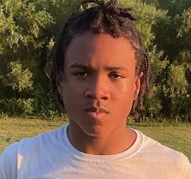
5 | Jordan | Hunter | 8th | 13 | 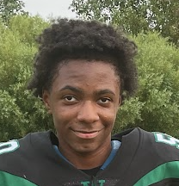
6 | Antoine | Ivy Jr | 7th | 12 | 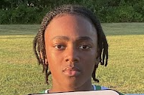
7 | Joseph | Kratz | 8th | 13 | 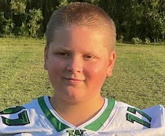
8 | DeAndre | Frazier JR | 7th | 12 | 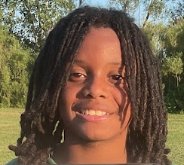
9 | Camir | Maxie | 8th | 13 | 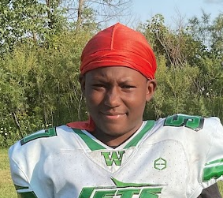
10 | Carter | Lewis | 8th | 13 | 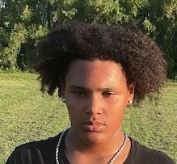
12 | Jayceon | Jones | 7th | 12 | 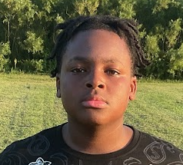
20 | Raylen | Cox | 8th | 12 | 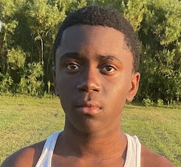
23 | Jeremiah | Brown-Townsend | 5th | 11 | 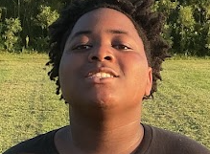
24 | Wyatt | Chaffee | 7th | 12 | 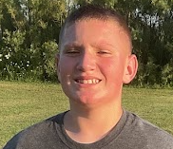
26 | Justice | Clabon | 7th | 12 | 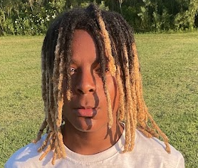
32 | Sean | Finley | 8th | 12 | 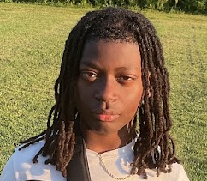
44 | Blake | Eaton Jr | 8th | 13 | 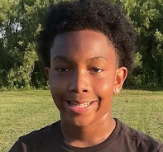
52 | Alonzo | Wilkens Jr | 6th | 12 | 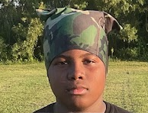
99 | TreVon | Chestnut | 8th | 13 | 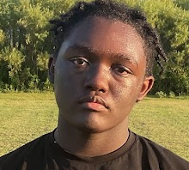
Click or tap here to enter text. | Click or tap here to enter text. |  | Click or tap here to enter text. | Click or tap here to enter text. | Click or tap here to enter text.
Click or tap here to enter text. | Click or tap here to enter text. | Click or tap here to enter text. | Click or tap here to enter text. | Click or tap here to enter text. | Click or tap here to enter text.
Click or tap here to enter text. | Click or tap here to enter text. | Click or tap here to enter text. | Click or tap here to enter text. | Click or tap here to enter text. | Click or tap here to enter text.
Click or tap here to enter text. | Click or tap here to enter text. | Click or tap here to enter text. | Click or tap here to enter text. | Click or tap here to enter text. | Click or tap here to enter text.
Click or tap here to enter text. | Click or tap here to enter text. | Click or tap here to enter text. | Click or tap here to enter text. | Click or tap here to enter text. | Click or tap here to enter text.
Click or tap here to enter text. | Click or tap here to enter text. | Click or tap here to enter text. | Click or tap here to enter text. | Click or tap here to enter text. | Click or tap here to enter text.
Click or tap here to enter text. | Click or tap here to enter text. | Click or tap here to enter text. | Click or tap here to enter text. | Click or tap here to enter text. | Click or tap here to enter text.
Click or tap here to enter text. | Click or tap here to enter text. | Click or tap here to enter text. | Click or tap here to enter text. | Click or tap here to enter text. | Click or tap here to enter text.
Click or tap here to enter text. | Click or tap here to enter text. | Click or tap here to enter text. | Click or tap here to enter text. | Click or tap here to enter text. | Click or tap here to enter text.
Click or tap here to enter text. | Click or tap here to enter text. | Click or tap here to enter text. | Click or tap here to enter text. | Click or tap here to enter text. | Click or tap here to enter text.
Click or tap here to enter text. | Click or tap here to enter text. | Click or tap here to enter text. | Click or tap here to enter text. | Click or tap here to enter text. | Click or tap here to enter text.
Click or tap here to enter text. | Click or tap here to enter text. | Click or tap here to enter text. | Click or tap here to enter text. | Click or tap here to enter text. | Click or tap here to enter text.
Click or tap here to enter text. | Click or tap here to enter text. | Click or tap here to enter text. | Click or tap here to enter text. | Click or tap here to enter text. | Click or tap here to enter text.
Click or tap here to enter text. | Click or tap here to enter text. | Click or tap here to enter text. | Click or tap here to enter text. | Click or tap here to enter text. | Click or tap here to enter text.
Click or tap here to enter text. | Click or tap here to enter text. | Click or tap here to enter text. | Click or tap here to enter text. | Click or tap here to enter text. | Click or tap here to enter text.
Click or tap here to enter text. | Click or tap here to enter text. | Click or tap here to enter text. | Click or tap here to enter text. | Click or tap here to enter text. | Click or tap here to enter text.
Click or tap here to enter text. | Click or tap here to enter text. | Click or tap here to enter text. | Click or tap here to enter text. | Click or tap here to enter text. | Click or tap here to enter text.
Click or tap here to enter text. | Click or tap here to enter text. | Click or tap here to enter text. | Click or tap here to enter text. | Click or tap here to enter text. | Click or tap here to enter text.
Click or tap here to enter text. | Click or tap here to enter text. | Click or tap here to enter text. | Click or tap here to enter text. | Click or tap here to enter text. | Click or tap here to enter text.
Click or tap here to enter text. | Click or tap here to enter text. | Click or tap here to enter text. | Click or tap here to enter text. | Click or tap here to enter text. | Click or tap here to enter text.
Click or tap here to enter text. | Click or tap here to enter text. | Click or tap here to enter text. | Click or tap here to enter text. | Click or tap here to enter text. | Click or tap here to enter text.
Click or tap here to enter text. | Click or tap here to enter text. | Click or tap here to enter text. | Click or tap here to enter text. | Click or tap here to enter text. | Click or tap here to enter text.
Click or tap here to enter text. | Click or tap here to enter text. | Click or tap here to enter text. | Click or tap here to enter text. | Click or tap here to enter text. | Click or tap here to enter text.
Click or tap here to enter text. | Click or tap here to enter text. | Click or tap here to enter text. | Click or tap here to enter text. | Click or tap here to enter text. | Click or tap here to enter text.
Click or tap here to enter text. | Click or tap here to enter text. | Click or tap here to enter text. | Click or tap here to enter text. | Click or tap here to enter text. | Click or tap here to enter text.
Click or tap here to enter text. | Click or tap here to enter text. | Click or tap here to enter text. | Click or tap here to enter text. | Click or tap here to enter text. | Click or tap here to enter text.
Click or tap here to enter text. | Click or tap here to enter text. | Click or tap here to enter text. | Click or tap here to enter text. | Click or tap here to enter text. | Click or tap here to enter text.

** Coaches not identified on this Roster with a photo and contact information are NOT permitted on the sidelines of any MYFCC game.

*** If a player’s information is not complete, the Player is not eligible to play in any MYFCC regular season or playoff game.

**** Jersey number MUST be in numerical order, lowest to highest.

