Organization: Westland Meteors

Team: Freshman

Title | Head Coach | Unit Director | Ass’t Coach | Ass’t Coach
Name | Tommie Walls | William Turman | Adam Walker | Joe Murphy
Email  Cell | T4walls@gmail.com (734) 716-9008 | (313) 208-9334 | abizness7@gmail.com (313) 208-9664 | joemurf36@gmail.com (313) 515-4585
Photo |  |  |  | 

Title | Ass’t Coach | Ass’t Coach | Ass’t Coach | Ass’t Coach
Name | Chaz Walls | Brian Ceckiewicz Jr | Click or tap here to enter text. | Click or tap here to enter text.
Email  Cell | (734) 716-9007 | (313) 549-3131 | Click or tap here to enter text. | Click or tap here to enter text.
Photo |  |  | Click or tap here to enter text. | Click or tap here to enter text.

Title | Ass’t Coach | Ass’t Coach | Ass’t Coach | Ass’t Coach
Name | Click or tap here to enter text. | Click or tap here to enter text. | Click or tap here to enter text. | Click or tap here to enter text.
Email  Cell | Click or tap here to enter text. | Click or tap here to enter text. | Click or tap here to enter text. | Click or tap here to enter text.
Photo | Click or tap here to enter text. | Click or tap here to enter text. | Click or tap here to enter text. | Click or tap here to enter text.

** Coaches not identified on this Roster with a photo and contact information are NOT permitted on the sidelines of any MYFCC game. Coaches are required to have a signed Code of Conduct form on file.

*** If a player’s information is not complete, the Player is not eligible to play in any MYFCC regular season or playoff game.

**** Jersey number MUST be in numerical order, lowest to highest.
Organization/ Team: Westland Meteors/Freshman

Jersey No. | First Name | Last Name | Grade | Playing Age  (Age before Sept 1st) | Photo
2 | King | Mason | 4 | 9 | 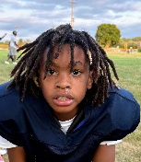
3 | Grayson | Johnson | 4 | 9 | 
5 | Legend | Dye | 4 | 9 | 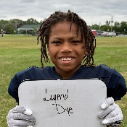
7 | Brandon | Beard Jr | 5 | 10 | 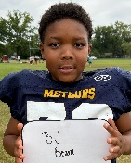
10 | Antoine | Johnson | 5 | 10 | 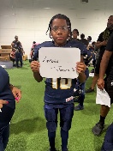
13 | Micah | Worthington | 5 | 10 | 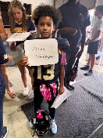
15 | River | Powers | 4 | 9 | 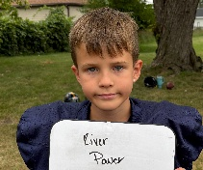
16 | Anthony | Crowe | 4 | 9 | 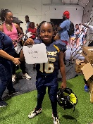
18 | Jamir | Walmsley | 5 | 10 | 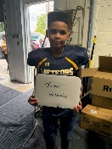
22 | Beckham | Johnson | 5 | 10 | 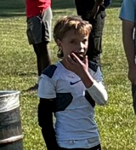
23 | Previn | Bowers | 5 | 9 | 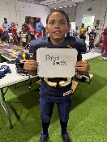
24 | Kyrie | Martin | 5 | 9 | 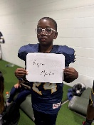
26 | Carter | King | 5 | 10 | 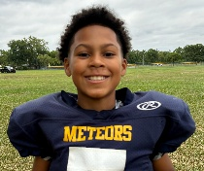
27 | Jordan | Murphy | 5 | 9 | 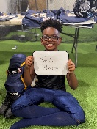
30 | Oliver | Anderson | 5 | 10 | 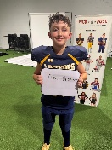
32 | Caz | Johnson | 4 | 9 | 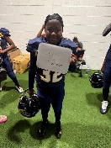
35 | Bryce | Ceckiewicz | 5 | 10 | 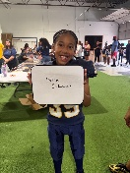
37 | Dre’Mond | Browning | 5 | 10 | 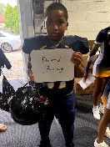
45 | Jaxson | Stockner | 2 | 8 | 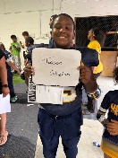
55 | Hunter | Johnston | 4 | 9 | 
72 | Jordan | Smith | 5 | 10 | 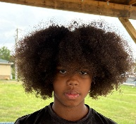
88 | Damian | Walls | 5 | 10 | 
Click or tap here to enter text. | Click or tap here to enter text. | Click or tap here to enter text. | Click or tap here to enter text. | Click or tap here to enter text. | Click or tap here to enter text.
Click or tap here to enter text. | Click or tap here to enter text. | Click or tap here to enter text. | Click or tap here to enter text. | Click or tap here to enter text. | Click or tap here to enter text.
Click or tap here to enter text. | Click or tap here to enter text. | Click or tap here to enter text. | Click or tap here to enter text. | Click or tap here to enter text. | Click or tap here to enter text.
Click or tap here to enter text. | Click or tap here to enter text. | Click or tap here to enter text. | Click or tap here to enter text. | Click or tap here to enter text. | Click or tap here to enter text.
Click or tap here to enter text. | Click or tap here to enter text. | Click or tap here to enter text. | Click or tap here to enter text. | Click or tap here to enter text. | Click or tap here to enter text.
Click or tap here to enter text. | Click or tap here to enter text. | Click or tap here to enter text. | Click or tap here to enter text. | Click or tap here to enter text. | Click or tap here to enter text.
Click or tap here to enter text. | Click or tap here to enter text. | Click or tap here to enter text. | Click or tap here to enter text. | Click or tap here to enter text. | Click or tap here to enter text.
Click or tap here to enter text. | Click or tap here to enter text. | Click or tap here to enter text. | Click or tap here to enter text. | Click or tap here to enter text. | Click or tap here to enter text.
Click or tap here to enter text. | Click or tap here to enter text. | Click or tap here to enter text. | Click or tap here to enter text. | Click or tap here to enter text. | Click or tap here to enter text.
Click or tap here to enter text. | Click or tap here to enter text. | Click or tap here to enter text. | Click or tap here to enter text. | Click or tap here to enter text. | Click or tap here to enter text.
Click or tap here to enter text. | Click or tap here to enter text. | Click or tap here to enter text. | Click or tap here to enter text. | Click or tap here to enter text. | Click or tap here to enter text.
Click or tap here to enter text. | Click or tap here to enter text. | Click or tap here to enter text. | Click or tap here to enter text. | Click or tap here to enter text. | Click or tap here to enter text.
Click or tap here to enter text. | Click or tap here to enter text. | Click or tap here to enter text. | Click or tap here to enter text. | Click or tap here to enter text. | Click or tap here to enter text.
Click or tap here to enter text. | Click or tap here to enter text. | Click or tap here to enter text. | Click or tap here to enter text. | Click or tap here to enter text. | Click or tap here to enter text.
Click or tap here to enter text. | Click or tap here to enter text. | Click or tap here to enter text. | Click or tap here to enter text. | Click or tap here to enter text. | Click or tap here to enter text.
Click or tap here to enter text. | Click or tap here to enter text. | Click or tap here to enter text. | Click or tap here to enter text. | Click or tap here to enter text. | Click or tap here to enter text.
Click or tap here to enter text. | Click or tap here to enter text. | Click or tap here to enter text. | Click or tap here to enter text. | Click or tap here to enter text. | Click or tap here to enter text.
Click or tap here to enter text. | Click or tap here to enter text. | Click or tap here to enter text. | Click or tap here to enter text. | Click or tap here to enter text. | Click or tap here to enter text.
Click or tap here to enter text. | Click or tap here to enter text. | Click or tap here to enter text. | Click or tap here to enter text. | Click or tap here to enter text. | Click or tap here to enter text.
Click or tap here to enter text. | Click or tap here to enter text. | Click or tap here to enter text. | Click or tap here to enter text. | Click or tap here to enter text. | Click or tap here to enter text.
Click or tap here to enter text. | Click or tap here to enter text. | Click or tap here to enter text. | Click or tap here to enter text. | Click or tap here to enter text. | Click or tap here to enter text.
Click or tap here to enter text. | Click or tap here to enter text. | 4 | Click or tap here to enter text. | Click or tap here to enter text. | Click or tap here to enter text.
Click or tap here to enter text. | Click or tap here to enter text. | Click or tap here to enter text. | Click or tap here to enter text. | Click or tap here to enter text. | Click or tap here to enter text.
Click or tap here to enter text. | Click or tap here to enter text. | Click or tap here to enter text. | Click or tap here to enter text. | Click or tap here to enter text. | Click or tap here to enter text.
Click or tap here to enter text. | Click or tap here to enter text. | Click or tap here to enter text. | Click or tap here to enter text. | Click or tap here to enter text. | Click or tap here to enter text.

** Coaches not identified on this Roster with a photo and contact information are NOT permitted on the sidelines of any MYFCC game.

*** If a player’s information is not complete, the Player is not eligible to play in any MYFCC regular season or playoff game.

**** Jersey number MUST be in numerical order, lowest to highest.

