Organization: Sterling Heights Kodiaks

Team: JV

Title | Head Coach | Unit Director | Ass’t Coach | Ass’t Coach
Name | Chris Brown | Bill Tull | Joe Martin | Justin Roth
Email  Cell | Click or tap here to enter text. | Click or tap here to enter text. | Click or tap here to enter text. | Click or tap here to enter text.
Photo |  | Click or tap here to enter text. |  | 

Title | Ass’t Coach | Ass’t Coach | Ass’t Coach | Ass’t Coach
Name | Brandon Radzik | Ryan Etherton | Click or tap here to enter text. | Click or tap here to enter text.
Email  Cell | Click or tap here to enter text. | Click or tap here to enter text. | Click or tap here to enter text. | Click or tap here to enter text.
Photo |  |  | Click or tap here to enter text. | Click or tap here to enter text.

Title | Ass’t Coach | Ass’t Coach | Ass’t Coach | Ass’t Coach
Name | Click or tap here to enter text. | Click or tap here to enter text. | Click or tap here to enter text. | Click or tap here to enter text.
Email  Cell | Click or tap here to enter text. | Click or tap here to enter text. | Click or tap here to enter text. | Click or tap here to enter text.
Photo | Click or tap here to enter text. | Click or tap here to enter text. | Click or tap here to enter text. | Click or tap here to enter text.

** Coaches not identified on this Roster with a photo and contact information are NOT permitted on the sidelines of any MYFCC game. Coaches are required to have a signed Code of Conduct form on file.

*** If a player’s information is not complete, the Player is not eligible to play in any MYFCC regular season or playoff game.

**** Jersey number MUST be in numerical order, lowest to highest.
Organization/ Team: JV

Jersey No. | First Name | Last Name | Grade | Playing Age  (Age before Sept 1st) | Photo
0 | Keegan | Somer Kline | 6 | 11 | 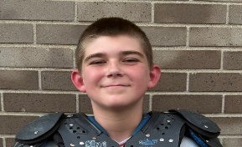
1 | Vincenzo | Pliva | 6 | 11 | 
2 | Hudson | Etherton | 6 | 10 | 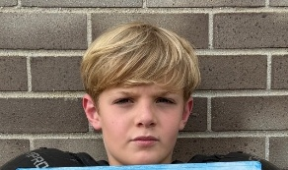
5 | Gavin | Degenhart | 5 | 10 | 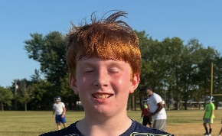
9 | Milo | Hofer | 6 | 11 | 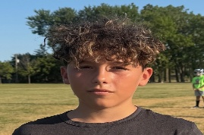
10 | Harrison | Razdik | 6 | 11 | 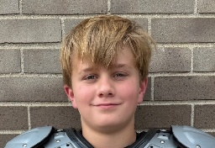
12 | Lennox | Hopkins | 6 | 11 | 
13 | Jensen | Selomi | 6 | 11 | 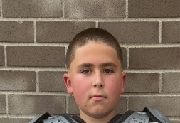
14 | Lorenzo | Pliva | 6 | 12 | 
15 | Jordan | Klos | 6 | 10 | 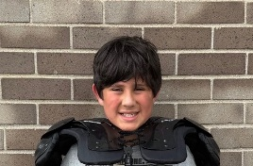
16 | Connor | Roth | 6 | 11 | 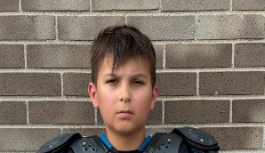
18 | Kevin | Ragsdale | 5 | 11 | 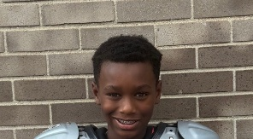
20 | Nicholas | Theel | 6 | 11 | 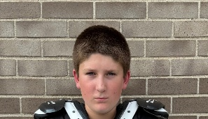
21 | Jackson | Bell | 6 | 11 | 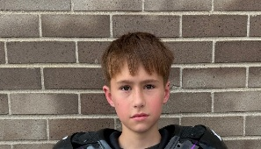
23 | Roman | Martin | 6 | 12 | 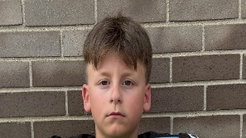
24 | Noah | Watts | 6 | 11 | 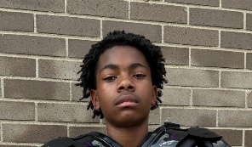
26 | Christopher | Polis | 6 | 11 | 
30 | Nathan | Vassel | 6 | 11 | 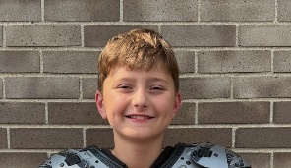
33 | Hunter | Murray | 6 | 11 | 
42 | Colton | Wedyke | 6 | 11 | 
44 | Skyler | Mowery | 6 | 11 | 
47 | Weston | Bucholtz | 5 | 10 | 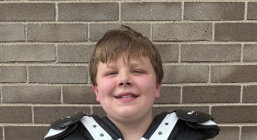
67 | Aiden | Preston | 6 | 11 | 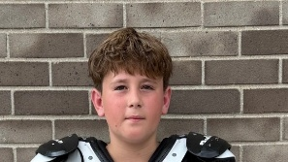
72 | Caleb | Dettloff | 6 | 11 | 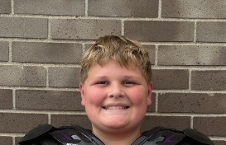
78 | Truman | Onley | 6 | 11 | 
87 | Darek | Harris | 7 | 12 | 
97 | Remington | Wright | 6 | 11 | 
6 | Jace | Brown | 6 | 11 | 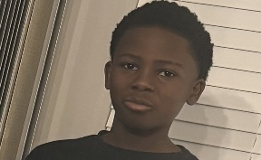
27 | Jalen | Harris | 6 | 11 | Click or tap here to enter text.
Click or tap here to enter text. | Click or tap here to enter text. | Click or tap here to enter text. | Click or tap here to enter text. | Click or tap here to enter text. | Click or tap here to enter text.
Click or tap here to enter text. | Click or tap here to enter text. | Click or tap here to enter text. | Click or tap here to enter text. | Click or tap here to enter text. | Click or tap here to enter text.
Click or tap here to enter text. | Click or tap here to enter text. | Click or tap here to enter text. | Click or tap here to enter text. | Click or tap here to enter text. | Click or tap here to enter text.
Click or tap here to enter text. | Click or tap here to enter text. | Click or tap here to enter text. | Click or tap here to enter text. | Click or tap here to enter text. | Click or tap here to enter text.
Click or tap here to enter text. | Click or tap here to enter text. | Click or tap here to enter text. | Click or tap here to enter text. | Click or tap here to enter text. | Click or tap here to enter text.
Click or tap here to enter text. | Click or tap here to enter text. | Click or tap here to enter text. | Click or tap here to enter text. | Click or tap here to enter text. | Click or tap here to enter text.
Click or tap here to enter text. | Click or tap here to enter text. | Click or tap here to enter text. | Click or tap here to enter text. | Click or tap here to enter text. | Click or tap here to enter text.
Click or tap here to enter text. | Click or tap here to enter text. | Click or tap here to enter text. | Click or tap here to enter text. | Click or tap here to enter text. | Click or tap here to enter text.
Click or tap here to enter text. | Click or tap here to enter text. | Click or tap here to enter text. | Click or tap here to enter text. | Click or tap here to enter text. | Click or tap here to enter text.
Click or tap here to enter text. | Click or tap here to enter text. | Click or tap here to enter text. | Click or tap here to enter text. | Click or tap here to enter text. | Click or tap here to enter text.
Click or tap here to enter text. | Click or tap here to enter text. | Click or tap here to enter text. | Click or tap here to enter text. | Click or tap here to enter text. | Click or tap here to enter text.
Click or tap here to enter text. | Click or tap here to enter text. | Click or tap here to enter text. | Click or tap here to enter text. | Click or tap here to enter text. | Click or tap here to enter text.
Click or tap here to enter text. | Click or tap here to enter text. | Click or tap here to enter text. | Click or tap here to enter text. | Click or tap here to enter text. | Click or tap here to enter text.
Click or tap here to enter text. | Click or tap here to enter text. | Click or tap here to enter text. | Click or tap here to enter text. | Click or tap here to enter text. | Click or tap here to enter text.
Click or tap here to enter text. | Click or tap here to enter text. | Click or tap here to enter text. | Click or tap here to enter text. | Click or tap here to enter text. | Click or tap here to enter text.
Click or tap here to enter text. | Click or tap here to enter text. | Click or tap here to enter text. | Click or tap here to enter text. | Click or tap here to enter text. | Click or tap here to enter text.
Click or tap here to enter text. | Click or tap here to enter text. | Click or tap here to enter text. | Click or tap here to enter text. | Click or tap here to enter text. | Click or tap here to enter text.
Click or tap here to enter text. | Click or tap here to enter text. | Click or tap here to enter text. | Click or tap here to enter text. | Click or tap here to enter text. | Click or tap here to enter text.

** Coaches not identified on this Roster with a photo and contact information are NOT permitted on the sidelines of any MYFCC game.

*** If a player’s information is not complete, the Player is not eligible to play in any MYFCC regular season or playoff game.

**** Jersey number MUST be in numerical order, lowest to highest.

