Organization: Rochester Raiders

Team: JV Gold

Title | Head Coach | Unit Director | Ass’t Coach | Ass’t Coach
Name | Ryan “Al” Alexander | Jim “Beef” Wellington | Kevin McGrogan | Bob Belke
Email  Cell | Ralexander1717@gmail.com  248.309.1715 | 248-703-7605  jwelling@aerotek.com | 2486221736  Kpoker@hotmail.com | 2482519374  Bob.belke@gmail.com
Photo |  |  |  | 

Title | Ass’t Coach | Ass’t Coach | Ass’t Coach | Ass’t Coach
Name | David Parrish | Justin McNamara | Brandon Dobos | Click or tap here to enter text.
Email  Cell | 2485151239  backstop1three@aol.com | Mcnama63@gmail.com  248.914.6270 | 3135751309  Dobosb82@gmail.com | Click or tap here to enter text.
Photo |  |  |  | Click or tap here to enter text.

Title | Ass’t Coach | Ass’t Coach | Ass’t Coach | Ass’t Coach
Name | Click or tap here to enter text. | Click or tap here to enter text. | Click or tap here to enter text. | Click or tap here to enter text.
Email  Cell | Click or tap here to enter text. | Click or tap here to enter text. | Click or tap here to enter text. | Click or tap here to enter text.
Photo | Click or tap here to enter text. | Click or tap here to enter text. | Click or tap here to enter text. | Click or tap here to enter text.

** Coaches not identified on this Roster with a photo and contact information are NOT permitted on the sidelines of any MYFCC game. Coaches are required to have a signed Code of Conduct form on file.

*** If a player’s information is not complete, the Player is not eligible to play in any MYFCC regular season or playoff game.

**** Jersey number MUST be in numerical order, lowest to highest.
Organization/ Team: Rochester JV Gold

Jersey No. | First Name | Last Name | Grade | Playing Age  (Age before Sept 1st) | Photo
1 | Miles | McNamara | 5th | 11 | 
3 | Owen | Papke | 6th | 11 | 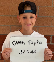
5 | John Henry | Huber | 7th | 12 | 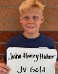
7 | Bobby | Belke | 7th | 12 | 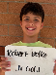
9 | Harrison | Montgomery | 6th | 11 | 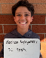
11 | Drew | Wellington | 7th | 12 | 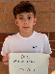
13 | Evan | Chase | 7th | 12 | 
15 | Briggs | Parrish | 7th | 12 | 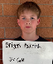
17 | Dylan | Lewis | 6th | 11 | 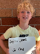
19 | Oliver | Ricketts | 7th | 12 | 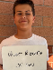
21 | Nathan | Dobos | 6th | 11 | 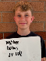
23 | Camden | Alexander | 7th | 12 | 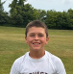
25 | Ryder | Heckman | 6th | 11 | 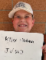
29 | Dominic | Saverino | 6th | 11 | 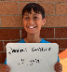
33 | Cole | Tredwell | 6th | 11 | 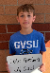
37 | Cody | Tredwell | 6th | 11 | 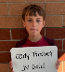
41 | Wyatt | Doski | 5th | 11 | 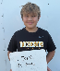
45 | Luca | Bonetti | 6th | 11 | 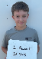
49 | Nico | Bonetti | 6th | 11 | 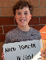
51 | Tyler | Zeigler | 7th | 12 | 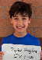
55 | Benjamin | Aidem | 7th | 12 | 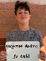
57 | Lochlan | McCoy | 5th | 11 | 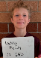
61 | Gavin | Papke | 7th | 12 | 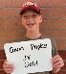
71 | Andrew | Williamson | 6th | 11 | 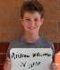
75 | Jude | Sorisho | 7th | 12 | 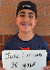
79 | Ethan | Noble | 6th | 12 | 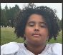
83 | Holden | Wilson | 7th | 12 | 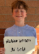
87 | Xander | Salem | 7th | 12 | 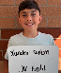
89 | Nathan | McGrogan | 7th | 12 | 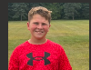
95 | William | Sesi | 6th | 11 | 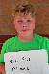

** Coaches not identified on this Roster with a photo and contact information are NOT permitted on the sidelines of any MYFCC game.

*** If a player’s information is not complete, the Player is not eligible to play in any MYFCC regular season or playoff game.

**** Jersey number MUST be in numerical order, lowest to highest.

